**First Word**

**First Christian Church Brownstown**

**September 2025**

**Family Movie Night**

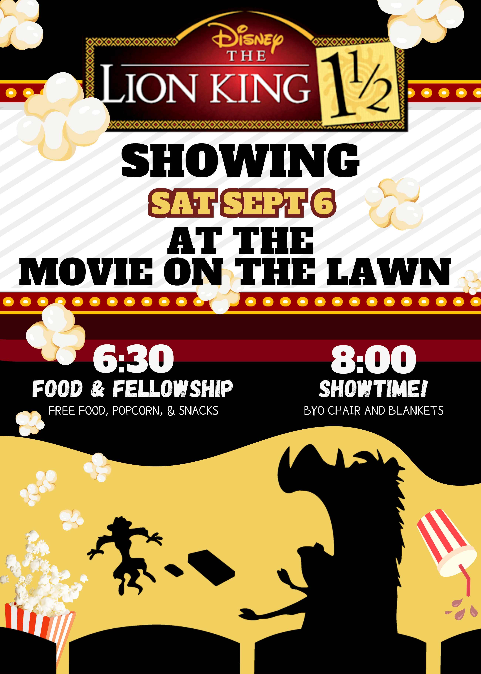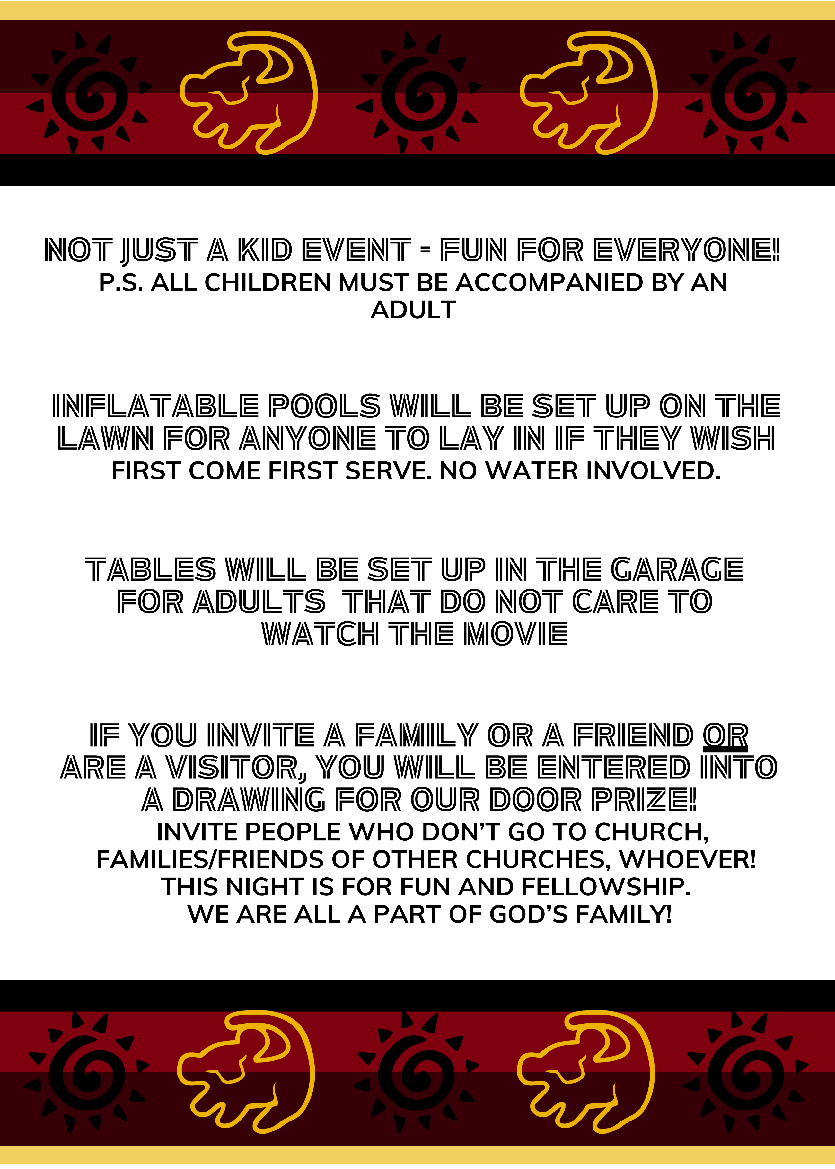

#### We Exist to:

#### * WORSHIP the Living God * WIN People to Jesus * TRAIN God’s People for Service

#### * SEND Them Out Into the World

#### 



**From the Minister**

I am in the middle of preaching a two-week sermon series on the creation of mankind and the fall of mankind. In doing this, I am preaching from Genesis 1-3. There is one thing of importance that does not fall within this mini-series though. Why create people knowing they are going to sin? This question can be answered with one word … LOVE.

God loved people so much he wanted to create them and love them and be with them. God loved people so much that he could not create beings without choice. This choice is paramount to free will and thus vital to us loving Him in return. In fact, love is not possible without free will. In order to love you must be able to choose to love. This is why sin was possible. To love God, people must be able to not love God. The choice is needed.

God bless,  
Nathan Brands

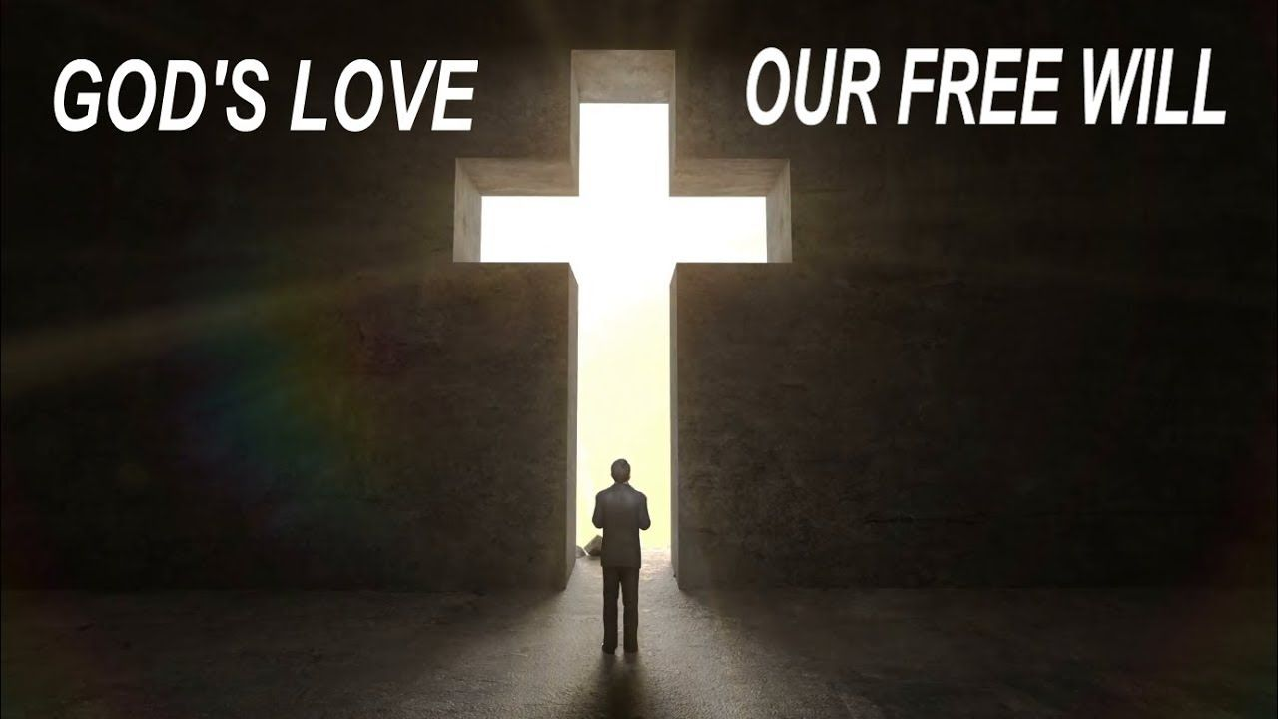

**Save the Date**

Our annual Fall Festival will be Sunday, October 12th. More information to come!



## What’s Going On?

**Breakfast Fellowship:** If you would like to provide breakfast on a Sunday morning, there will be a sign-up sheet in the kitchen. Breakfast starts at 9:00 am.

**Leadership Team (Elder’s & Deacon’s) Meeting** is Tuesday, Sept. 9th @ 7:00 pm.

**Youth Groups** will resume on Sunday, September 6th @ 6:00 pm.

## 



## 5th Sunday

A 5th Sunday Offering will be taken up on Sunday, November 30th. The entire amount collected will be going to the Building Loan Principle. The goal is $22,000. There will also be a potluck following Sunday School.

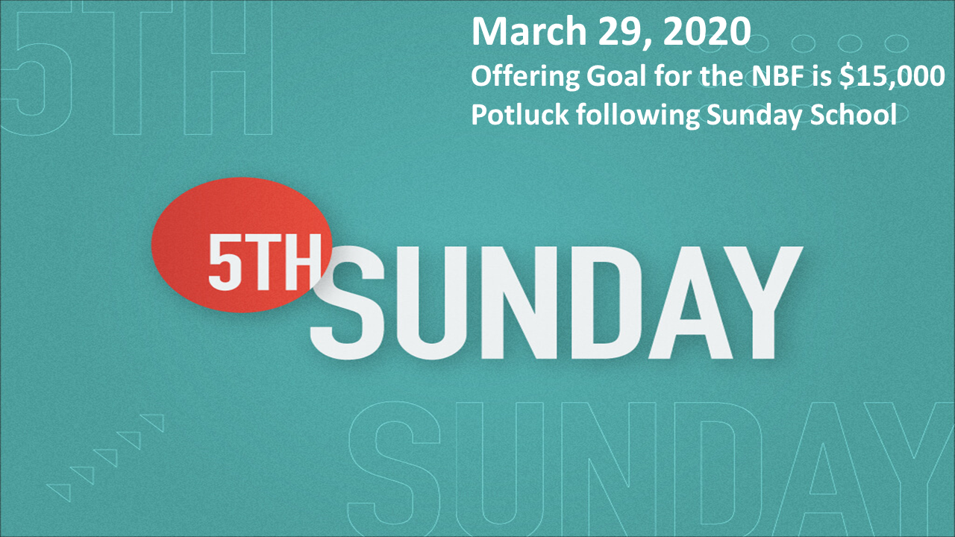

## For the Record

Date Attendance Offering Building Fund

7/27 45 $2,173.00 $1,230.00

8/3 51 $2,640.00 $1,235.00

8/10 58 $4,705.82 $38.00

8/17 54 $1,898.00 $30.00

8/24 48 $1,621.50 $51.00



First Christian Church

Brownstown

516 W. Cumberland Rd.

P.O. Box 296

Brownstown, IL 62418

618-427-3687

Website: fcc-brownstown.com

Email: [brownstownfcc@gmail.com](mailto:brownstownfcc@gmail.com)

Nathan Brands, Preaching Minister Jamie Smith, Administrative Assistant

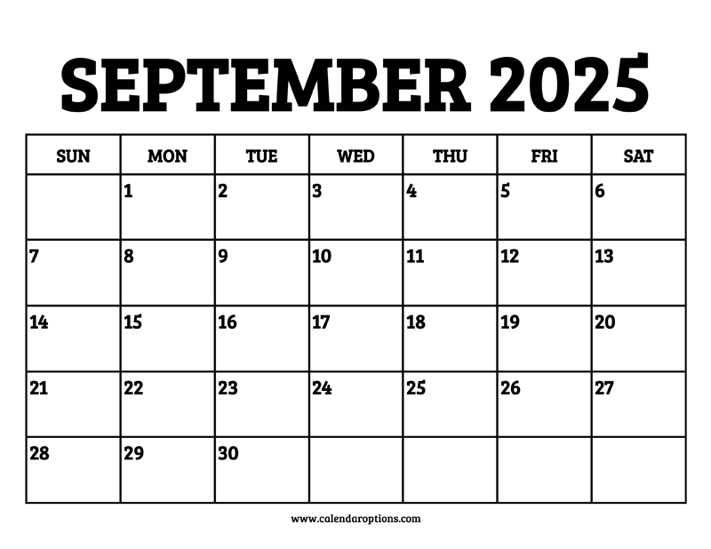

*Zayne Koehler

*Mitch Koehler

*Jamie Meador

*Kent/Tammy Woolsey

*Jody Meador

**Choya/Karen Morrison

*Bill Holman

*Birthday

**Anniversary