First Word

First Christian Church Brownstown
November 2025

Operation Christmas Child
The mission of Operation Christmas Child is to demonstrate God’s love in a tangible way to children in need around the world. Through this project, Samaritan’s Purse partners with the local church worldwide to share the Good News of Jesus Christ and make disciples of the nations.
“Let the children come to Me; do not hinder them, for to such belongs the kingdom of God.” Mark 10:14, ESV
Fill your box, attach your label, place box on the back table in fellowship hall, and place shipping donation of $10 (made out to the church) in the offering plate.
Please do not place shipping donation inside of the shoebox!
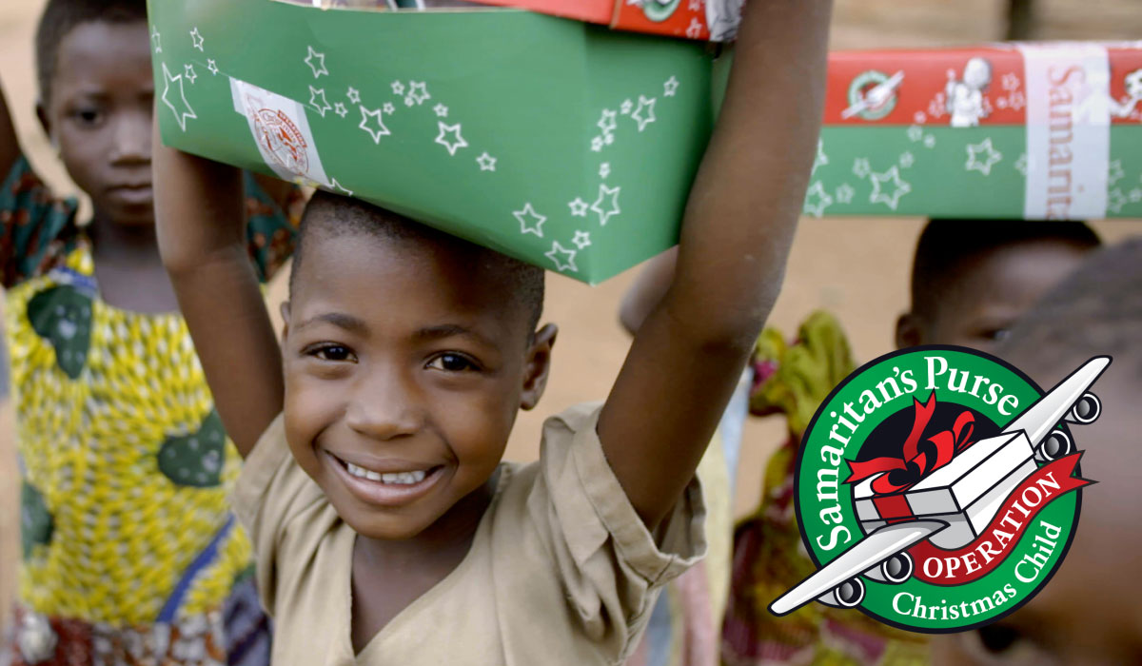
Return your box by Sunday, November 2nd.

Caring & Sharing
Caring & Sharing will be giving out Christmas Baskets in the Brownstown community once again. With your help, we will do the best to provide deserving families with a Christmas dinner complete with all the trimmings plus gifts for the children.
Items you can donate:
Non-perishable food items New toys, puzzles, games
Hats, gloves, mittens, scarves, socks Teen items
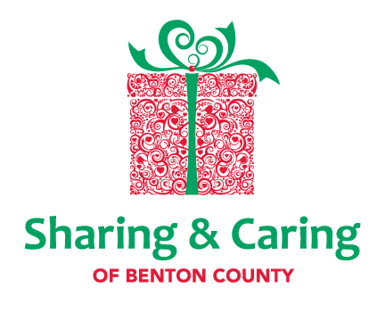
Christmas decorations and disposable dinnerware
Monetary Contributions (mark as Caring & Sharing)

All collections should be completed by Sunday, November 30th.
Please place all items in the box at the back of the fellowship hall.

We Exist to:

* WORSHIP the Living God * WIN People to Jesus * TRAIN God’s People for Service

* SEND Them Out Into the World

From the Minister

Thank you. I am very fortunate to be allowed to minister at First Christian Church.
I say this because October was Minister’s Appreciation Month. It is a reminder of how fortunate I am to be able to minister here in Brownstown. The people here have treated me amazingly well. I cannot thank you enough. I have been very grateful that I am here amongst such great people. This is especially true over the last few years. I have gone through some hard times, and through these times you all have been understanding and caring. Even though I minister to you as your preacher, I feel you have ministered to me even more so. For this and so much more, Thank you.

God bless,
Nathan Brands

Baby Bottle Campaign
Help us share the truth with young women and teens facing an unplanned pregnancy. There is a large baby bottle at the back of the fellowship hall to place your donations of coins, dollars, or checks into for Lighthouse Pregnancy & Health Services.


Worship Center Construction Project Update
Fulk Construction has assured us that they would begin working on the worship center in November. The pew chairs (200) have arrived and have been paid for ($16,448.81). Three video monitors have been donated. Five stained glass windows from the old church have been delivered to be evaluated for possible use in the worship center.
Other Projects
Mini Split for the minister’s Office has been installed
Grading and landscape rock have been placed at the front of the building


What’s Going On?
Breakfast Fellowship: If you would like to provide breakfast on a Sunday morning, there will be a sign-up sheet in the kitchen. Breakfast starts at 9:00 am.
Leadership Team (Elder’s & Deacon’s) Meeting is Tuesday, November 11th @ 7:00 pm.
Christmas Program Practice will be Sundays from 5:00 – 6:30 pm.
Youth Groups will meet on Sundays from 6:30 – 8:00 pm.
Time Change: Don’t forget to set your clocks back 1 hour as time changes on Sunday, November 2nd.
Brownstown Community Schools - Teacher Appreciation Day: On Wednesday, Nov. 5th, we will be honoring the teachers and staff with an appreciation meal. We have been asked to bring soups or desserts. Please bring your donation to the Elementary School Cafeteria that morning. See Joann Strobel for more information.



5th Sunday
A 5th Sunday Offering will be taken up on Sunday, November 30th. The entire amount collected will be going to the Building Loan Principle. The goal is $22,000. There will also be a potluck following Sunday School.
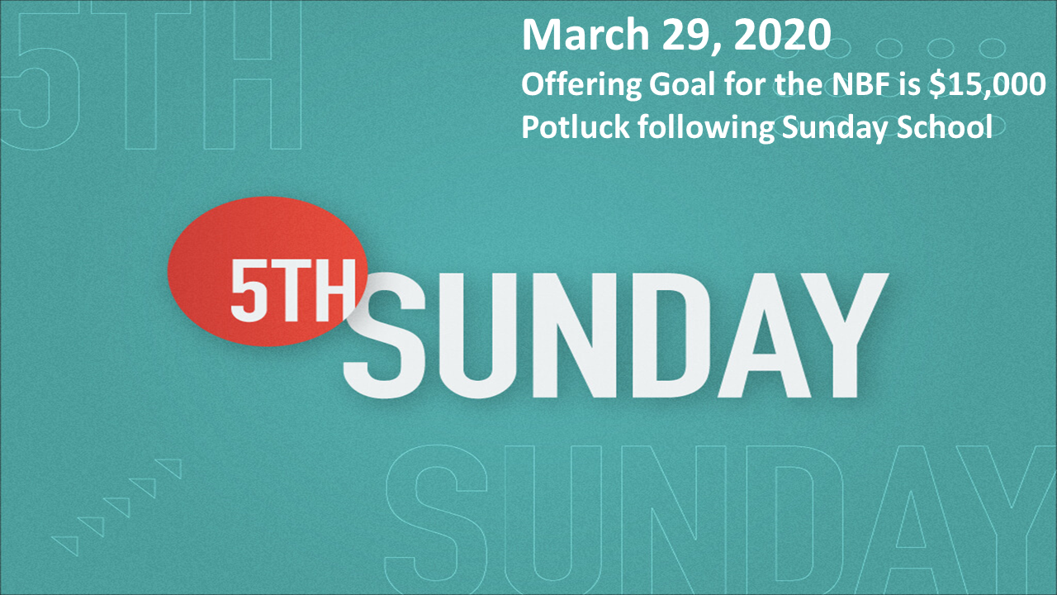

For the Record

Date Attendance Offering Building Fund
9/28 57 $1,876.00 $35.00
10/5 58 $2,599.00 $280.00
10/12 52 $1,842.00 $135.00
10/19 46 $2,378.00 $235.00



First Christian Church
Brownstown
516 W. Cumberland Rd.
P.O. Box 296
Brownstown, IL 62418
618-427-3687
Website: fcc-brownstown.com
Email: brownstownfcc@gmail.com

Nathan Brands, Preaching Minister Jamie Smith, Administrative Assistant


*Amy Jachino
*Joyce Garrison
*Robin Lovett
*Matthew Smith
**Ron/Tena Gould
*Birthday
**Anniversary

