First Word

First Christian Church Brownstown
December 2025

Upcoming Christmas Events:

ONE WINTERY NIGHT:
Join us on Sunday, December 14th at 9:30 am for our All-Church Christmas Program. The program is about a snowy night, a warm cabin, and a child who hears the Christmas story for the first time, beginning with creation and ending with Jesus’ resurrection.
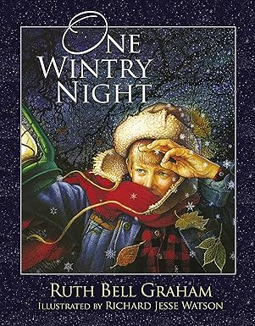

CHRISTMAS CAROLING:
We will be leaving the church at 6:00 pm to go Christmas Caroling on Sunday, December 14th. Everyone is invited to come along and spread some Christmas cheer.


COMBINED CHRISTMAS SERVICE:
Join us at Liberty Christian Church on Sunday, December 21st at 6:00 pm for a combined Christmas worship service.


LADIES CHRISTMAS GATHERING AND SECRET SISTER REVEAL:
Please bring a dozen cookies and your reveal gift to the church on Saturday, January 10th at 9:30 am. We will be visiting some of our shut-ins and then going out for lunch.


We Exist to:

* WORSHIP the Living God * WIN People to Jesus * TRAIN God’s People for Service

* SEND Them Out Into the World

Worship Center Construction Project Update
Fulk Construction has been framing walls and building the stage and sound booth. The next step will be installing electric wires and audio/video wiring in the walls.
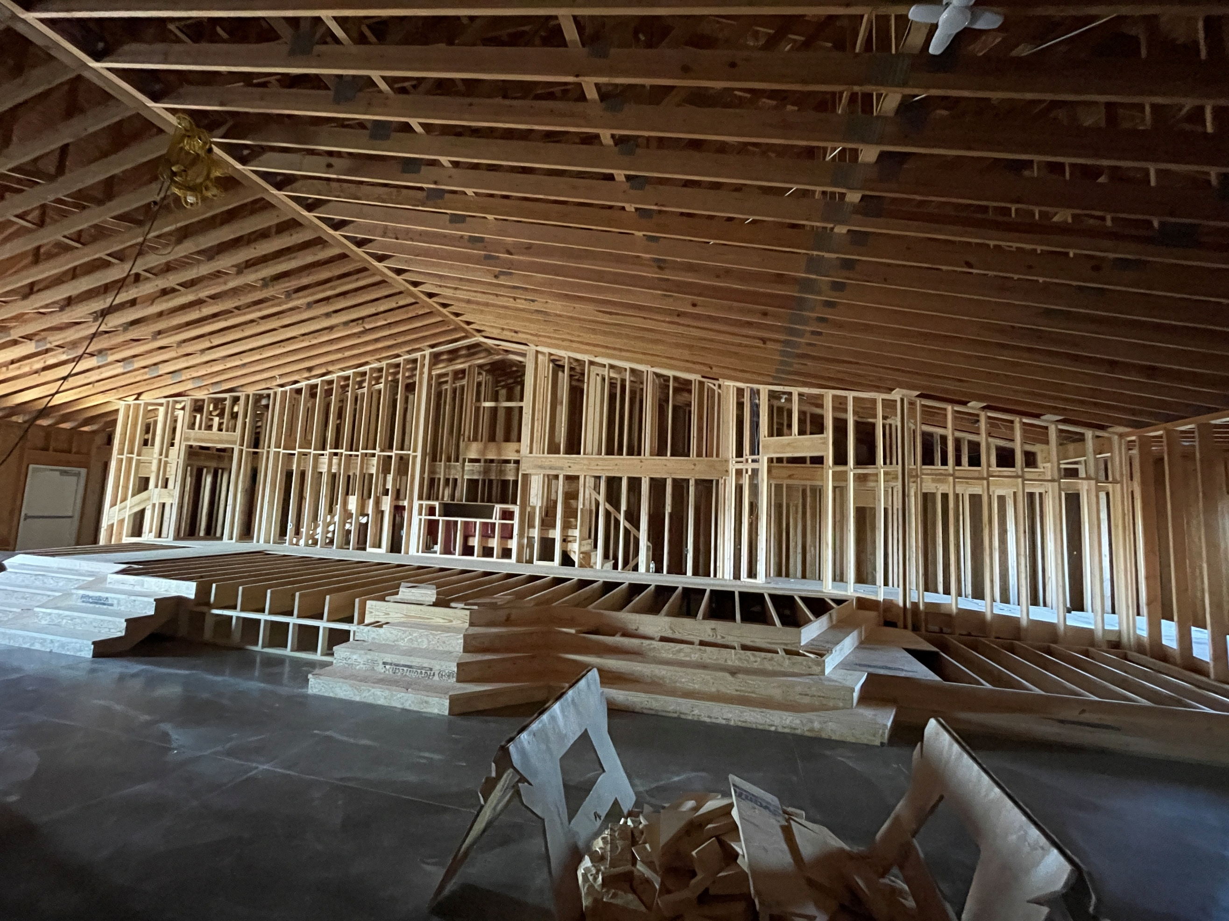
Stage View in the Worship Center

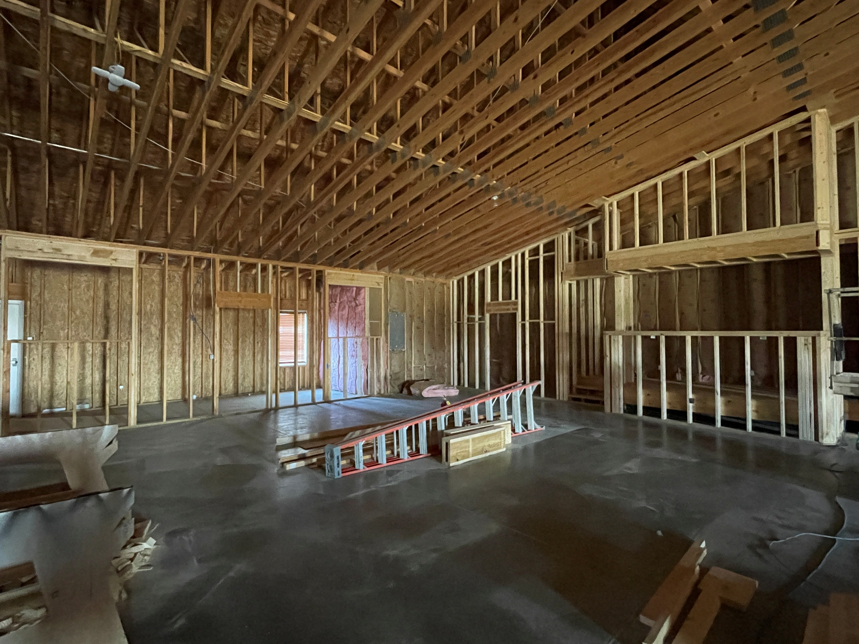
Sound Booth/Room in the Back of Worship Center

What’s Going On?
Breakfast Fellowship: If you would like to provide breakfast on a Sunday morning, there will be a sign-up sheet in the kitchen. Breakfast starts at 9:00 am.
Leadership Team (Elder’s & Deacon’s) Meeting is Tuesday, December 9th @ 7:00 pm.
Christmas Program Practices will be Sunday, December 7th from 5:00 – 6:30 pm. We will be having a dress rehearsal on Saturday, December 13th from 9:00 – 11:00 am (breakfast will be provided).
Youth Groups will meet on Sundays from 6:30 – 8:00 pm. The final youth group for the year will be Sunday, December 7th.



5th Sunday
A 5th Sunday Offering will be taken up on Sunday, March 29th. The entire amount collected will be going to the Building Loan Principle. The goal is $22,000. There will also be a potluck following Sunday School.


For the Record

Date Attendance Offering Building Fund
10/26 55 $1,116.00 $1,230.00
11/2 65 $2,656.59 $35.00
11/9 55 $1,939.00 $330.00
11/16 44 $2,859.25 $38.00
11/23 52 $1,884.00 $35.00



First Christian Church
Brownstown
516 W. Cumberland Rd.
P.O. Box 296
Brownstown, IL 62418
618-427-3687
Website: fcc-brownstown.com
Email: brownstownfcc@gmail.com

Nathan Brands, Preaching Minister Jamie Smith, Administrative Assistant


*Andrew Shelton
*Chris Meador
*Taylor Claycomb
*Amanda Koehler *Avelyn Brands
*Jamie Smith
*Eric Adams
*Birthday
**Anniversary

