**First Word**

**First Christian Church Brownstown**

**November 2024**

**Christmas Program**

This is Joy reporting to you live from Riley’s mind. On December 15th at 9:30 am, the emotions and I will be paying a visit to the First Christian Church Brownstown to give a report on Riley. Come see us to better understand the emotions that go along with growing up!



Practices are on Sundays from 4:30 – 6:00 pm.

**Time Change**

Don’t forget to set your clocks back one hour before bed on Saturday, November 2nd.



**Community Thanksgiving Service**

The community will be gathering on Sunday, November 24th at 6:00 pm for our annual Thanksgiving Service. More information to come.

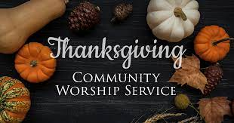

#### We Exist to:

#### * WORSHIP the Living God * WIN People to Jesus * TRAIN God’s People for Service

#### * SEND Them Out Into the World

#### 



**From the Minister**

Rejoice always, pray without ceasing, give thanks in all circumstances; for this is the will of God in Christ Jesus for you.

– 1 Thessalonians 5:16-18

We have probably all read this verse before. We probably even agree that this verse is good advice. However, easier said than done.

Life often stands in the way of us giving thanks. When we face the downs of life, we do not feel very thankful. However, this is when we need to give thanks the most. When life gets you down, we need to focus on what God has done and give thanks to him. This focuses us on the good in life that God is doing.

For we know that:

God is good, all the time. All the time, God is good.

If we believe this, then we all have something to give thanks about.

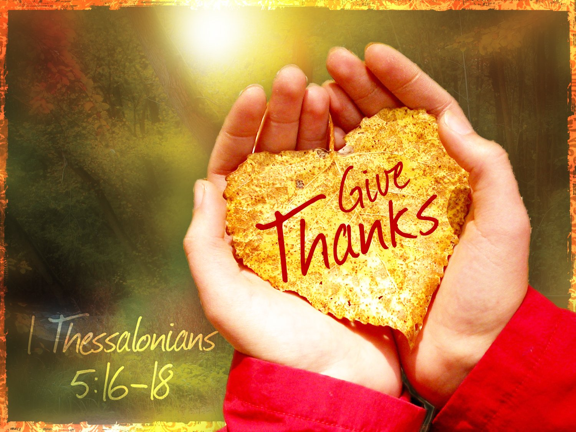

God bless,  
Nathan Brands

**Teacher Appreciation**

Wednesday, November 6th will be a day of appreciation for our local school teachers and staff. Churches are asked to bring soup and desserts. Please let Joann Strobel know if you care to participate and what you are planning to bring.



## What’s Going On?

**Breakfast Fellowship:** If you would like to provide breakfast on a Sunday morning, there will be a sign-up sheet in the kitchen. Breakfast starts at 9:00 am.

**Leadership Team (Elder’s & Deacon’s) Meeting** is Tuesday, November 12th @ 7:00 pm.

**Women’s Bible Study** will be Wednesdays at 6:30 pm.

**Christmas Program Practice** will be Sunday evenings from 4:30 – 6:00 pm.

**Youth Groups for 4th – 12th Grade** are Sunday evenings from 6:00 – 7:30 pm.

VB



## 5th Sunday

A 5th Sunday Offering will be taken up on Sunday, December 29th. The entire amount collected will be going to the Building Loan Principle. The goal is $22,000. There will be a potluck following at noon.



## For the Record

Date Attendance Offering Building Fund

9/29 72 5th Sunday $20,256.25

10/6 75 $2,627.00 $9,310.00

10/13 62 $1,558.00 $50.00

10/13 Love Offering $1,000.00 Prison Ministry

10/20 62 $2,292.77 $0.00

New Building Fund - $93,122.40



First Christian Church

Brownstown

516 W. Cumberland Rd.

P.O. Box 296

Brownstown, IL 62418

618-427-3687

Website: [www.fccbrownstown.com](http://www.fccbrownstown.com) Email: [brownstownfcc@gmail.com](mailto:brownstownfcc@gmail.com)

Nathan Brands, Preaching Minister Jamie Smith, Administrative Assistant



*Birthday

**Anniversary

*Joyce Garrison

*Amy Jachino

*Robin Lovett

*Matthew Smith

**Ron & Tena Gould