First Word

First Christian Church Brownstown
January 2026

Ladies Christmas Party/Secret Sis Reveal

Please bring a dozen cookies and your reveal gift to the church on Saturday, January 10th at 9:30 am. We will be visiting some of our shut-ins and then going out for lunch.


Worship Center Construction Project Update
The electric technicians have been installing electric wires and audio/video wiring in the walls.
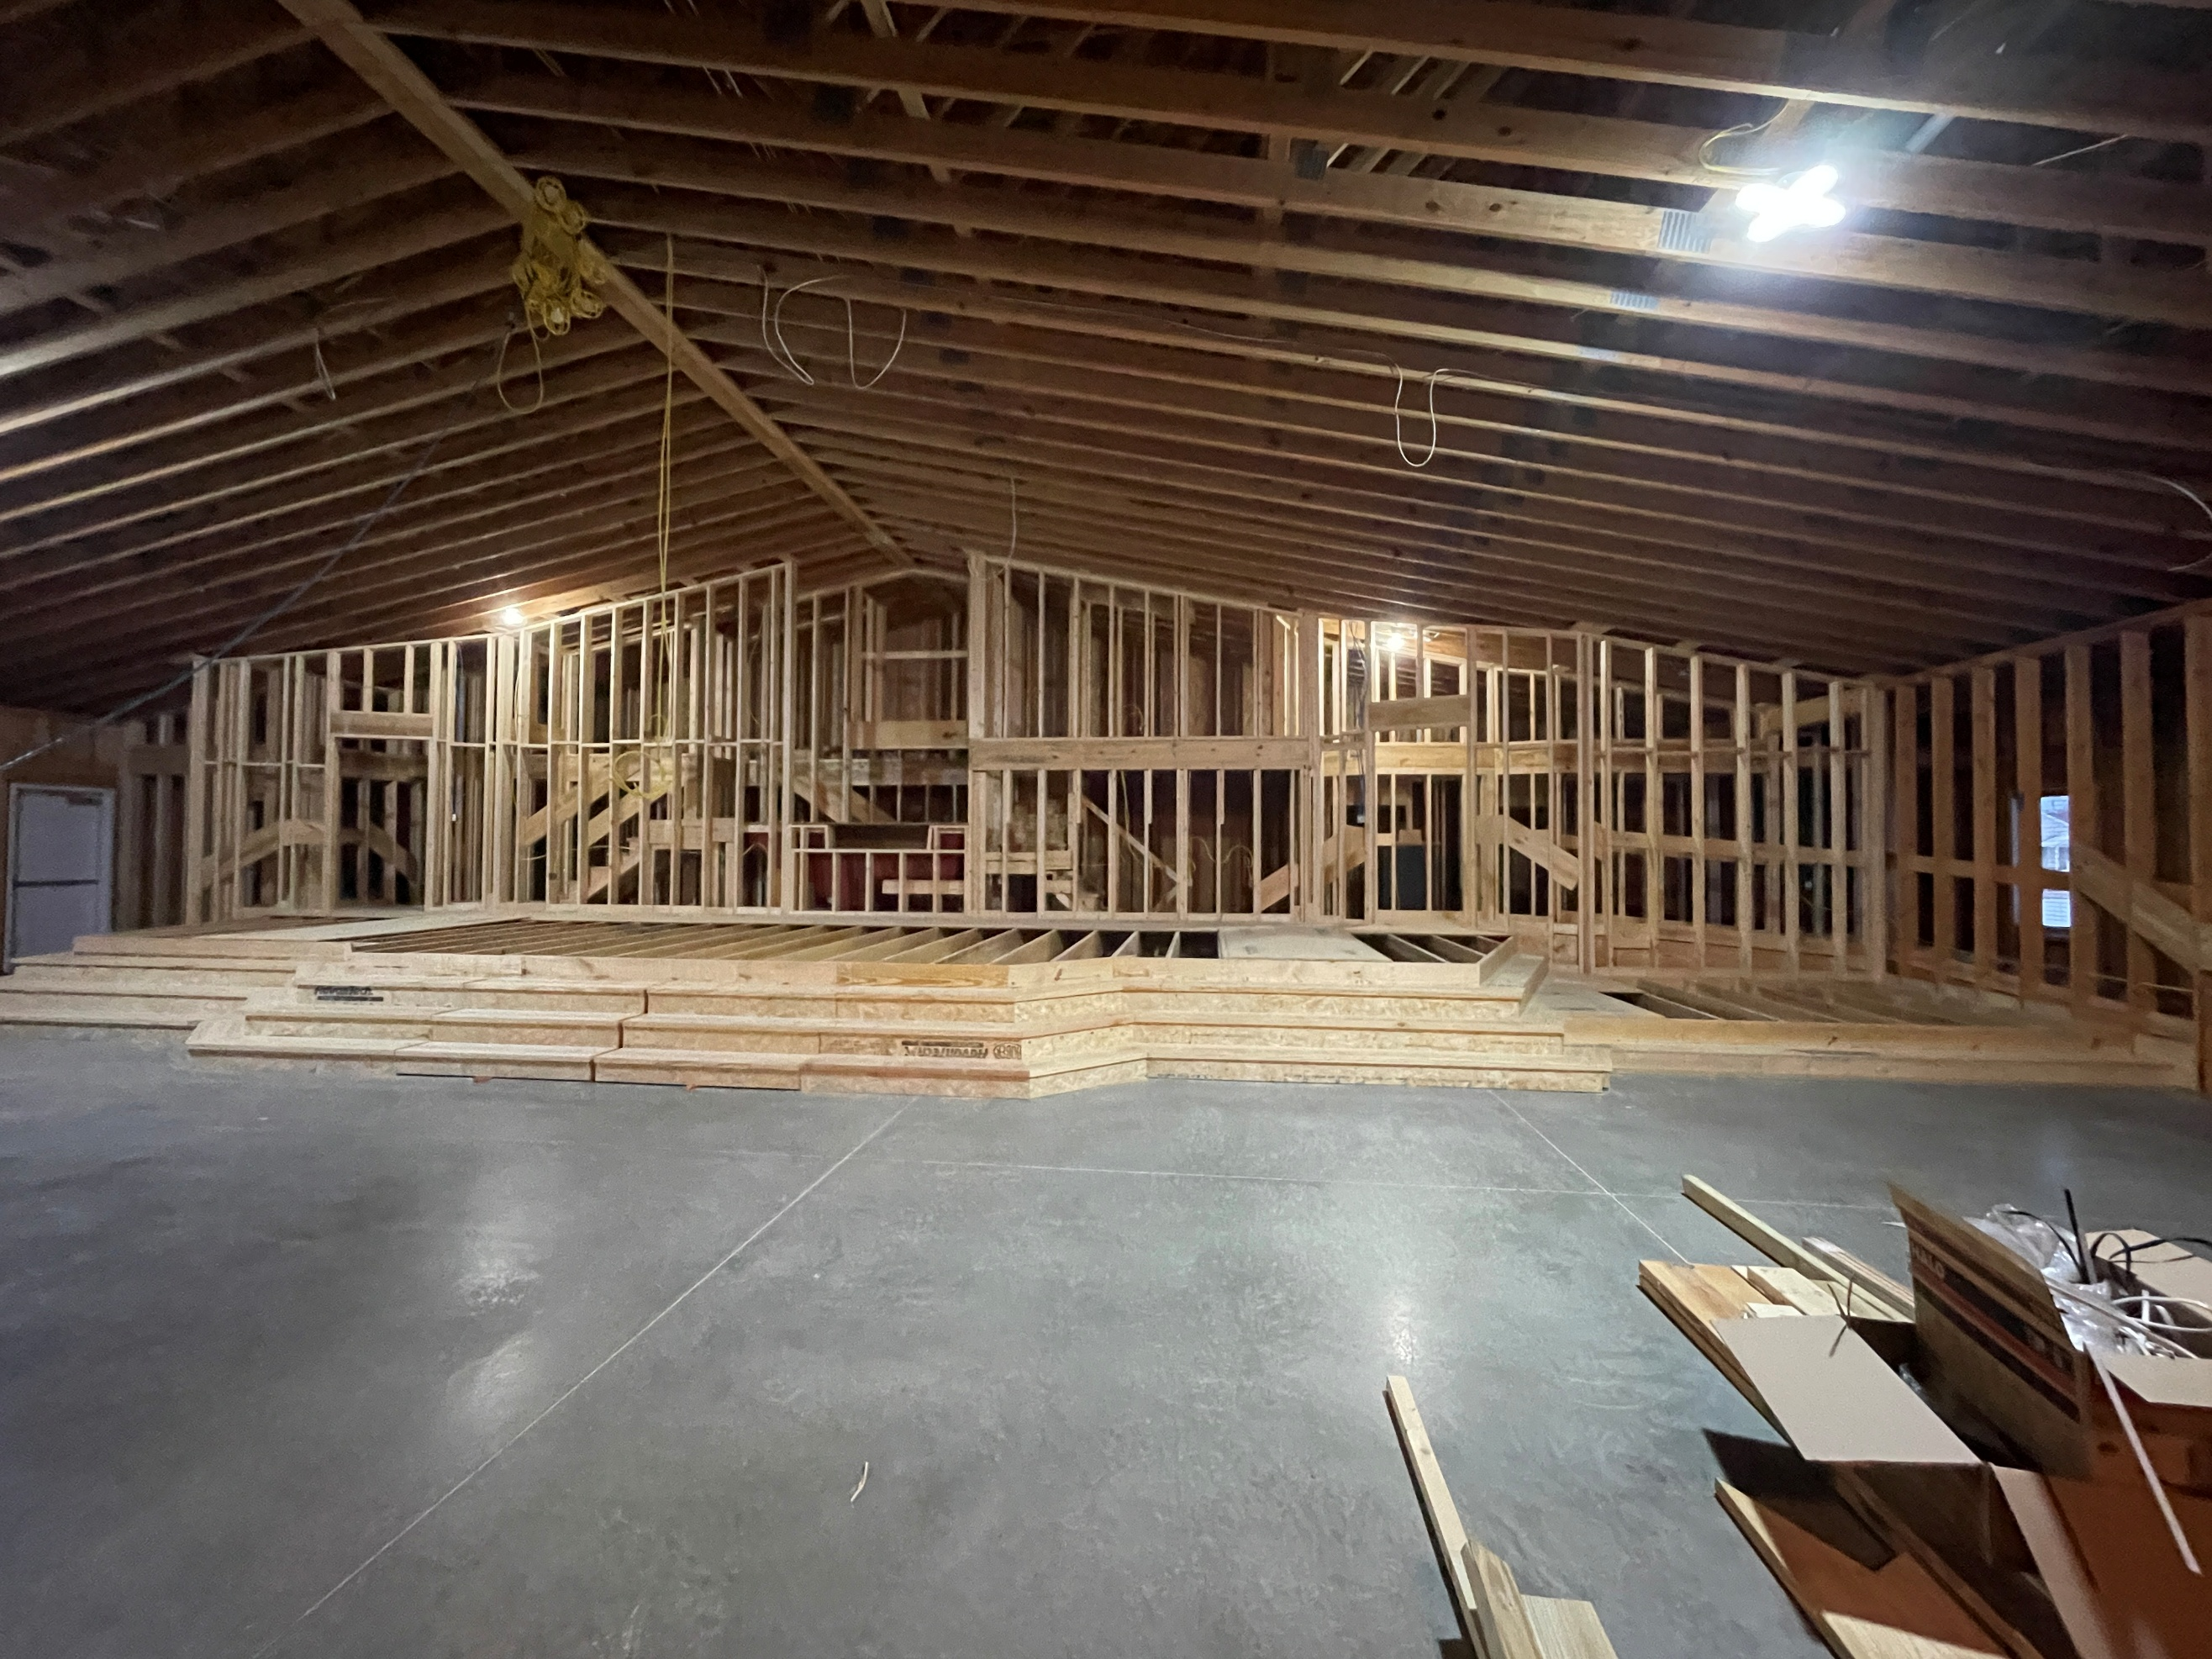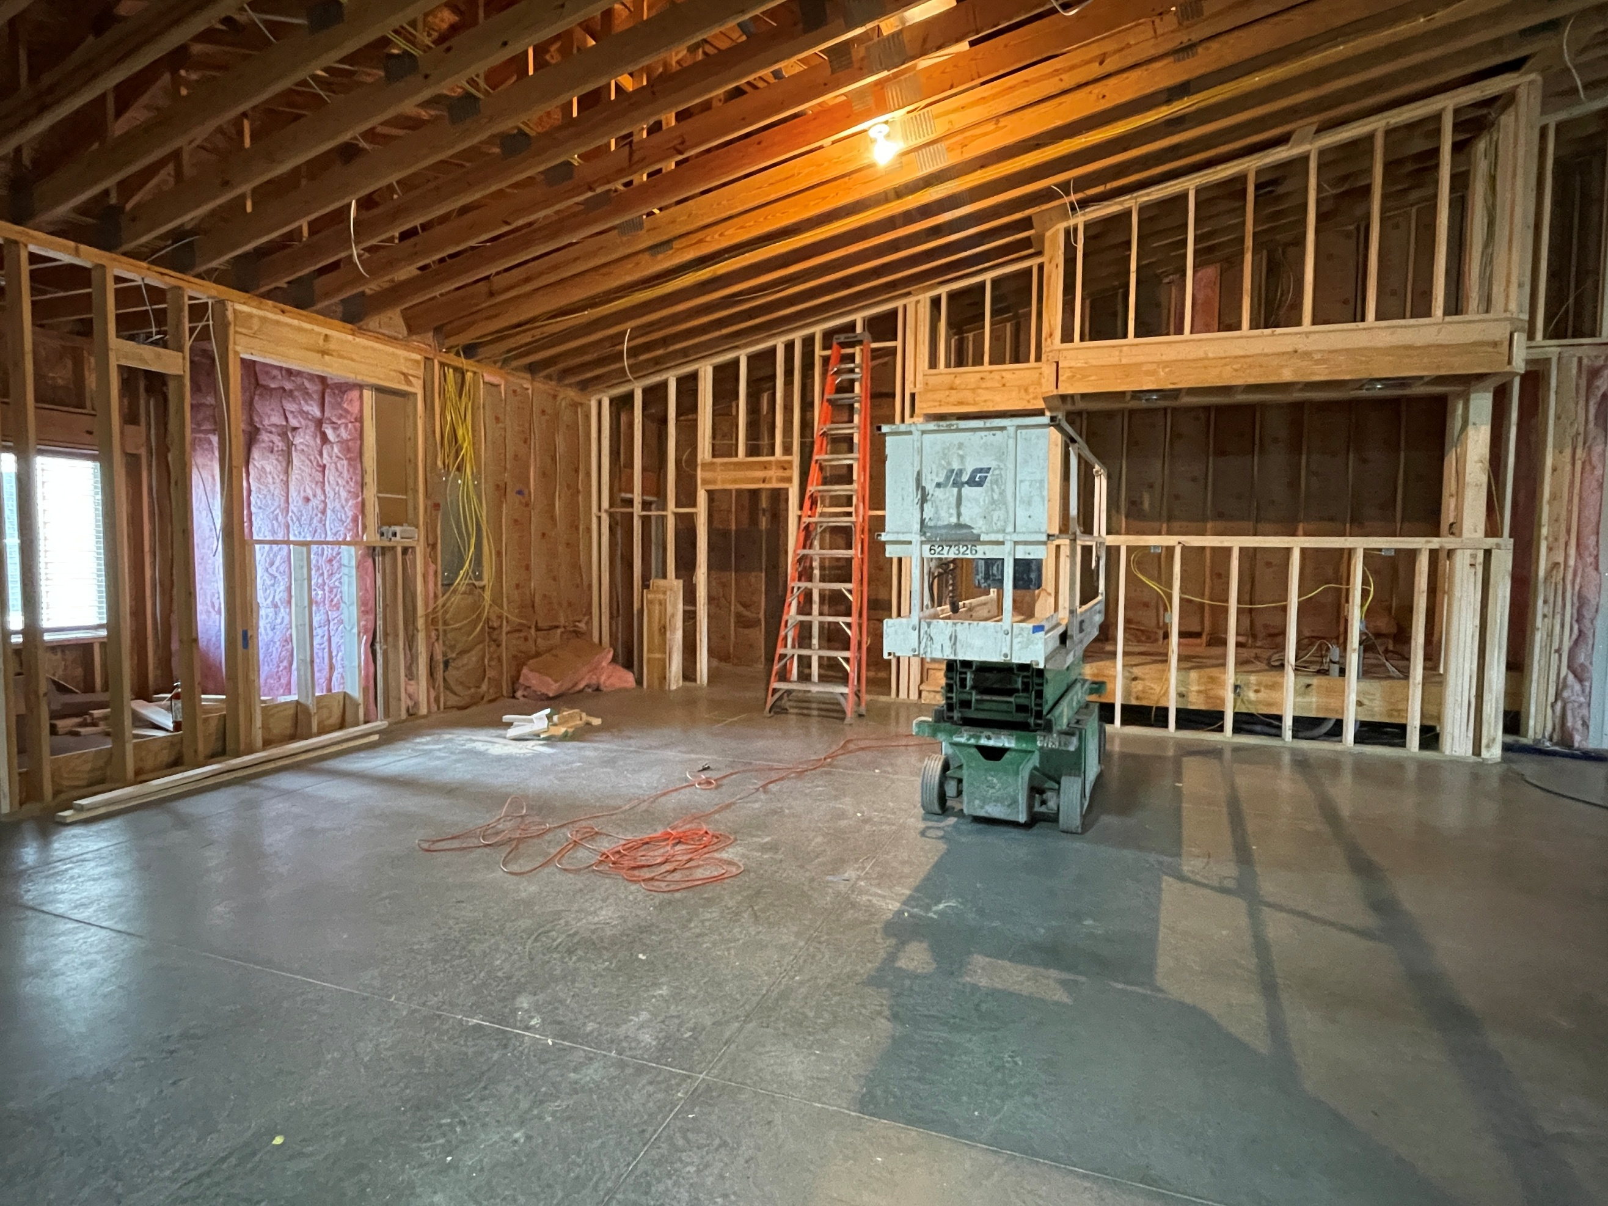
Stage View in the Worship Center Sound Booth/Room (Back of Worship Center)
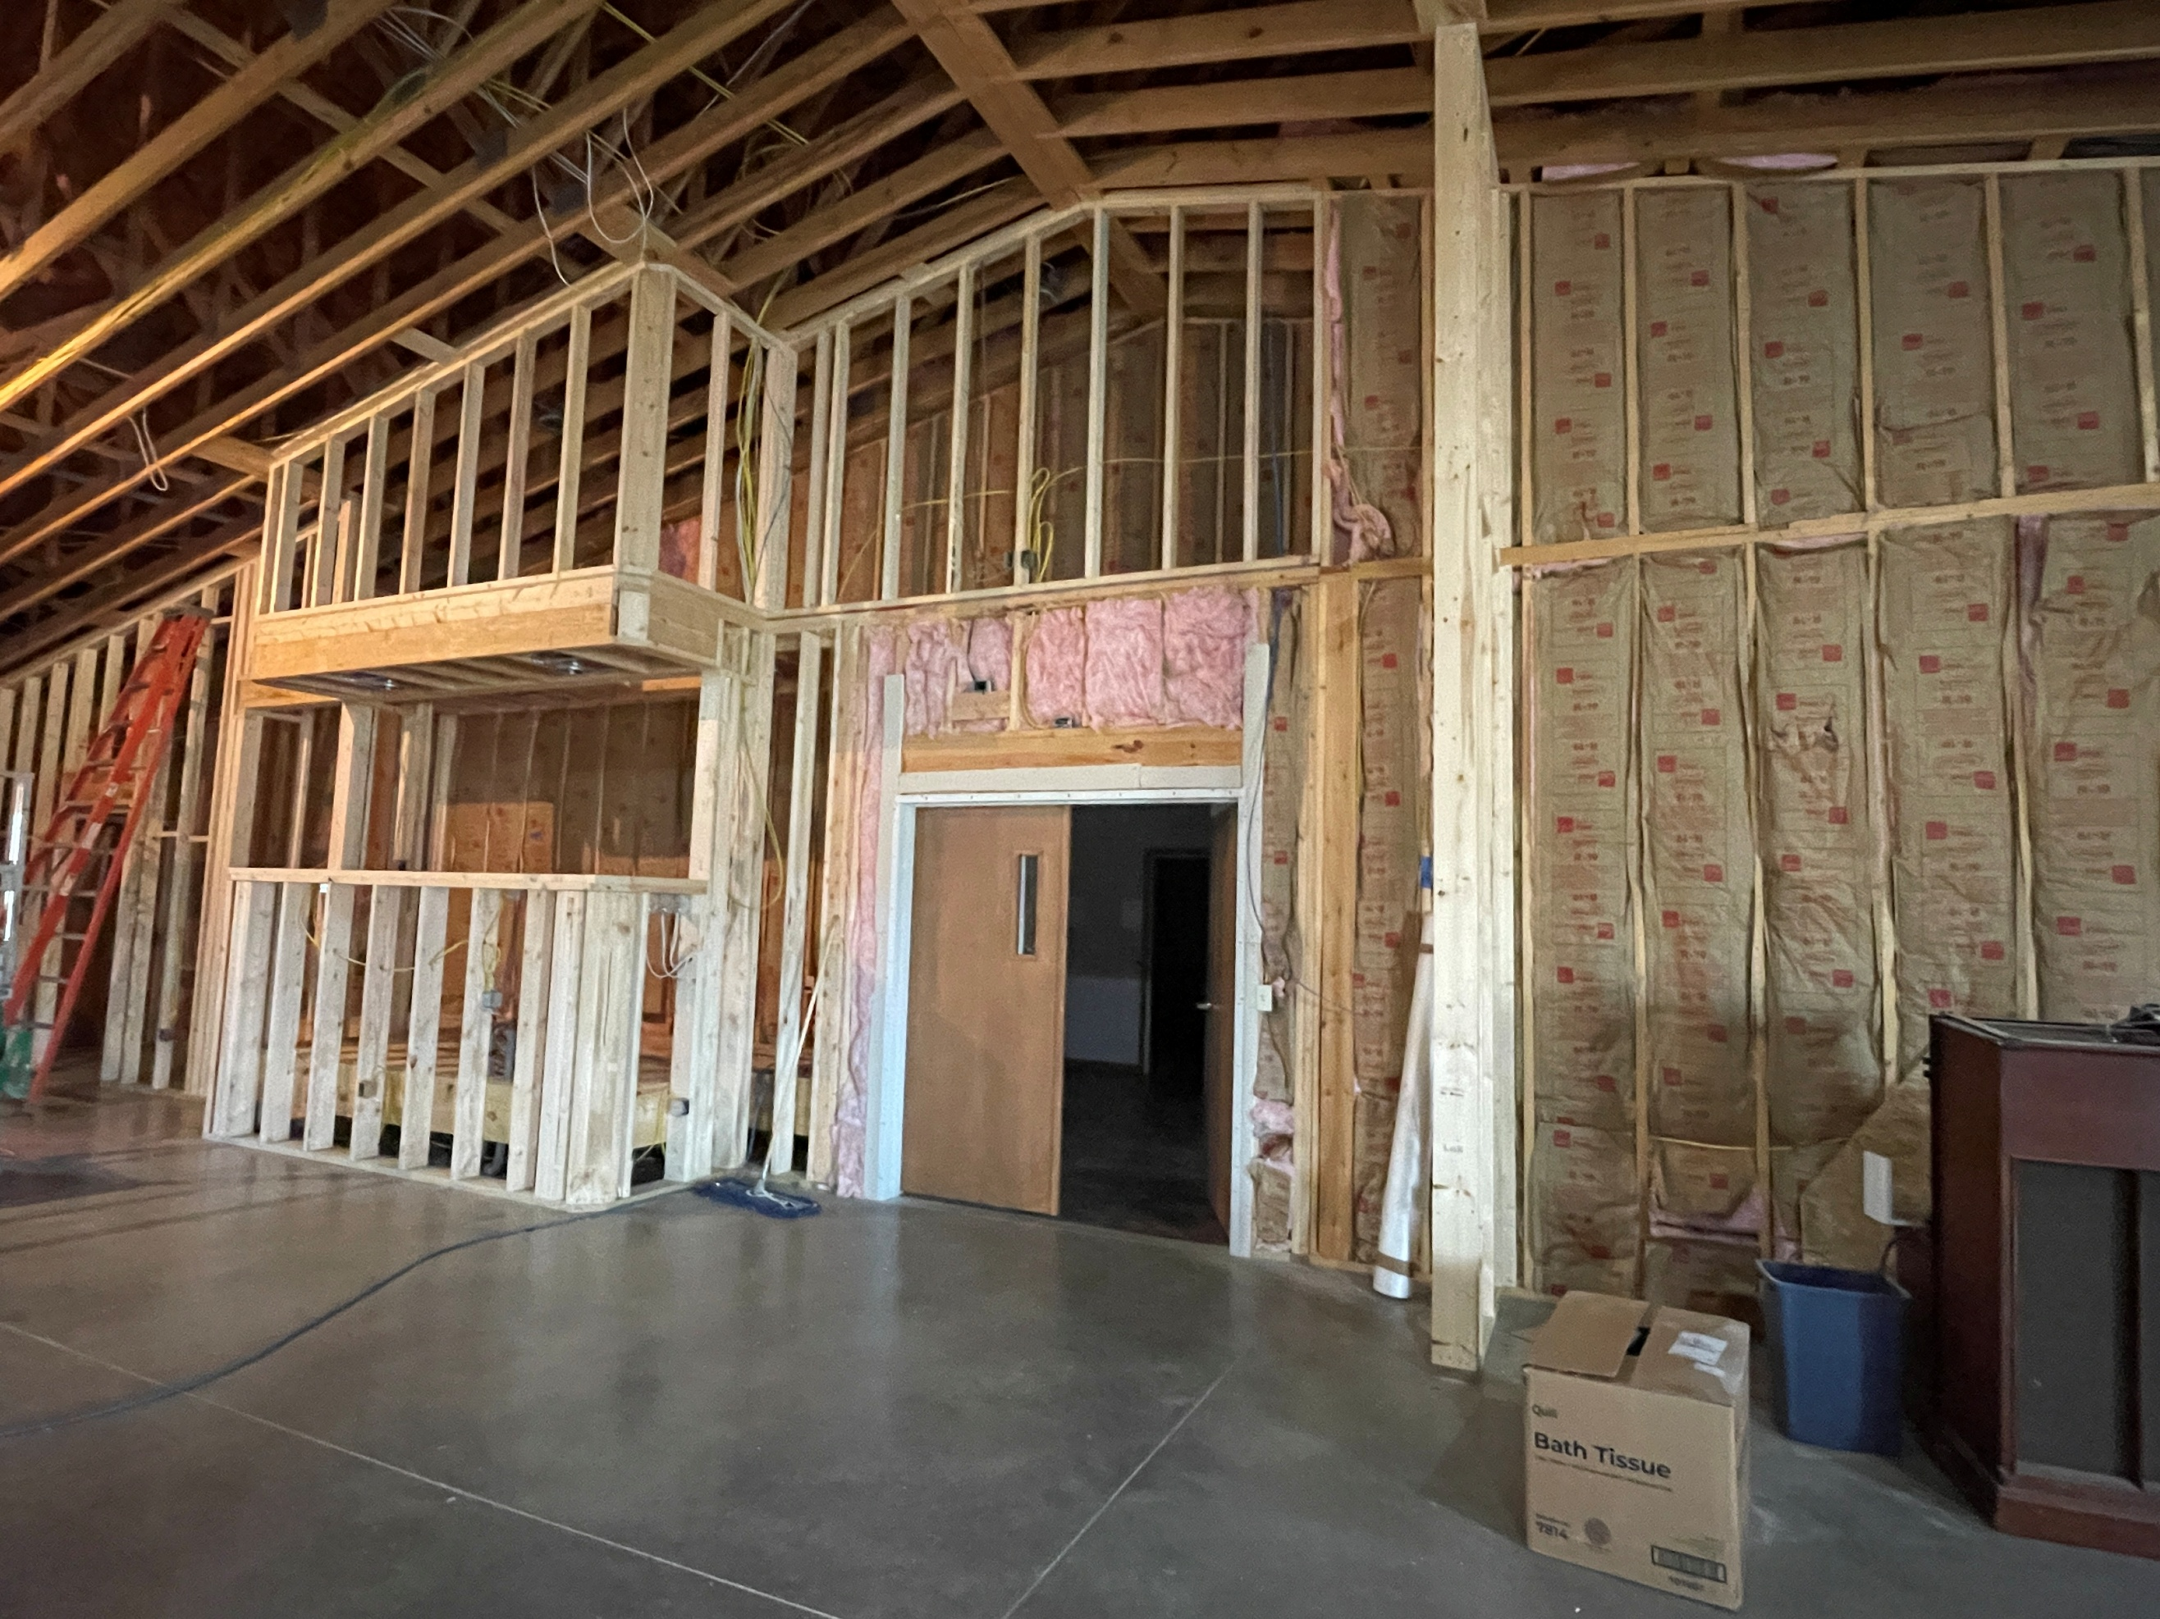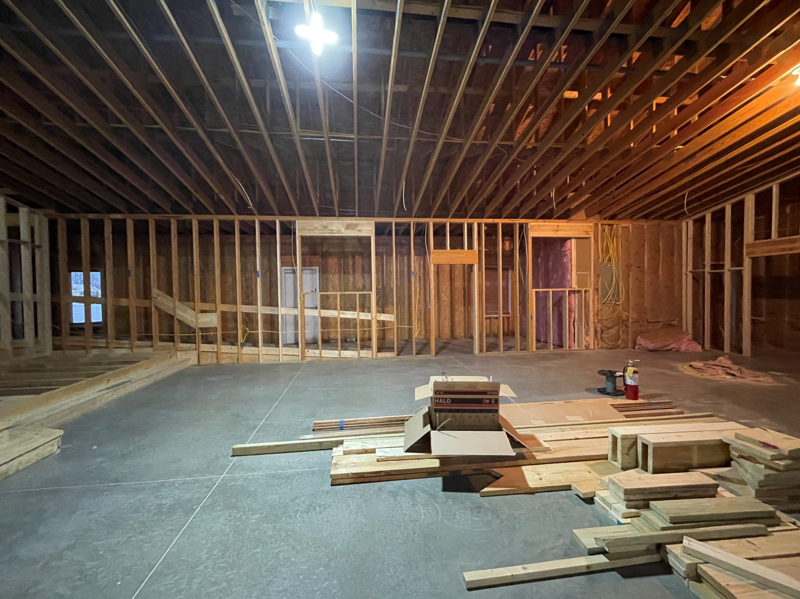
Sound Booth/Main Worship Center Doors Hallway along the East side of Worship Center

We Exist to:

* WORSHIP the Living God * WIN People to Jesus * TRAIN God’s People for Service

* SEND Them Out Into the World

From the Minister

We are approaching the end of 2025 and the beginning of 2026. It is the time of the year that people make New Year’s resolutions. It seems like I have often written on this subject, however I think it is a good reminder to continue to write on this. If you wish to make a resolution this year, here are so suggestions:
- Read your bible more.
  - If you aren’t reading your Bible consistently, try to read your Bible at least 4-5 days a week.
  - If you are reading your Bible consistently, try to read your Bible every day.
  - If you are reading your Bible daily, try to read the entire Bible this year.
- Set a time that you pray every day.
- Share the gospel with someone. It can be a family member, friend, neighbor, co-worker, etc.
- Find a place to serve.
  - Be a greeter at church.
  - Bring breakfast for the fellowship breakfast.
  - Prepare communion.
  - Be an usher that passes out the communion and offering plates.
- Increase your giving in the offering.
  - Back in August, we encouraged everyone to give at least ten percent on a single Sunday. Maybe you can do this for the entire year or you can increase your offering to more than ten percent.
I encourage you take this opportunity to make some positive changes in your life. Pray that God leads you to an area in which you can improve to grow closer to God.

God bless,
Nathan Brands
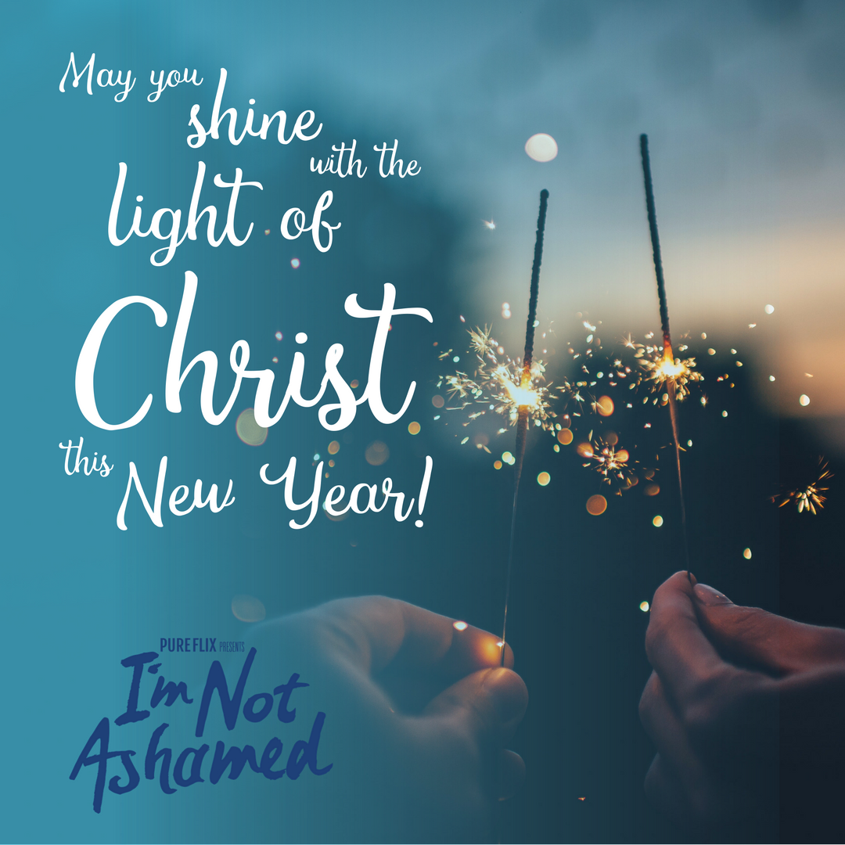

What’s Going On?
Breakfast Fellowship: If you would like to provide breakfast on a Sunday morning, there will be a sign-up sheet in the kitchen. Breakfast starts at 9:00 am.
Leadership Team (Elder’s & Deacon’s) Meeting is Tuesday, January 13th @ 7:00 pm.
Youth Groups will meet on Sundays from 6:30 – 8:00 pm. Youth Groups will resume in February. Watch for a start-up date coming soon!
Sanctity of Human Life Sunday will be Sunday, January 18th. We will be taking up a special offering for LPHS during the morning service.



5th Sunday
A 5th Sunday Offering will be taken up on Sunday, March 29th. The entire amount collected will be going to the Building Loan Principle. The goal is $22,000. There will also be a potluck following Sunday School.
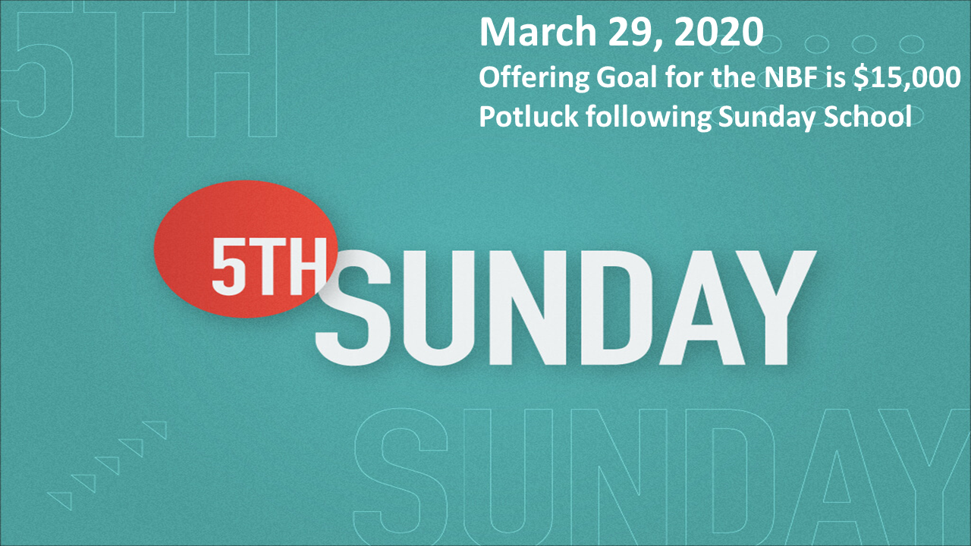

For the Record

Date Attendance Offering Building Fund
11/30 50 5th Sunday $20,513.00
12/7 51 $2,567.00 $2,446.42
12/14 N/C $2,251.00 $90.00
12/21 57 $2,462.00 $1,025.00



First Christian Church
Brownstown
516 W. Cumberland Rd.
P.O. Box 296
Brownstown, IL 62418
618-427-3687
Website: fcc-brownstown.com
Email: brownstownfcc@gmail.com

Nathan Brands, Preaching Minister Jamie Smith, Administrative Assistant


*Frank Rook
*Jessa Adams
*Hudson Smith
*Nikki Sidwell
*Ashton Smith
*Faye Schwarm
**Bruce/ Stephanie Miller
*David Hipsher
*Patrick Satterthwaite
*Bruce Miller
*Tiffany Hipsher
*Birthday
**Anniversary

