First Word

First Christian Church Brownstown
October 2024

Operation Christmas Child
“Let the children come to Me; do not hinder them, for to such belongs the kingdom of God.”
Mark 10:14, ESV
The mission of Operation Christmas Child is to demonstrate God’s love in a tangible way to children in need around the world. Through this project, Samaritan’s Purse partners with the local church worldwide to share the Good News of Jesus Christ and make disciples of the nations.
In the summer of 1993, Samaritan’s Purse President Franklin Graham received a call from a man in England asking if he’d be willing to fill shoeboxes with gifts for children in Eastern Europe. Franklin agreed, but figured Christmas was months away. He forgot about the promise until he received a call back around Thanksgiving asking about the gifts. Franklin asked his friend, the late Pastor Ross Rhoads of Calvary Church of Charlotte to see if he could help with the need. A Sunday shortly afterward, Pastor Rhoads demonstrated for his congregation how to fill a shoebox with simple gifts and encouraged them to include a letter to the child as well. Within weeks, the church had 11,000 shoeboxes lining their hallways.
Due to their generosity and additional gifts from Canada, Samaritan’s Purse sent 28,000 shoebox gifts to children in the Balkans that Christmas. Through these gifts, we communicated to children and their families what the angel said to the shepherds about Jesus’ birth: “I bring you good news of great joy that will be for all the people”
(Luke 2:10, ESV).
Every year since, Samaritan’s Purse has collected shoebox gifts filled with toys, school supplies, and hygiene items for children around the world. Since 1993, more than 220 million children in more than 170 countries and territories have received an Operation Christmas Child shoebox. The project delivers not only the joy of what, for many kids, is their first gift ever, but also gives them a tangible expression of God’s love.
Tens of thousands of volunteers from local churches around the world partner with us to present the Gospel of Jesus Christ at festive outreach events where children are surprised with these shoebox gifts.
We will start collecting items for this year’s OCC boxes Sunday, October 6th. Boxes and collections items will be available at the back of the fellowship hall. Please return your boxes by Sunday, October 27th.
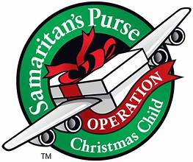

We Exist to:

* WORSHIP the Living God * WIN People to Jesus * TRAIN God’s People for Service

* SEND Them Out Into the World

From the Minister

The late Jack Cottrell, a Christian Church theologian, had a saying about salvation.
“We are saved BY grace, THROUGH faith, AT baptism, FOR good works.”
I have always liked the concise nature of this statement. I bring this up, because we are getting ready to start a series on Ephesians, which is where the majority of this saying comes from.
“For it is by grace you have been saved, through faith—and this is not from yourselves, it is the gift of God — not by works, so that no one can boast. For we are God’s handiwork, created in Christ Jesus to do good works, which God prepared in advance for us to do.
- Ephesians 2:8-10
While baptism is not mentioned in this text, it is mentioned in Ephesians 4:5 and other places in the Bible. This wraps up nicely what I believe. We are saved by the grace of God. We do not deserve this grace, but due to God’s love for us, he gives it to us. This grace comes to us through the sacrifice of Jesus, God’s Son. Who took the punishment for our sin by dying on the cross. This satisfied God’s holiness, justice, and wrath, thus allowing us to receive the grace of God through our faith in Jesus Christ and his sacrifice. In baptism, we act out the death and resurrection of Jesus. We symbolically die and rise again, dying to our old self and rising a new creation. This is when the Holy Spirit comes to dwell within us. All of this is what we call justification, which is the legal part of salvation in which we are declared not guilty of our sin.
The last part of the saying, “… for good works,” is about the ongoing part of salvation. This is becoming more holy, more like Jesus. This is called sanctification, the process of becoming holy. This is an ongoing process of living a Christian life by doing good deeds, or as Jesus said in the gospels, producing good fruit.
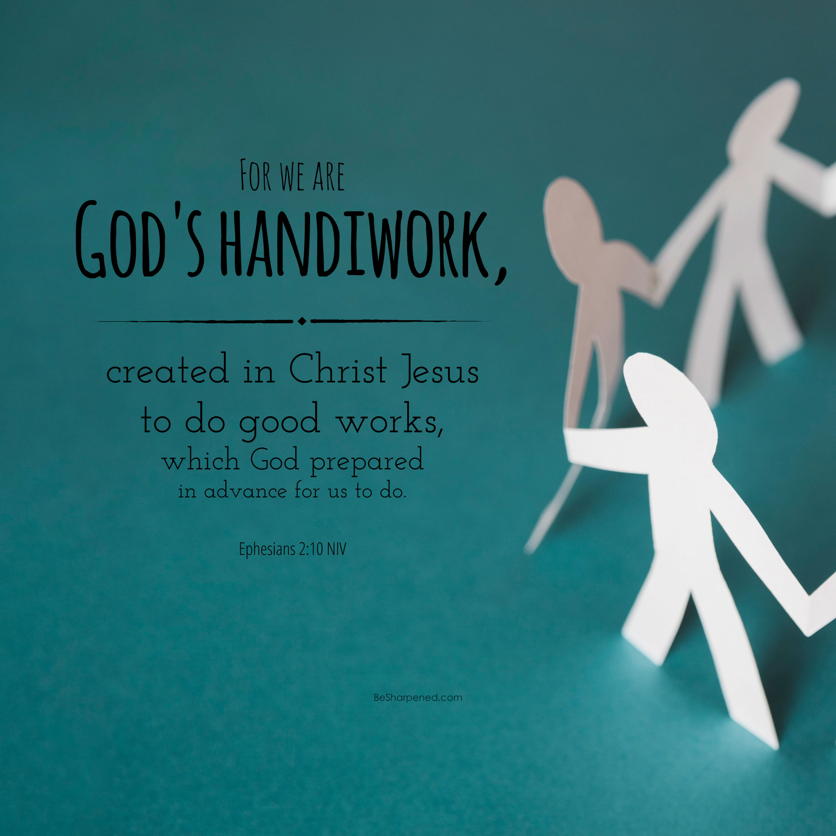

God bless,
Nathan Brands

Adult Bus Trip
On Saturday, October 12th, we will be taking a bus trip to Moonshine & Casey, IL to see the Big Stuff. We will be leaving the church at 10:30 am. There will be a sign-up sheet at the back of the fellowship hall.
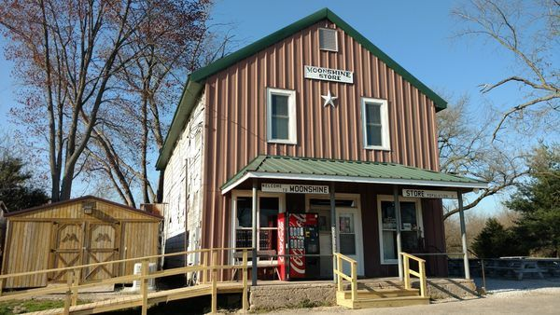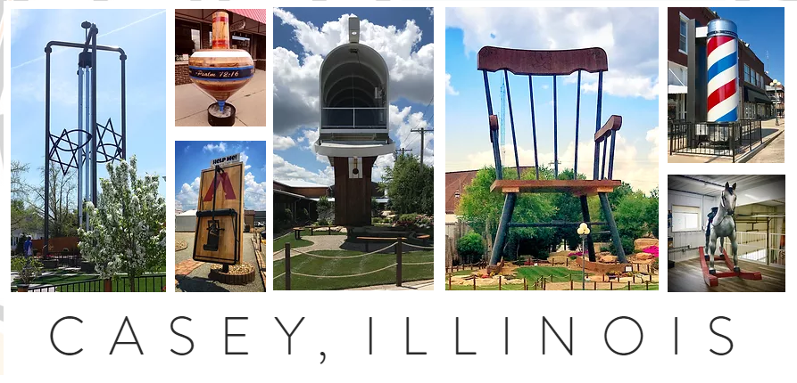

What’s Going On?
Breakfast Fellowship: If you would like to provide breakfast on a Sunday morning, there will be a sign-up sheet in the kitchen. Breakfast starts at 9:00 am.
Leadership Team (Elder’s & Deacon’s) Meeting is Tuesday, October 8th @ 7:00 pm.
Directory Pictures will be taken on Sunday, October 6th & 13th. Please sign up for a time for you/your family to be photographed.
Women’s Bible Study will be Wednesdays at 6:30 pm.
Christmas Program Practice will be Sunday evenings from 4:30 – 6:00 pm.
Youth Groups for 4th – 12th Grade are Sunday evenings from 6:00 – 7:30 pm.

VB



Baby Bottle Campaign
Lighthouse Pregnancy & Health Services will be having a fall baby bottle campaign this year. Grab your bottle at the back of the fellowship hall and fill it with your change/bills/check.


5th Sunday

A 5th Sunday Offering will be taken up on Sunday, December 29th. The entire amount collected will be going to the Building Loan Principle. The goal is $22,000. There will be a potluck following at noon.
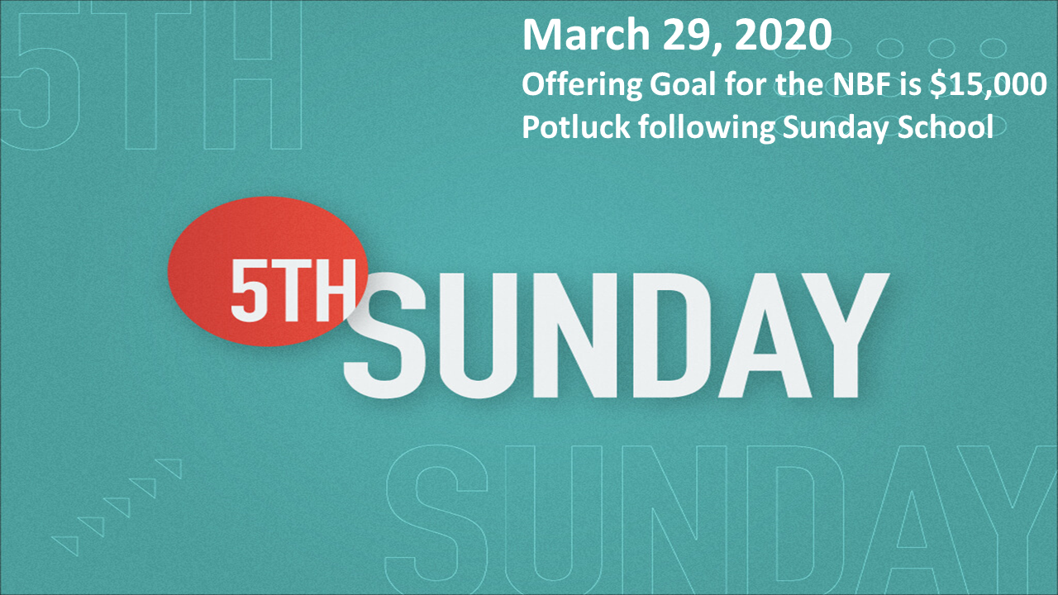

Preacher Appreciation Month
On October 13th, Mark Wilkerson will be coming to preach and do a presentation during Sunday School for Minister's appreciation.
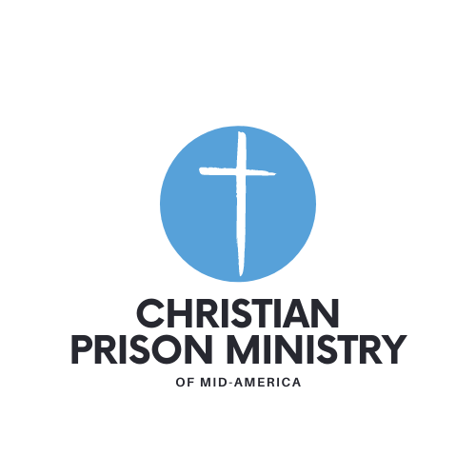
Let’s go above and beyond to show our appreciation to Nathan this month.

For the Record

Date Attendance Offering Building Fund
8/25 62 $1,953.00 $210.00
9/1 61 $2,625.00 $1,290.00
9/8 65 $1,630.00 $3,577.00
9/15 70 $2,697.00 $30.00
9/22 56 $1,476.00 $225.00
New Building Fund - $62,839.15



First Christian Church
Brownstown
516 W. Cumberland Rd.
P.O. Box 296
Brownstown, IL 62418
618-427-3687
Website: www.fccbrownstown.com Email: brownstownfcc@gmail.com

Nathan Brands, Preaching Minister Jamie Smith, Administrative Assistant

*Birthday
**Anniversary

*Hazel Jachino
*Trevor Willms
*Deanna Miller
*Emalee Smith
**Jody/Jamie Meador
*Jared Winters
**Patrick/Kaci Sattherthwaite
**Travis/Lauren Gould
*Choya Morrison
*Jack Shelton
*Susan Smith

