First Word

First Christian Church Brownstown
August 2026

Worship Center Construction Project Update
The audio & lighting equipment is being installed. The tile work around the baptistery has been completed. The pew chairs have been placed in the Worship Center. The stained-glass window light bars have been installed and the windows should be installed this month. We are getting very close!! Thank you to the ones that helped and sacrificed your time for this project. It could not have been done without you.
We are in need of your help…There are a few things that need to be done before we are ready to move in. There is a sign-up sheet on the back table in the fellowship hall for dusting, moving bigger items, etc.
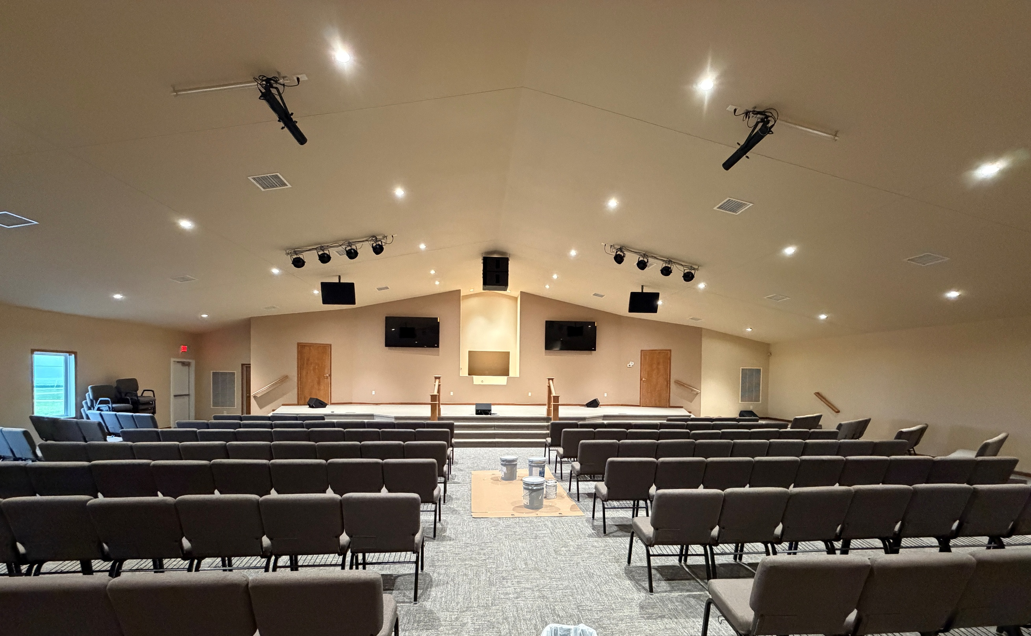
Stage
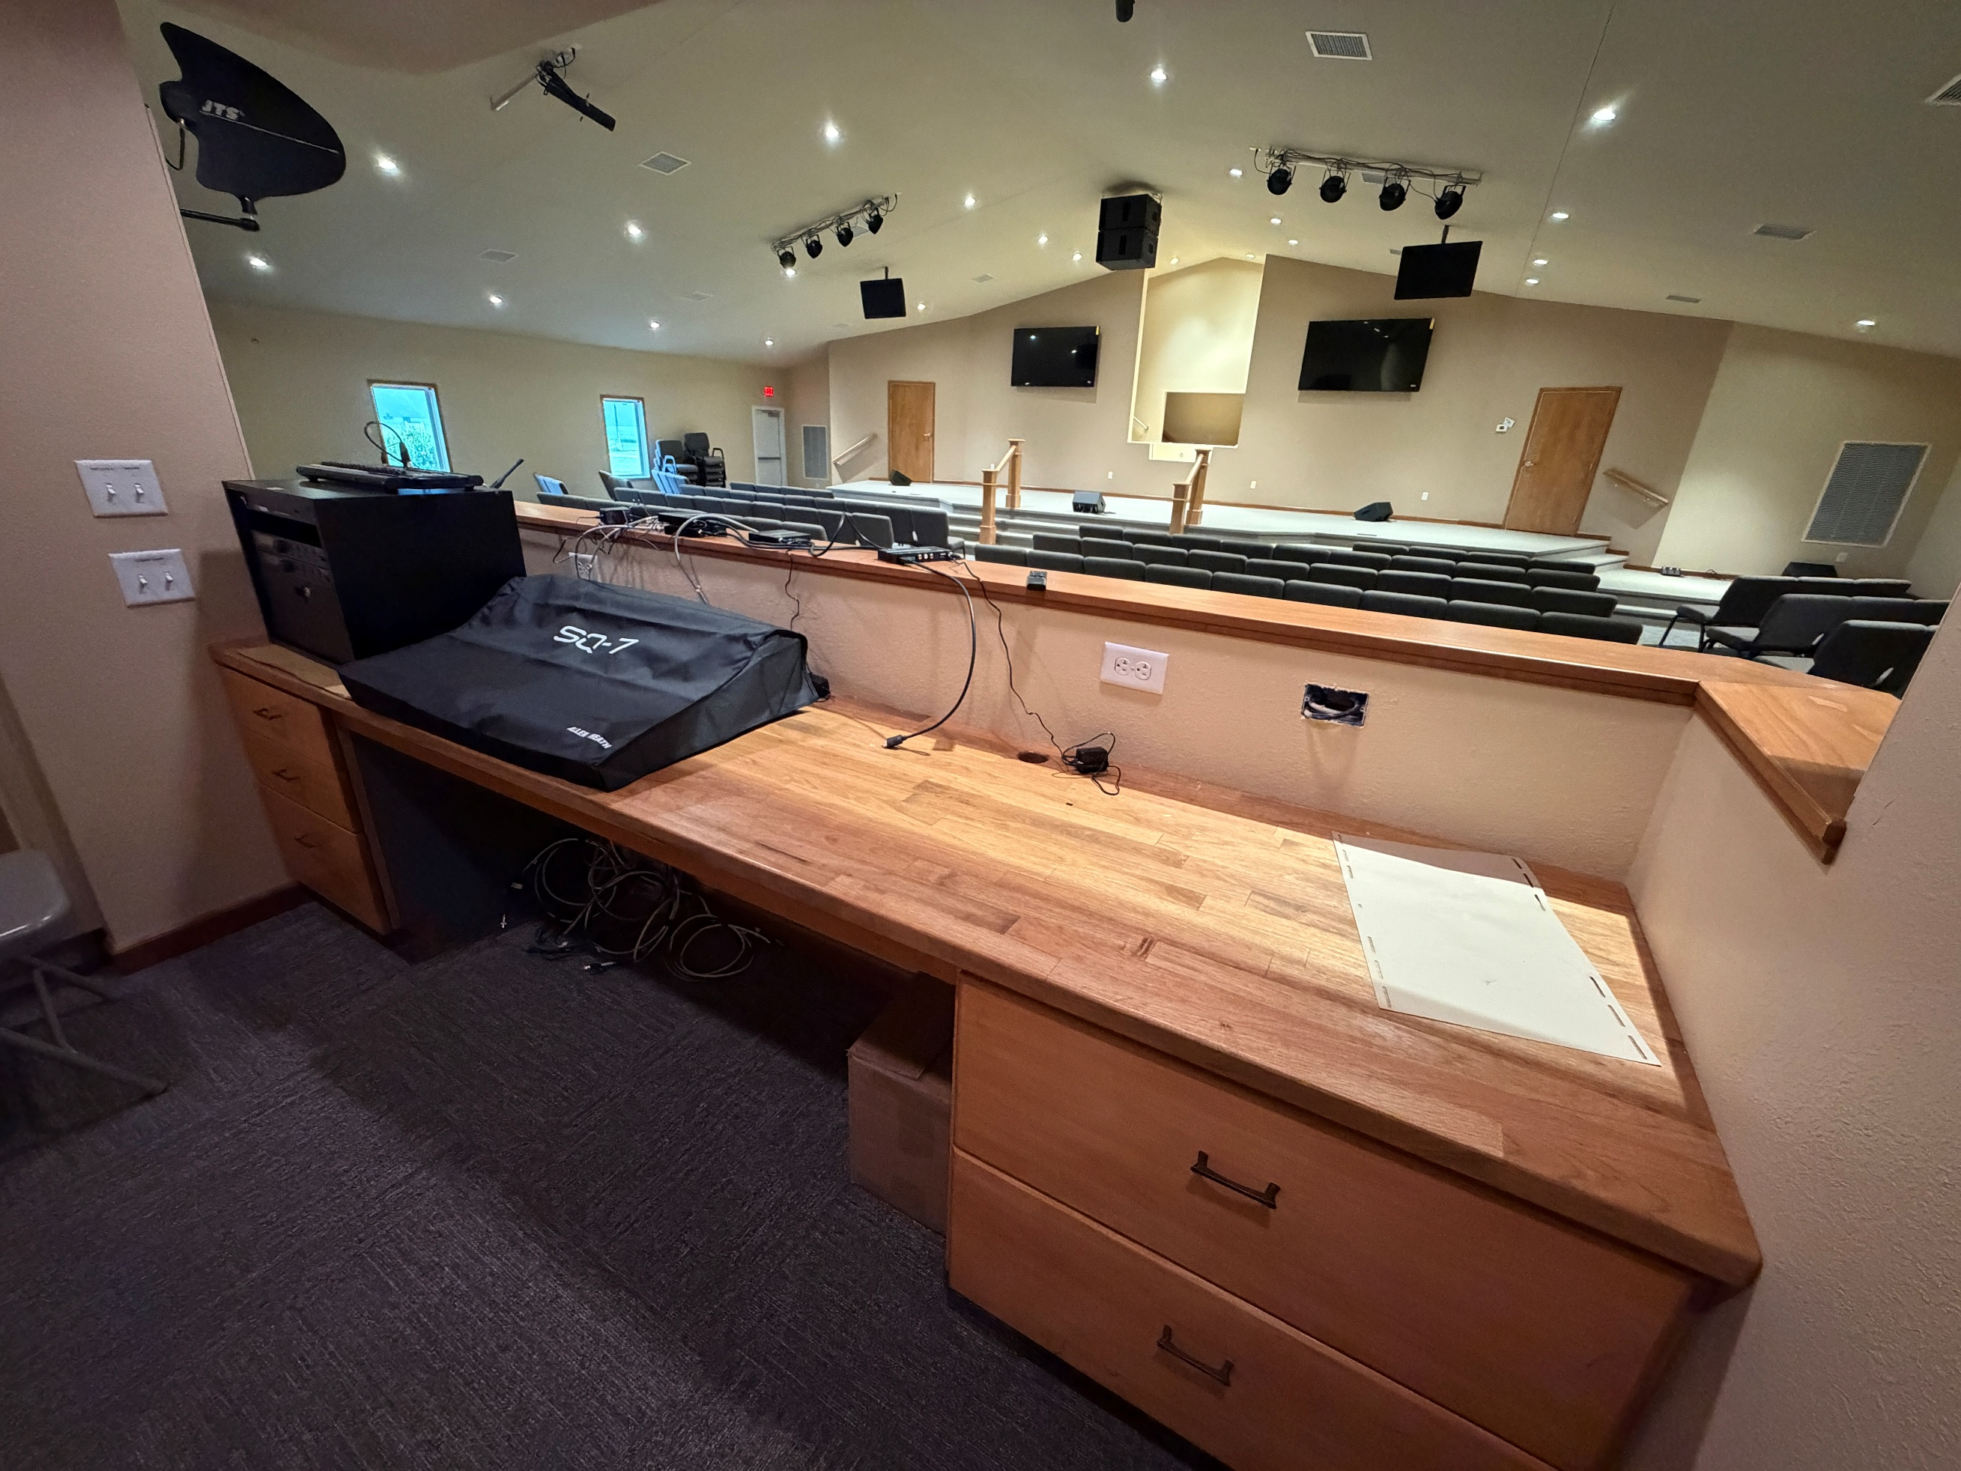
Sound Booth

We Exist to:

* WORSHIP the Living God * WIN People to Jesus * TRAIN God’s People for Service

* SEND Them Out Into the World

Upcoming Family Events
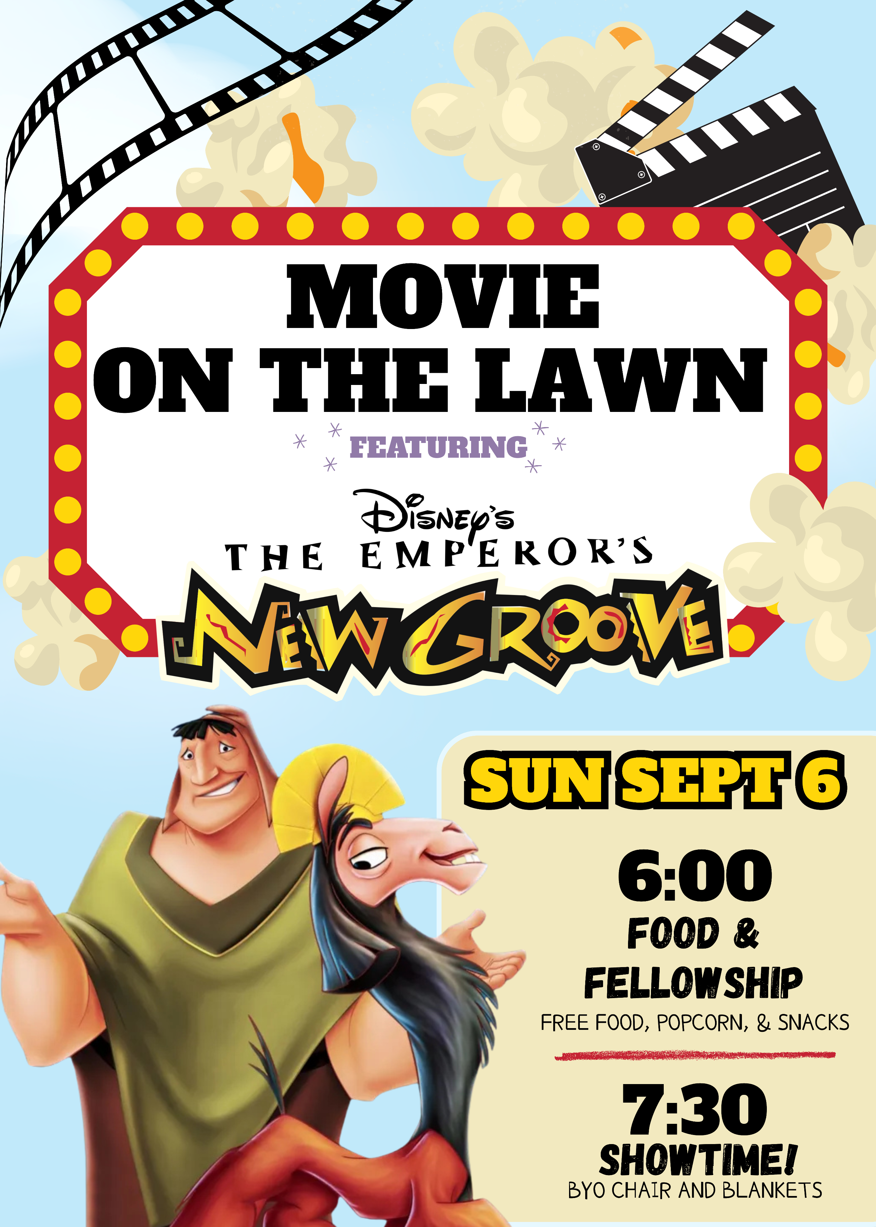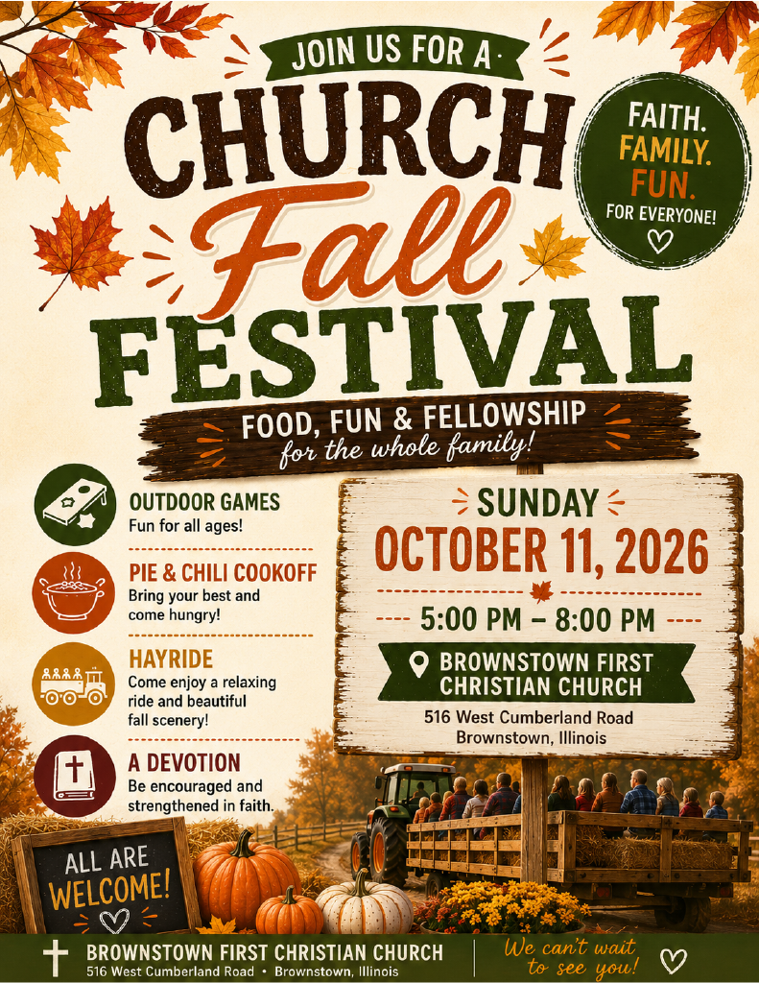

For more information, see Ashton Smith.

5th Sunday
A 5th Sunday Offering will be taken up on Sunday, August 30th. The entire amount collected will be going to the Building Fund. A potluck will follow Sunday School.
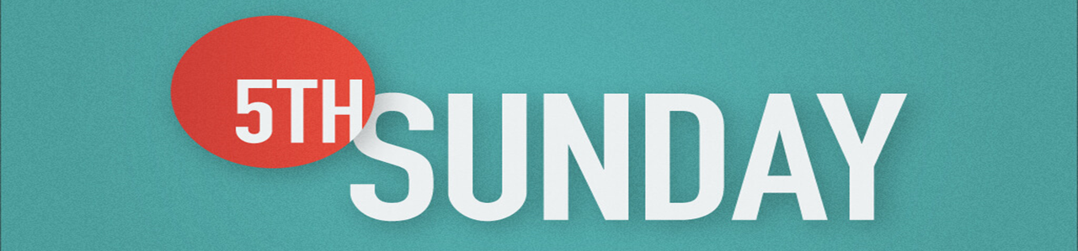

What’s Going On?
Breakfast Fellowship: If you would like to provide breakfast on a Sunday morning, there will be a sign-up sheet in the kitchen. Breakfast starts at 9:00 am.
Leadership Team (Elder’s & Deacon’s) Meeting is Tuesday, July 14th @ 7:00 pm.

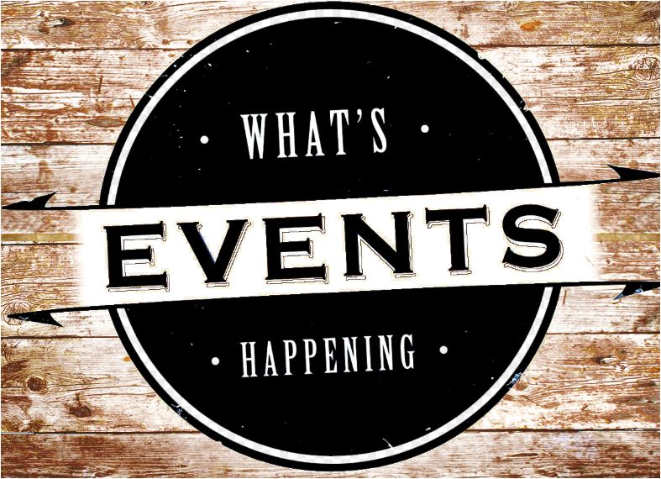

Volunteers Needed
Looking for volunteers to mow the parsonage monthly for each month August -September.
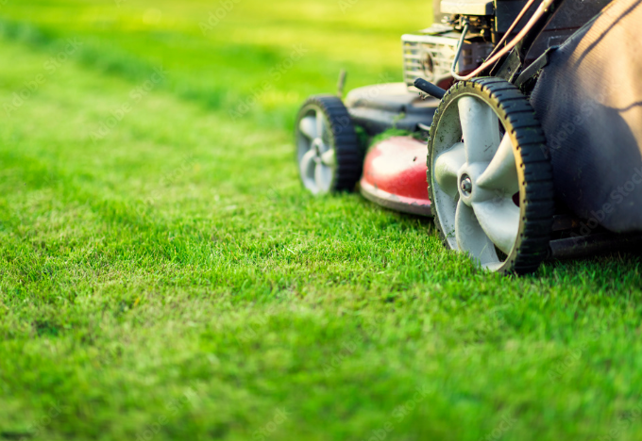
Contact Don Lovett for more information.

For the Record

Date Attendance Offering Building Fund
6/28 61 $1,407.00 $25.00
7/5 49 $2,660.00 $35.00
7/12 47 $1,941.00 $25.00
7/19 59 $2,485.00 $2,035.00



First Christian Church
Brownstown
516 W. Cumberland Rd.
P.O. Box 296
Brownstown, IL 62418
618-427-3687
Website: fcc-brownstown.com
Email: brownstownfcc@gmail.com

Nathan Brands, Preaching Minister Jamie Smith, Administrative Assistant

*Birthday
**Anniversary
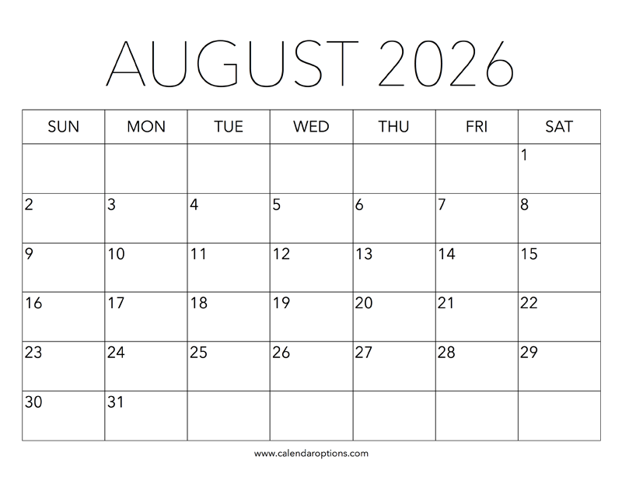
**Eric/Tresnee Adams
*Duane Willms
*Phyllis Pryor
*Aiden Smith
**Jeremy/Shannon Claycomb
*Wilma Kruger *Judy Palecek
*Gracie Meador
*Jori Adams **Matthew/Jamie Smith
*Karen Morrison

