**First Word**

**First Christian Church Brownstown**

**April 2025**

**Bond Christian Service Camp**

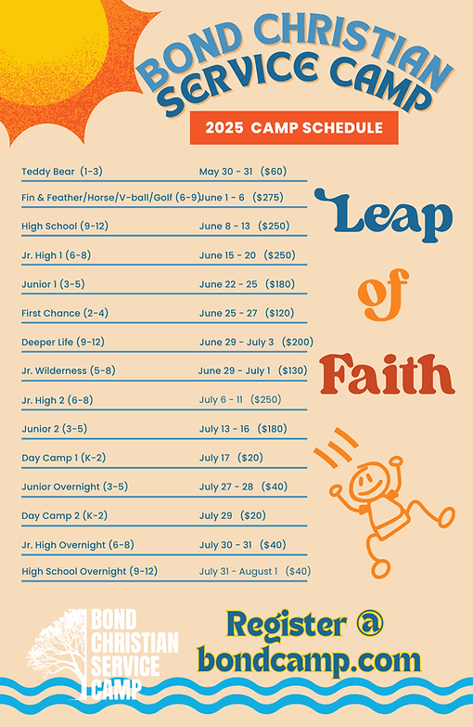

Camp registration begins March 1st! To register go to bondcamp.com.

The church will pay for one week of camp per camper for church members.

#### We Exist to:

#### * WORSHIP the Living God * WIN People to Jesus * TRAIN God’s People for Service

#### * SEND Them Out Into the World

#### 



**From the Minister**

*For if the dead are not raised, not even Christ has been raised. And if Christ has not been raised, your faith is futile and you are still in your sins. Then those also who have fallen asleep in Christ have perished. If in Christ we have hope in this life only, we are of all people most to be pitied.*

* 1 Corinthains 15:16-19

This verse tells us the importance of the resurrection of Jesus. Without the resurrection, the Christian faith is pointless. Without the resurrection, life on this earth is simply nihilism, existence without meaning or purpose, because we would have no hope beyond life on this earth. This is what makes Easter so very important. The resurrection did happen. Thus, our faith and lives are not meaningless. We live for eternity, for the hope of the resurrection. As Hebrews 11:1 says, “… faith is the assurance of things hoped for ….” The assurance of what we hope for is the resurrection, eternal life.

This reminds me of the beginning of 1 Peter 1:3-5.

*Blessed be the God and Father of our Lord Jesus Christ! According to his great mercy, he has caused us to be born again to a living hope through the resurrection of Jesus Christ from the dead, to an inheritance that is imperishable, undefiled, and unfading, kept in heaven for you, who by God's power are being guarded through faith for a salvation ready to be revealed in the last time.*

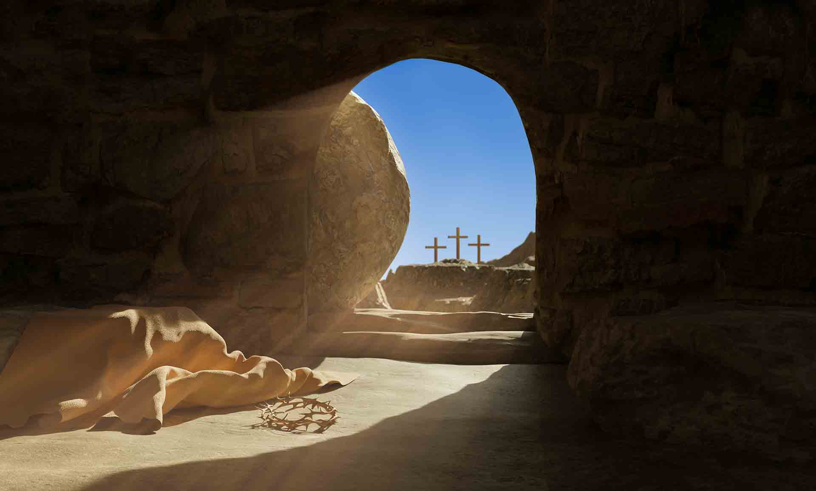

God bless,  
Nathan Brands

**Easter**

Join us at FCCB at 7:00 am on Sunday, April 20th for SONrise Service with Liberty Christian Church. There will be a breakfast fellowship following the service.

Then at 9:30 am, we will be having Easter Sunday worship service. We will be taking up a 30 pieces of silver offering that morning.

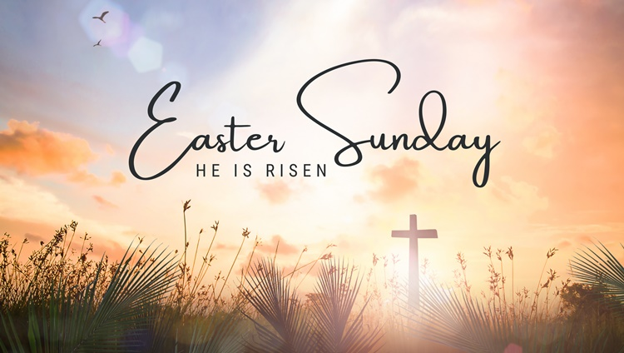

## What’s Going On?

**Breakfast Fellowship:** If you would like to provide breakfast on a Sunday morning, there will be a sign-up sheet in the kitchen. Breakfast starts at 9:00 am.

**Leadership Team (Elder’s & Deacon’s) Meeting** is Tuesday, April 8th @ 7:00 pm.

**Youth Groups for 4th – 12th Grade** will meet Sundays from 6:00 – 7:30 pm.

**Ladies Bible Study** will be Wednesdays at 6:30 pm. It is a Beth Moore study, “To Live is Christ: The Life and Ministry of the Apostle Paul.” Get to know the man who said, “To live as Christ and die is gain.” Along the way you will get to know the “Apostle to the Gentiles” in a new way.

## 



## 5th Sunday

A 5th Sunday Offering will be taken up on Sunday, June 29th. The entire amount collected will be going to the Building Loan Principle. The goal is $22,000. There will also be a potluck following Sunday School.

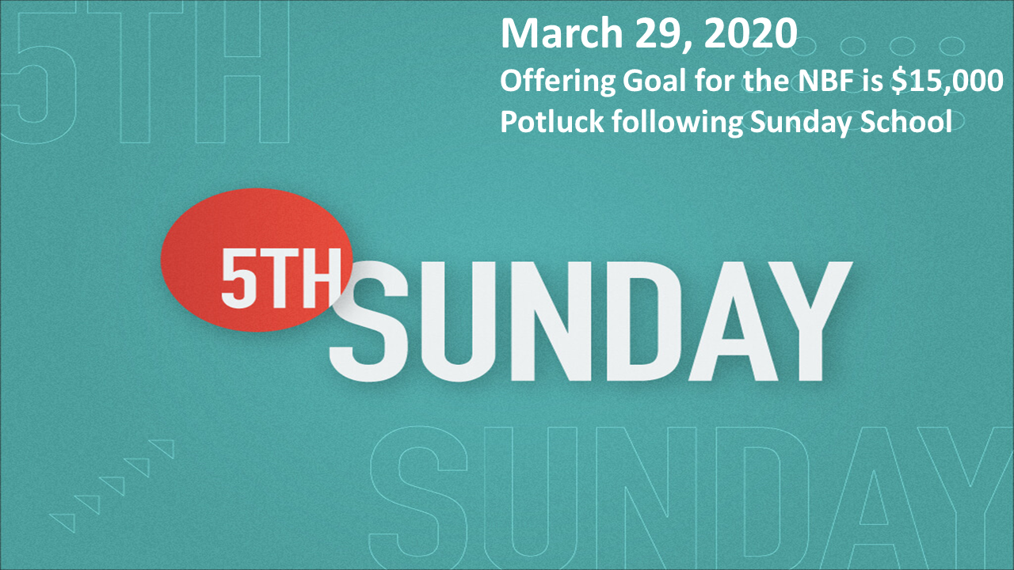

## For the Record

Date Attendance Offering Building Fund

2/23 53 $2,350.00 $480.00

3/2 62 $2,357.00 $25.00

3/9 48 $2,477.00 $38.00

3/16 52 $1,969.00 $0.00

3/23 62 $2,041.82 $130.00



First Christian Church

Brownstown

516 W. Cumberland Rd.

P.O. Box 296

Brownstown, IL 62418

618-427-3687

Website: [www.fccbrownstown.com](http://www.fccbrownstown.com) Email: [brownstownfcc@gmail.com](mailto:brownstownfcc@gmail.com)

Nathan Brands, Preaching Minister Jamie Smith, Administrative Assistant



**Mitch/Rae Lynn Koehler

*Kent Durbin *Dona Adams

*Bonnie Shelton

*Sandy Gelsinger

*Laura Willms *Lauren Gould *Nathan Brands

*Stephanie Miller

*Karen Miller *Liz Oberlink

*Tresnee Adams

*Ella Satterthwaite

*Randy Gelsinger

*Sherry Meador

*Kent Woolsey

*Teresa Durbin

*Birthday

**Anniversary