**First Word**

**First Christian Church Brownstown**

**March 2025**

**Bond Christian Service Camp**

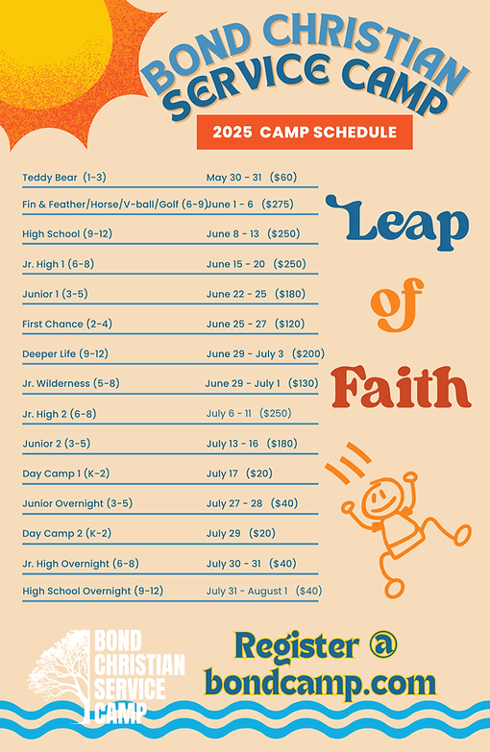

Camp registration begins March 1st! To register go to bondcamp.com.

The church will pay for one week of camp per camper for church members.

#### We Exist to:

#### * WORSHIP the Living God * WIN People to Jesus * TRAIN God’s People for Service

#### * SEND Them Out Into the World

#### 



**From the Minister**

On March 17th, we will celebrate St. Patrick’s Day. However, who was St. Patrick?

Patrick was born in Britian in the early fourth century. Around the time that Patrick was 16, his family’s villa was attacked by Irish pirates. Patrick’s family escaped, but he was not so fortunate. He was taken and sold as a slave to Miliuc of Slemich, a Druid tribal chieftain in Ireland. There he worked as a herdsman.

While enslaved, Patrick leaned on the Christian teachings he received as a child. He became so devoted to God during this time that he earned the nickname “Holy Boy” from the other slaves.

At the age of 22, Patrick escaped his enslavement and traveled 200 miles to the coast of Ireland. He was able to secure passage on a boat that took him back to Britian. It took two years until he was reunited with his family. Once home, he began to study to become a Catholic priest. One night he had a dream that he went back to Ireland to carry a letter with the words “The Voice of the Irish.” In the dream he began to read this letter and heard the voices of the men he worked with in Ireland calling him to come back to them.

Patrick went back to Ireland to minister to the people that had enslaved him. He even tried to share the gospel to his former slave owner, Miliuc, but was unsuccessful in this. During his time witnessing to the Druids of Ireland, Patrick was under constant threat. The people tried to poison him, speared his chariot driver, ambushed him, enslaved him for a short time, imprisoned, etc. Despite all of this, Patrick continued to share the gospel to the people of Ireland until his death on March 17th, around the year 461 AD.

Patrick was a great example of faith in Jesus despite persecution and relentlessly sharing the gospel to those that needed salvation.

As you wear green on March 17th this year to avoid being pinched, I encourage you to remember the life and example of Patrick. Maybe use that day to tell someone the gospel message in honor of Patrick.



God bless,  
Nathan Brands

**Thank you!**

The Gelsinger Family would like to express their sincere gratitude for the church’s prayers, support, the services provided, the many acts of kindness and the thoughtful meal provided for our family during this difficult time.

## What’s Going On?

**Breakfast Fellowship:** If you would like to provide breakfast on a Sunday morning, there will be a sign-up sheet in the kitchen. Breakfast starts at 9:00 am.

**Leadership Team (Elder’s & Deacon’s) Meeting** is Tuesday, March 11th @ 7:00 pm.

**Youth Groups for 4th – 12th Grade** will resume on Sunday, March 2nd from 6:00 – 7:30 pm.

## 



## 5th Sunday

A 5th Sunday Offering will be taken up on Sunday, March 30th. The entire amount collected will be going to the Building Loan Principle. The goal is $22,000. There will also be a potluck following Sunday School.

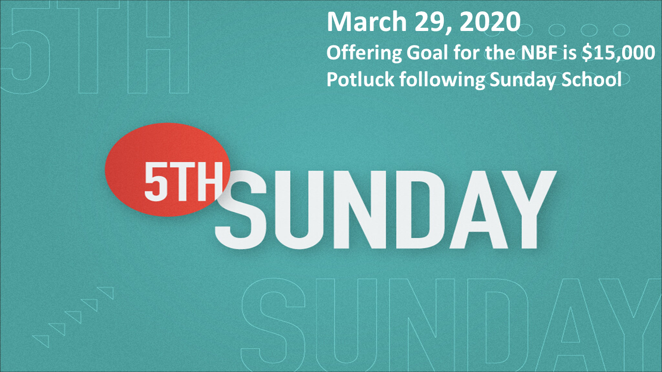

## For the Record

Date Attendance Offering Building Fund

1/26 57 $2,309.00 $2,335.00

2/2 54 $2,727.00 $1,390.00

2/9 46 $1,580.00 $30.00

2/16 50 $2,080.00 $25.00



First Christian Church

Brownstown

516 W. Cumberland Rd.

P.O. Box 296

Brownstown, IL 62418

618-427-3687

Website: [www.fccbrownstown.com](http://www.fccbrownstown.com) Email: [brownstownfcc@gmail.com](mailto:brownstownfcc@gmail.com)

Nathan Brands, Preaching Minister Jamie Smith, Administrative Assistant



*Zach Koehler

**Randy/Sandy Gelsinger

*Ellen Willms

**Duane/Laura Willms

*Sandra Lovett

*Birthday

**Anniversary