First Word

First Christian Church Brownstown
March 2026

LPHS Banquet


We Exist to:

* WORSHIP the Living God * WIN People to Jesus * TRAIN God’s People for Service

* SEND Them Out Into the World

Worship Center Construction Project Update
The insulation has been finished and the drywall has begun. The drywall finishers start the last week of February and are expected to finish mid-March.
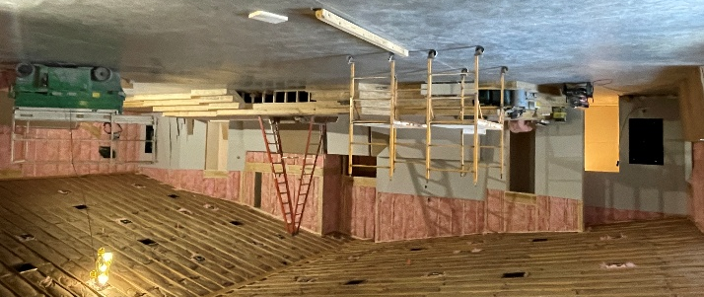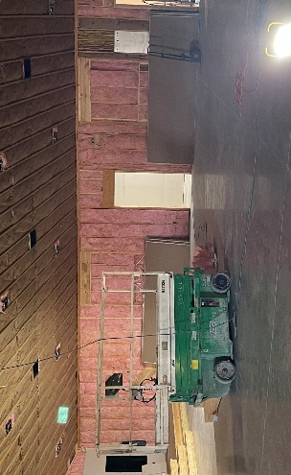
The building committee has decided to add three smaller projects (Basement, Stained Glass, Marquee) to the Worship Center Project. The basement project consists of finishing the basement with two classrooms, a bathroom, kitchenette, and a gathering room. The stained glass will consist of refurbishing three windows from the old church, installing one above the baptistry (Jesus knocking at the door) and two on the interior wall in the worship center inside a lighted cabinet. The marquee will consist of a LED sign, the bell, and the cornerstone from the old church.
The estimated costs for each project are listed here. Donations for any project are greatly appreciated. When making your donation, please specify which project your donation is to be applied to.
Stained Glass Project
Windows (3) $26,000

Marquee Project
Concrete $2,000
Electric $3,000
Digital Sign $20,000

Basement Project
Plumbing $4,000
Electric $2,500
Insulation $1,000
Drywall $2,500
Drop Ceiling $3,500
Flooring $6,800
Doors (4) $4,000
Paint $1,000

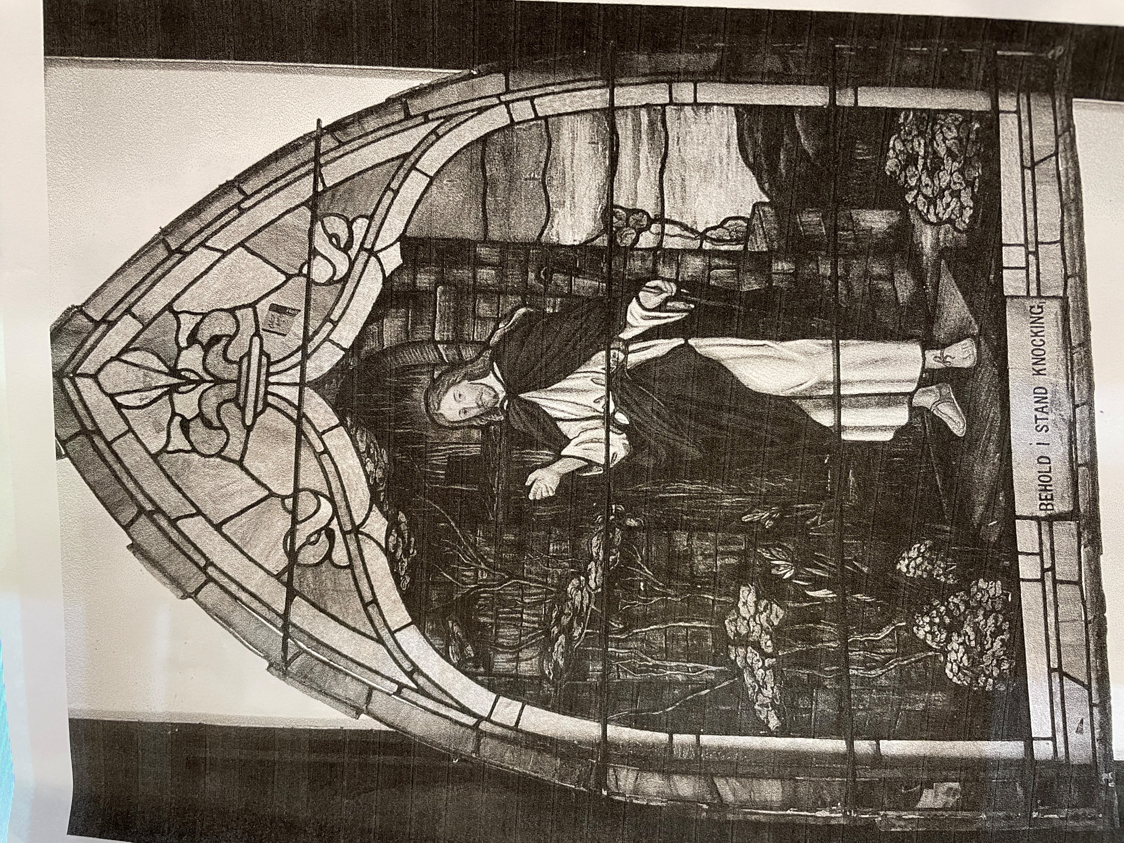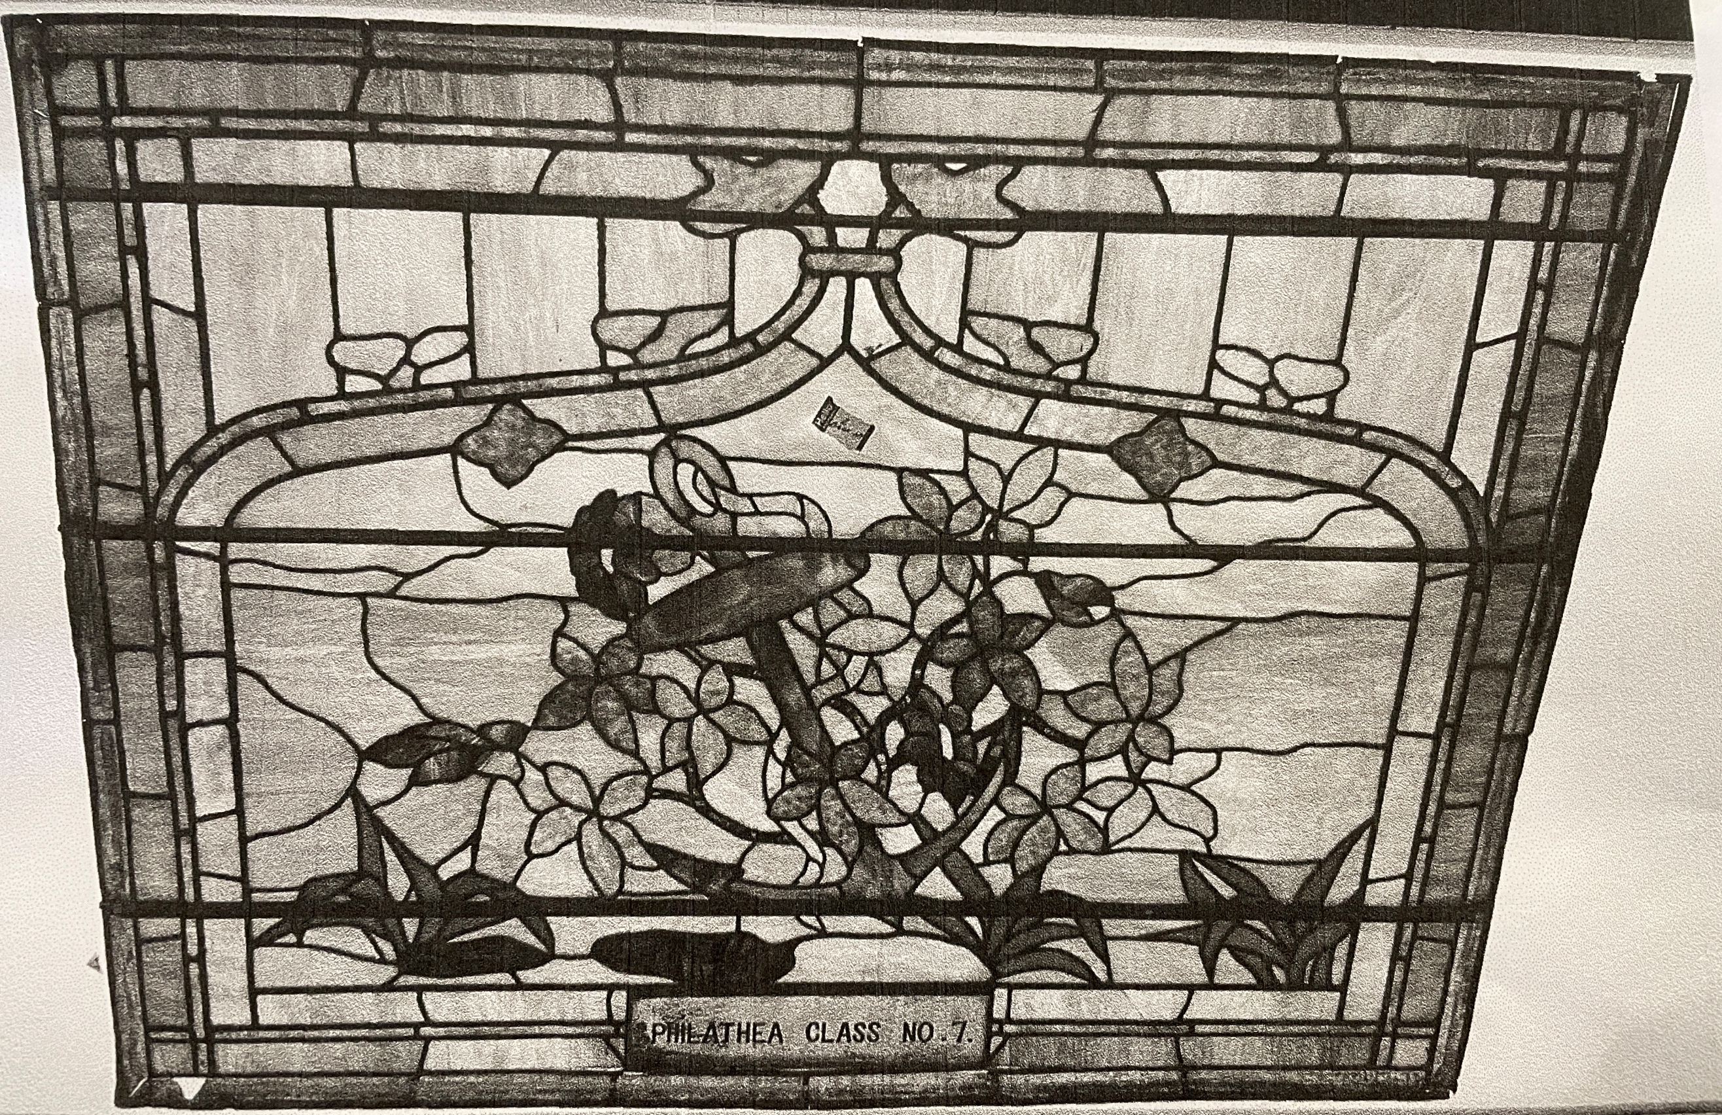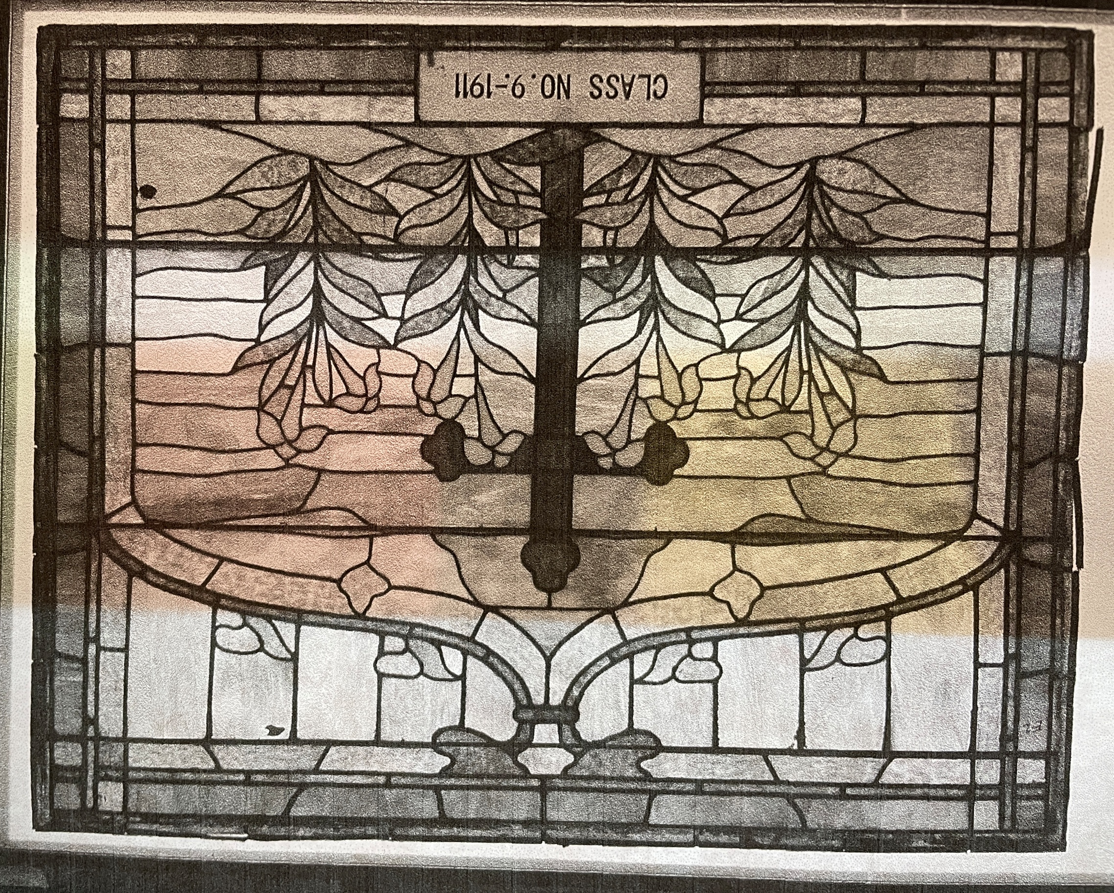
Rough Opening Dimensions (tall x wide):
58 ¼” x 73” 47” x 58 ¼” 47” x 58 ¼”

What’s Going On?
Breakfast Fellowship: If you would like to provide breakfast on a Sunday morning, there will be a sign-up sheet in the kitchen. Breakfast starts at 9:00 am.
Leadership Team (Elder’s & Deacon’s) Meeting is Tuesday, March 10th @ 7:00 pm.
Youth Groups will meet on Sundays from 6:30 – 8:00 pm. Watch for a start-up date coming soon!



Time Change
On Sunday, March 8, 2026 Daylight Savings Time begins! Don’t forget to set your clocks ahead one hour before bed.


5th Sunday
A 5th Sunday Offering will be taken up on Sunday, March 29th. The entire amount collected will be going to the Building Fund.


For the Record

Date Attendance Offering Building Fund
1/25 Snow Storm $0.00 $0.00
2/1 50 $4,833.00 $1,280.00
2/8 55 $1,553.00 $39.00
2/15 57 $2,215.00 $25.00
2/15 Love Banquet $1,346.00



First Christian Church
Brownstown
516 W. Cumberland Rd.
P.O. Box 296
Brownstown, IL 62418
618-427-3687
Website: fcc-brownstown.com
Email: brownstownfcc@gmail.com

Nathan Brands, Preaching Minister Jamie Smith, Administrative Assistant


*Birthday
**Anniversary
*Zach Koehler
**Randy/Sandy Gelsinger
*Ellen Willms
**Duane/Laura Willms
*Sandra Lovett

