First Word

First Christian Church Brownstown
June 2026

Worship Center Construction Project Update

The flooring has been completed. The woodwork (hang doors, hand rail, and trim) along with the audio & lighting equipment are being installed. The tile work around the baptistery is expected to be completed this month along with the installation of the pew chairs. Thank you to the ones that helped and sacrificed your time for this project. It could not have been done without you.
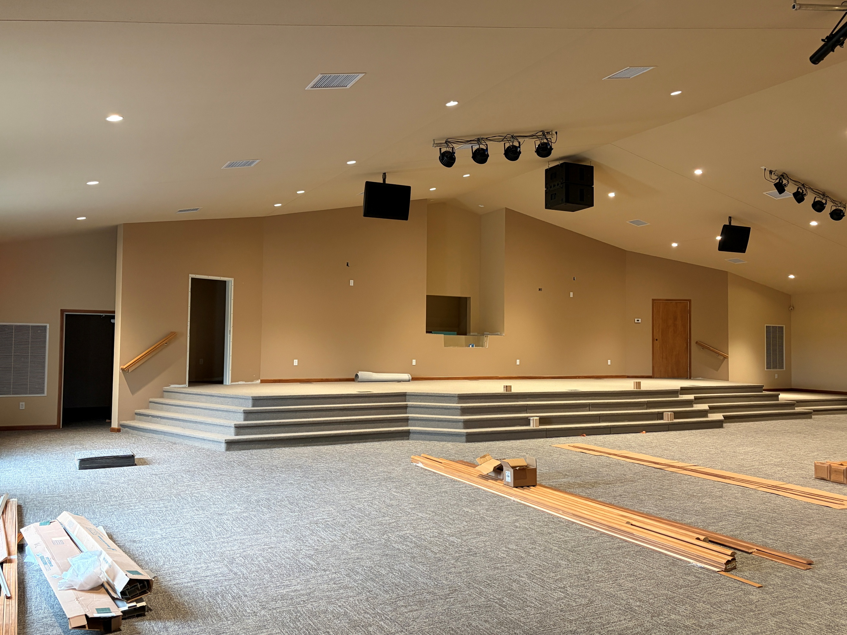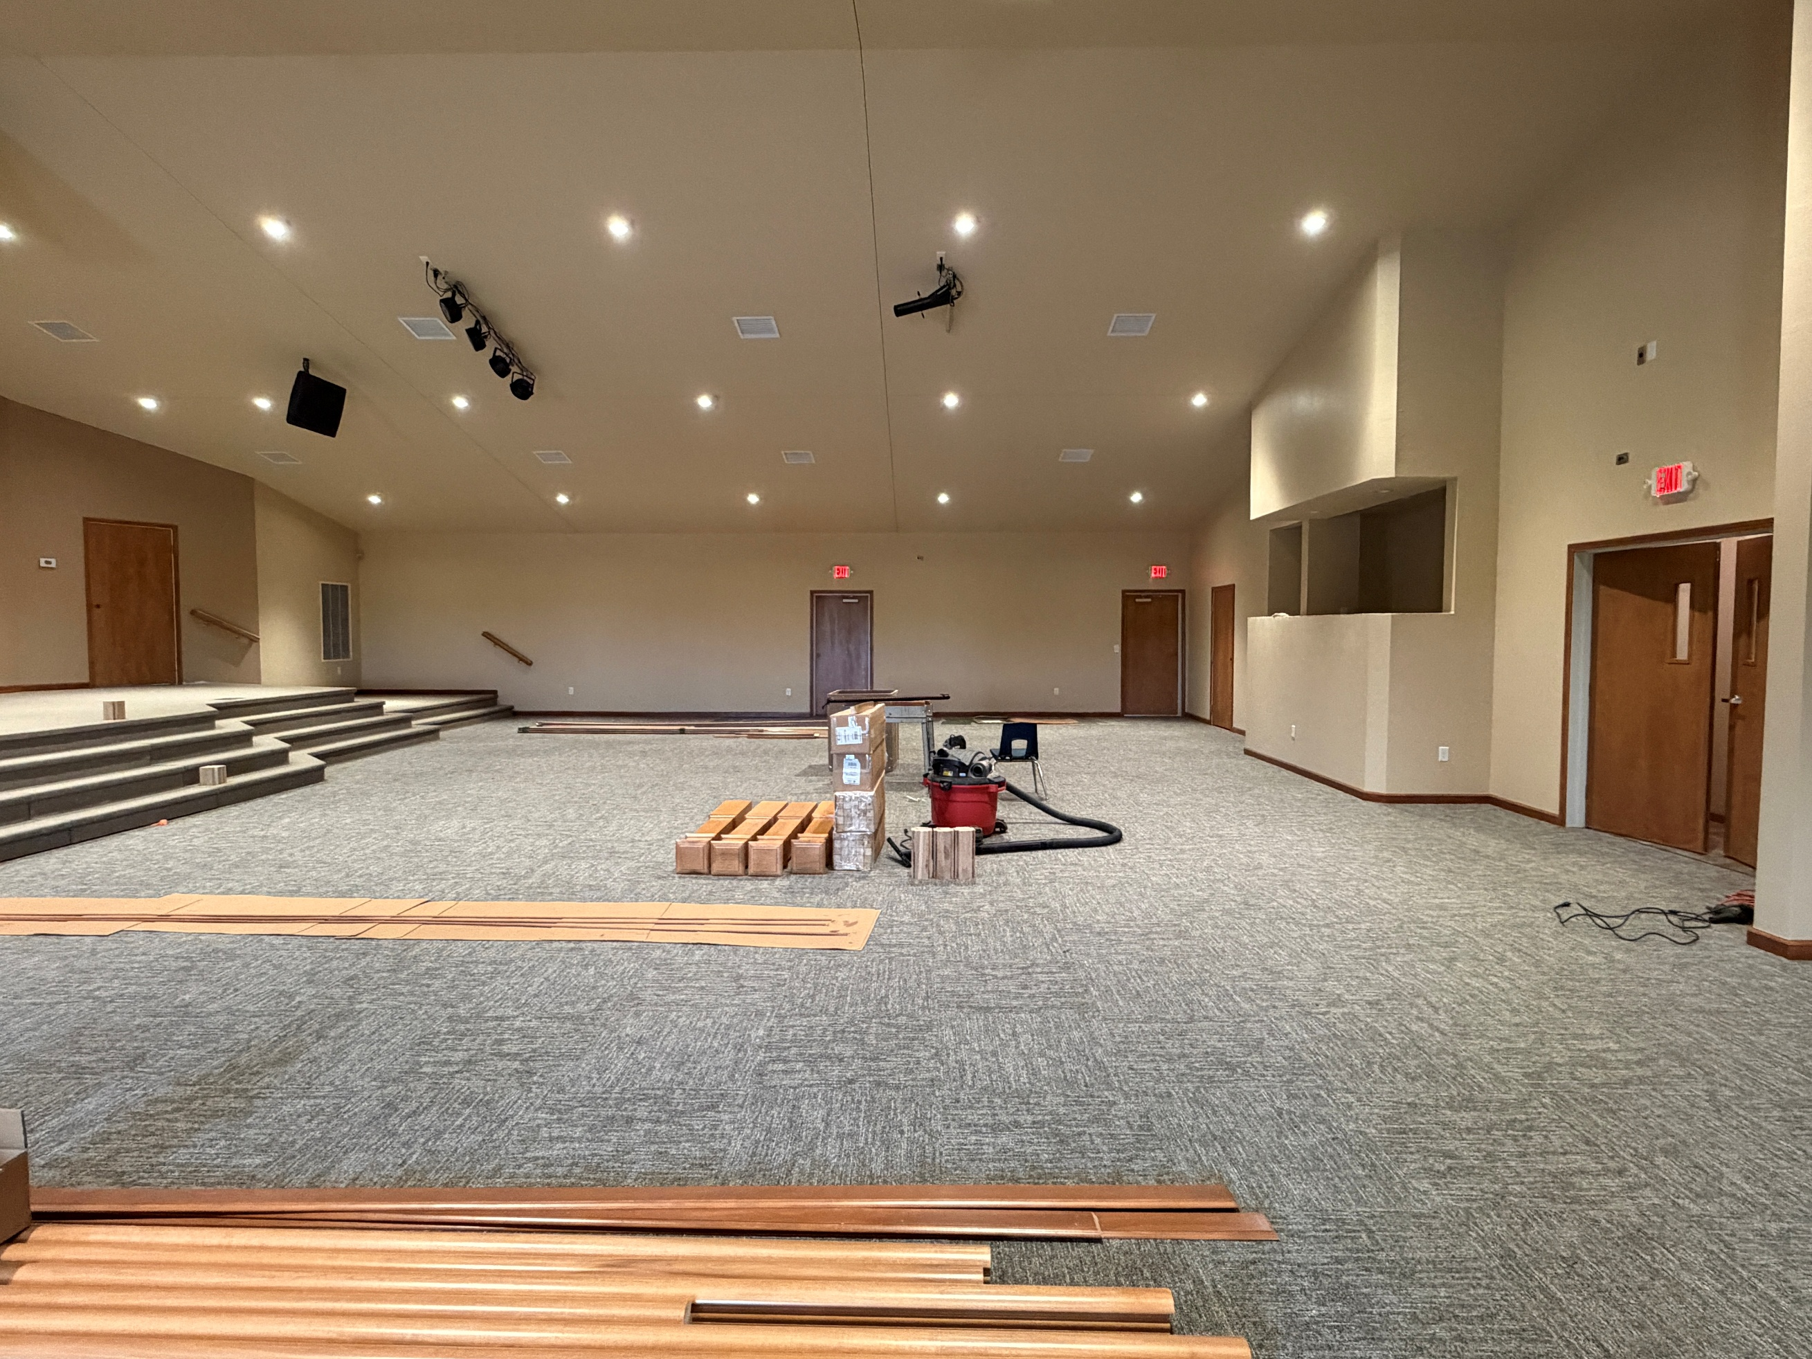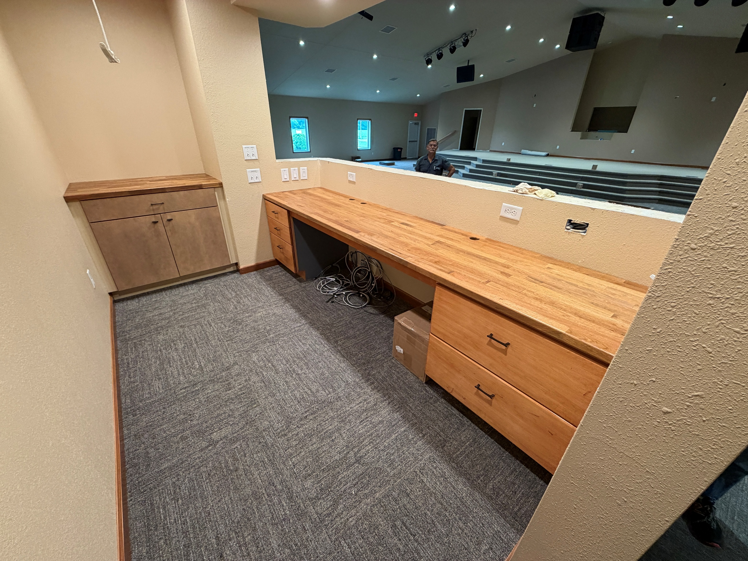
Stage Back of Worship Center Sound Booth

Volunteers Needed
Looking for volunteers to mow the parsonage monthly for each month June-September.

Contact Don Lovett for more information.

We Exist to:

* WORSHIP the Living God * WIN People to Jesus * TRAIN God’s People for Service

* SEND Them Out Into the World

From the Minister
“And let us consider how to stir up one another to love and good works, not neglecting to meet together, as is the habit of some, but encouraging one another, and all the more as you see the Day drawing near.”
- Hebrews 10:24-25
Regular church attendance is often a problem for many churches, especially during the summer months. Many families go camping, go to the lake, or go on vacation during the summer. While doing such things, they neglect going to church. This is a problem for many reasons, but I would like to point out two specific issues while neglecting church attendance.
- You miss out on one of God’s primary designs for spiritual growth.
Many that don’t go to church regularly will say they read their Bibles and pray regularly. Of course this is a good thing, but not the only way God grows us spiritually. In Acts 2, it says that when the believers met, they devoted themselves to four things: the apostles’ teachings, fellowship, breaking of bread (communion), and prayer. By not going to church, you miss out on two of these, and I would say a third as well. The two are fellowship and communion, and the third is the apostles’ teaching.
- You are disobeying God’s desire for Christians.
The point of the verse I began with is God’s desire for us to meet together regularly. This is not an optional suggestion but a command for Christians to follow. It is not our place to decide whether or not to follow such commands given to us by God.
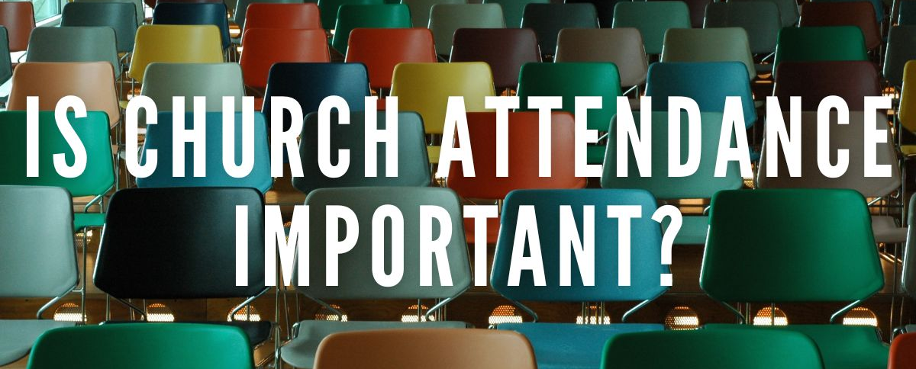
God bless,
Nathan Brands

5th Sunday
A 5th Sunday Offering will be taken up on Sunday, August 30th. The entire amount collected will be going to the Building Fund. A potluck will follow Sunday School.
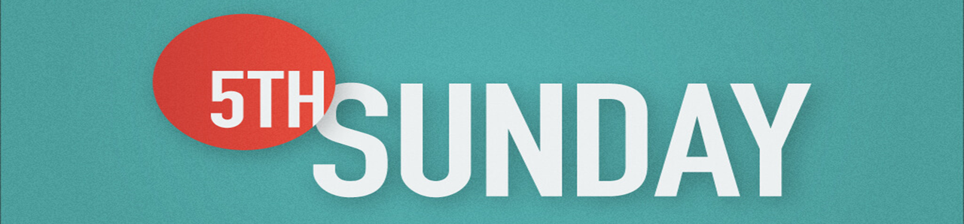

What’s Going On?
Breakfast Fellowship: If you would like to provide breakfast on a Sunday morning, there will be a sign-up sheet in the kitchen. Breakfast starts at 9:00 am.
Leadership Team (Elder’s & Deacon’s) Meeting is Tuesday, June 9th @ 7:00 pm.
Guest Speakers: Sunday, June 7th – Matthew Smith & Sunday, June 14th – Silas McCormick from Lincoln Christian Institute will be speaking during the morning service. He will also be doing a presentation during SS for our adults.



Bond Camp Schedule
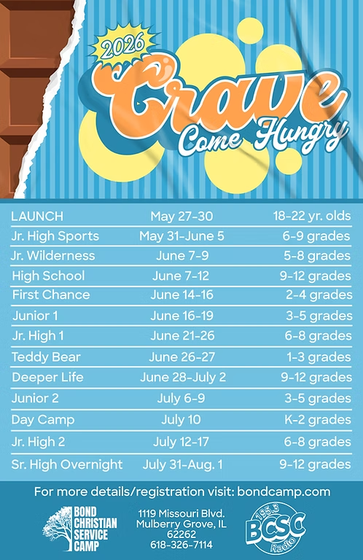
We are collecting dish soap for Bond Camp!
Place your items on the table in the back of the fellowship hall.

Camp registration has begun! Go to bondcamp.com to register. The church will pay for 1 week of camp per camper

For the Record

Date Attendance Offering Building Fund
4/26 43 $1,091.00 $1,225.00
5/3 66 $3,240.00 $30.00
5/10 87 $2,298.25 $25.00
5/17 59 $2,535.00 $25.00
5/24 59 $1,599.00 $290.00



First Christian Church
Brownstown
516 W. Cumberland Rd.
P.O. Box 296
Brownstown, IL 62418
618-427-3687
Website: fcc-brownstown.com
Email: brownstownfcc@gmail.com

Nathan Brands, Preaching Minister Jamie Smith, Administrative Assistant


*Cambree Jachino
**Terry/Susan Smith
*Asa Satterthwaite
*Samuel Miller
**Don/Robin Lovett
*Carter Smith
*Kyndal Adams
**Brad/Nikki Sidwell
**Bill/Cathy Smith
*Kaci Satterthwaite
*Terry Smith
*Judy Feltner
*Alivia Claycomb *Cathy Smith
*Birthday
**Anniversary

