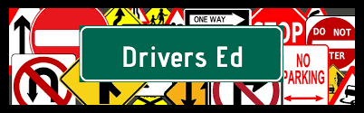
Forrest Bird Charter School
Panhandle Driving School
☐ Meet with Mitzi to learn about Advanced Opportunity funding requirements
☐ Request a Fast Forward Participation Form
☐ Complete the Fast Forward Participation form and return it to Mitzi

☐ Check course availability on website: Panhandledrivingschool.com
☐ Check availability by clicking on the course /DO NOT REGISTER
☐ Clicking on the course will show you the number of seats available
☐ Download and print/save the course packet for the course date you would like

☐ Call Julia Klontz from Panhandle Driving School (208) 265-2262
☐ Identify yourself as a Forrest Bird Charter student wanting to register
☐ Let Julia know which course you are interested in (dates)
☐ Follow any additional instructions she may have

☐ Once Julia has confirmed you are registered for a class:
☐ Request a VOC (verification of Compliance) from Christi at FBCS (this may take a day or two so let her know BEFORE you need it)
☐ Purchase a driver permit (must be at least 14.5 years of age) Cost is approximately $26.50 due at time of applying for permit
☐ **Follow directions on Panhandle Driving School Course packet (on website)

