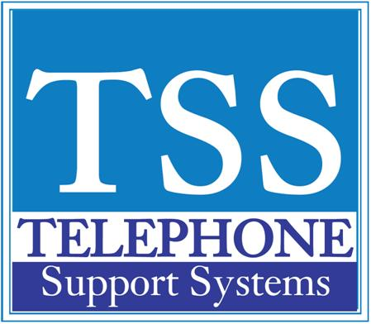

|  |  |  |
| --- | --- | --- |
|  |  |  |

|  |  |  |  |  |
| --- | --- | --- | --- | --- |
| |  |  |  | | --- | --- | --- | | **Turn On/Off Background Music** |  |  |  |  | | --- | | **Turn On/Off Background Music  You can set background music on your telephone speaker*  To Enable:**  **Press your DN button and #490 + n + #,  n=where the music source is 1-15**    **To Cancel:**  **Press your DN button and #491**    **\*You must have a music source connected to the telephone system. Up to 16 music sources can be connected to the CIX system.** |     For additional help please call us at 249-248-0000 (Michigan) or 239-561-0090 (Florida) |