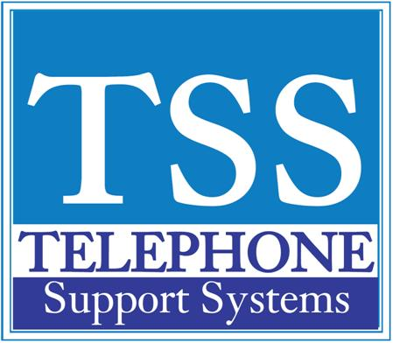

|  |  |  |
| --- | --- | --- |
|  |  |  |

|  |  |  |  |  |
| --- | --- | --- | --- | --- |
| |  |  |  | | --- | --- | --- | | **Clearing Your Message Waiting Light** |  |  |  |  | | --- | | **Clearing Your Message Waiting Light  - There is a feature on the phone system that when another extension is not available you may press your Msg Waiting button. When you do this  it will light the other parties Msg Waiting Light. Whenever they press the blinking light the system will automatically call you back.  1. Leave the handset on hook 2. Press #409 3. This will clear a message waiting light** |   **For additional help please call us at 249-248-0000 (Michigan) or 239-561-0090 (Florida)** |