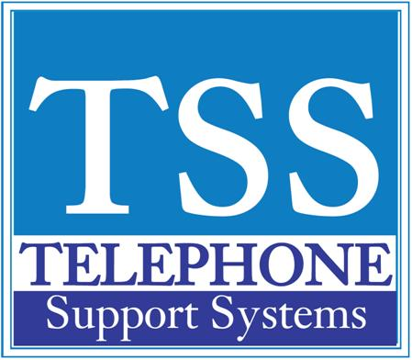

|  |  |  |
| --- | --- | --- |
|  |  |  |

|  |  |  |  |  |  |  |  |  |  |  |  |  |  |  |  |  |  |  |  |  |  |  |  |  |  |  |  |  |  |  |  |  |  |  |  |  |  |  |  |  |  |  |  |  |  |  |  |  |  |  |  |  |  |  |  |  |  |  |  |  |
| --- | --- | --- | --- | --- | --- | --- | --- | --- | --- | --- | --- | --- | --- | --- | --- | --- | --- | --- | --- | --- | --- | --- | --- | --- | --- | --- | --- | --- | --- | --- | --- | --- | --- | --- | --- | --- | --- | --- | --- | --- | --- | --- | --- | --- | --- | --- | --- | --- | --- | --- | --- | --- | --- | --- | --- | --- | --- | --- | --- | --- |
| |  |  |  | | --- | --- | --- | | **Programming Flexible Buttons (CTX/CIX Only)** |  |  |  |  |  |  |  |  |  |  |  |  |  |  |  |  |  |  |  |  |  |  |  |  |  |  |  |  |  |  |  |  |  |  |  |  |  |  |  |  |  |  |  |  |  |  |  |  |  |  |  |  |  |  |  |  |  |  |  |  | | --- | --- | --- | --- | --- | --- | --- | --- | --- | --- | --- | --- | --- | --- | --- | --- | --- | --- | --- | --- | --- | --- | --- | --- | --- | --- | --- | --- | --- | --- | --- | --- | --- | --- | --- | --- | --- | --- | --- | --- | --- | --- | --- | --- | --- | --- | --- | --- | --- | --- | --- | --- | --- | --- | --- | --- | --- | | 1.  Press #9876 to enter User Programming Mode 2.  Press HOLD 3.  Press the Flexible Button to set or change 4.  Enter the Flexible Button Code (see table below) 5.  Press the same Flexible Button (flashing) to save the setting "DATA PROGRAMMED" appears in your LCD     |  |  |  |  | | --- | --- | --- | --- | | **Feature** | **Code** | **Feature** | **Code** | | Automatic Busy Redial On | 150 | Caller ID | 580 | | Automatic Call Back | 160 | Do Not Disturb (on/off) | 180 | | Background Music | 530 | Direct Station Selection Button | 610 | | Call Forward * |  | One Touch Button | 570 | | *All Calls | 340 | Paging All Groups | 220 | | *Busy | 350 | Night Transfer | 600 | | *No Answer | 360 | Record to VM (if system programmed) | 630 | | *Busy/No Answer | 370 | Release Button | 270 | | Call Forward -Outside Calls* |  | Release/Answer Button | 280 | | *All Calls | 380 | Speed Dial | 260 | | *Busy | 390 | User Programming Mode | 650 | | *No Answer | 400 | Call Park Orbit | 170 | | *Busy/No Answer | 420 | Automatic Busy Redial On | 150 | |   **For additional help please call us at 249-248-0000 (Michigan) or 239-561-0090 (Florida)** |