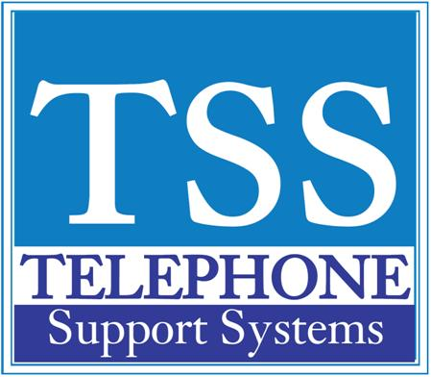

Programming a One Touch Key

*First you must be sure the button you wish to program is a "One Touch Button" see programming flexible buttons to ensure
1. Press #9876 to enter User Programming Mode
2. Press the One Touch button to be set
3. Enter the digits or special buttons for the function to be dialed - maximum 32 characters
- To program a feature access code see: helpful feature codes on this page
4. Press the One Touch button to save the entry

For additional help please call us at 249-248-0000 (Michigan) or 239-561-0090 (Florida)

