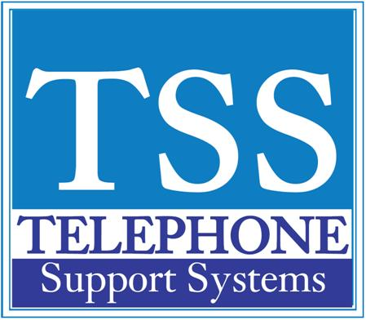

|  |  |  |
| --- | --- | --- |
|  |  |  |

|  |  |  |  |  |  |  |  |  |  |  |  |  |  |  |  |  |  |  |  |  |  |  |  |  |  |  |  |  |  |  |  |  |  |  |  |  |  |  |
| --- | --- | --- | --- | --- | --- | --- | --- | --- | --- | --- | --- | --- | --- | --- | --- | --- | --- | --- | --- | --- | --- | --- | --- | --- | --- | --- | --- | --- | --- | --- | --- | --- | --- | --- | --- | --- | --- | --- |
| |  |  |  | | --- | --- | --- | | **Helpful Feature Codes** |  |  |  |  |  |  |  |  |  |  |  |  |  |  |  |  |  |  |  |  |  |  |  |  |  |  |  |  |  |  |  |  |  |  |  |  |  |  | | --- | --- | --- | --- | --- | --- | --- | --- | --- | --- | --- | --- | --- | --- | --- | --- | --- | --- | --- | --- | --- | --- | --- | --- | --- | --- | --- | --- | --- | --- | --- | --- | --- | --- | --- | | |  |  | | --- | --- | | **Feature** | **FFeature Access Code Sequences** | | Automatic Busy Redial On | Cnf/Trn + #441, hang up | | Automatic Busy Redial Off | Ext. button + #442 | | Automatic Call Back Cancel | Ext. button + #431 | | Call Park * |  | | *Activate (while on call) | Cnf/Trn + #33 + orbit no. or your ext. no. | | *Retrieve (while on call) | Ext. button + #32 + orbit no. or your ext. no | | Call Pick Up * |  | | *Directed DN pickup of ringing or held calls | Ext. button + #5#6 + ext. no. | | *Directed DN pickup of ringing, held or parked calls | Ext. button + #5#29 + ext. no. to be picked up | | *Incoming - Group pickup | Ext. button + #5#34 + group no. to be picked up | | *Incoming - Direct extension pickup | Ext. button + #5#5 + Primary ext. no. to be picked up | | *Incoming - Directed group pickup | Ext. button + #5#32 + group no. to be picked up | | *Incoming - Directed extension pickup | Ext. button + #5#22 + ext. no. | | Conferencing - Three Way | #494 | | Direct Transfer to Voice Mail | While on call, press Cnf/Trn + #407. Dial VM mailbox # | | Paging | #30 | |   **For additional help please call us at 249-248-0000 (Michigan) or 239-561-0090 (Florida)** |