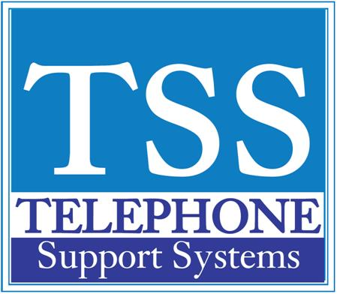

|  |  |  |
| --- | --- | --- |
|  |  |  |

|  |  |  |  |  |
| --- | --- | --- | --- | --- |
| |  |  |  | | --- | --- | --- | | **Stratagy Voice Mail Administration** |  |  |  |  | | --- | | **1. From your desk dial voice mail pilot extension - usually 500 2. When the security code prompt plays press the # key 3. Press the * key and then enter 999 followed by the # key 4. Enter the security code - if you do not know this code contact your system administrator or a Telephone Support Systems representative 5. Select option 8 for System Administration 6. Follow the prompts to: - Record the system announcement - option 1 - Delete the system announcement - option 2 - To Manager Users - option 4 * To lock a mailbox press 1 * To unlock a mailbox press 2 * To reset a mailbox press 3 (this will reset everything in the mailbox) * To delete a mailbox press 4 * To reset a security code press 5 - resets security code to default = mailbox number + 997 - for example if the mailbox is 200 the default security code will be 200997 - To add a new user or modify the directory- option 5 - To set the data/time- option 6 - To hear the system status press \*** |   **For additional help please call our office at 249-248-0000 (Michigan) or 239-561-0090 (Florida)** |