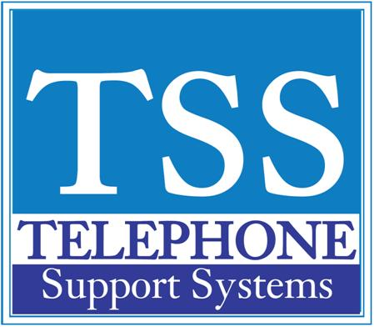

LCD Display Soft Key Definitions

Soft Key | Definition
ABR | Activates Automatic Busy Redial after dialing a busy outside telephone number
ACB | Activates Automatic Callback after reaching a busy station , CO line, or CO line group
BUSY | (Busy Override) Sends a call-waiting tone to a busy station
CONF | Initiates or completes a conference
EXEC | (Executive Override) Breaks into the conversation of a busy called station
EXIT | Exits you from a conference; remaining parties are connected
JOIN | Joins all parties to a conference while on a conference call
LINE | Adds a CO line to an existing call while in the Conference mode. The LCD prompts you to access a CO line after you press this key
MESG | Sets a message waiting indication at a busy or unanswered station
OVRD | Overrides options, busy mode, or overrides Do Not Disturb mode
PGE | Enables you to enter a Page Group number (01-16)
RING | Makes a called station ring when making a voice announce call to the station
RLS | Disconnects a call and returns telephone to the idle state
RTRN | Terminates a feature operation and to return to a previously displayed state
SPLT | Enables you to break off from a conference call with another conference call member for a private conversation (split). You can use the Join key to reconnect both of you back into the conference.
STA. | Adds a station to an existing call while in the conference mode. The LCD prompts you to dial a station number after you press this key
TALK | Makes a voice announcement to a called station that is ringing
TRNS | Initiates or completes a Transfer while on an outside call. Press once for an immediate or announced transfer, depending on system programming. Pressing TRNS again completes the transfer.

For additional help please call our office at 249-248-0000 (Michigan) or 239-561-0090 (Florida)

