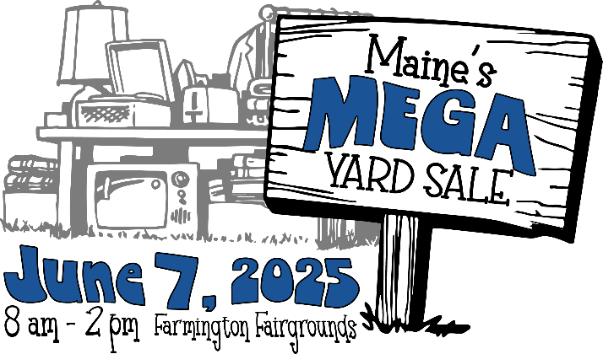

**Maine’s Mega Yard Sale**

**Frequently Asked Questions**

**How much is it?** Take advantage of early bird registration during March 2025 and outside spots are $25. April 1st and after, all outdoor spots are $35. **Indoor spots are $50, with no early bird pricing, and are limited quantity.**

**Can you accommodate large trailers?** If you have a trailer that you would like to park and sell from, let us know. We will assign a space where you can park it. You will need to pay for 3 or possibly 4 spots, depending on the size of your trailer. Small trailers will need to reserve at least 2 spaces.

**How do I register?** You can register online at https://fcanimalshelter.org/maine-mega-yard-sale-2025 or download the registration, then mail it or drop it off at the FCAS, 550 Industry Road, Farmington, ME 04938.

**How big are the spaces?** All spaces are approximately 12’ x 12’.

**Can I pick my spot?** We assign spots on a first registered, first served, basis. Let us know your preference at registration and we will do our best to accommodate it.

**What can I sell?** Direct sale items (Lularoe, Usborne Books, Tupperware etc We reserve the right to limit this category), henna, hand crafts, yard sale items, packaged foods (candy, honey, and other cottage foods), canned goods, antiques and more. If you are unsure, please email [peri@fcanimalshelter.org](mailto:info@fcanimalshelter.org) and ask!

**What CAN’T I sell?** We do not allow sales of any weapons, firearms and knives OR any items that will compete with FCAS concessions, so food prepared on site, like food trucks.

**Does the FCAS provide tables or tents?** NO we do not provide these. Your fee is simply to reserve your space.

**Is there access to electricity?** No, there will NOT be access to electricity.

**What time is set-up?** Set-up begins at 6:00 a.m. sharp and should be completed by 7:30 a.m. Please enter at the Maple Avenue gate and follow the directions provided by volunteers who will directly assist you. All vehicles MUST be removed from the sale area and parked in vendor parking by 7:30 a.m. and remain there until the event is finished at 2:00 p.m. Large items may be picked up by vehicle at 2:00 p.m.

**When does the sale actually start?** The sale begins at 8:00 a.m. and ends at 2:00 p.m.

**How much is it to enter and shop at the event?** Shoppers aged 7 years and older may enter the sale for just $1.00.All proceeds from entrance fees and registration go to our furry friends at the FCAS, so spread the word!