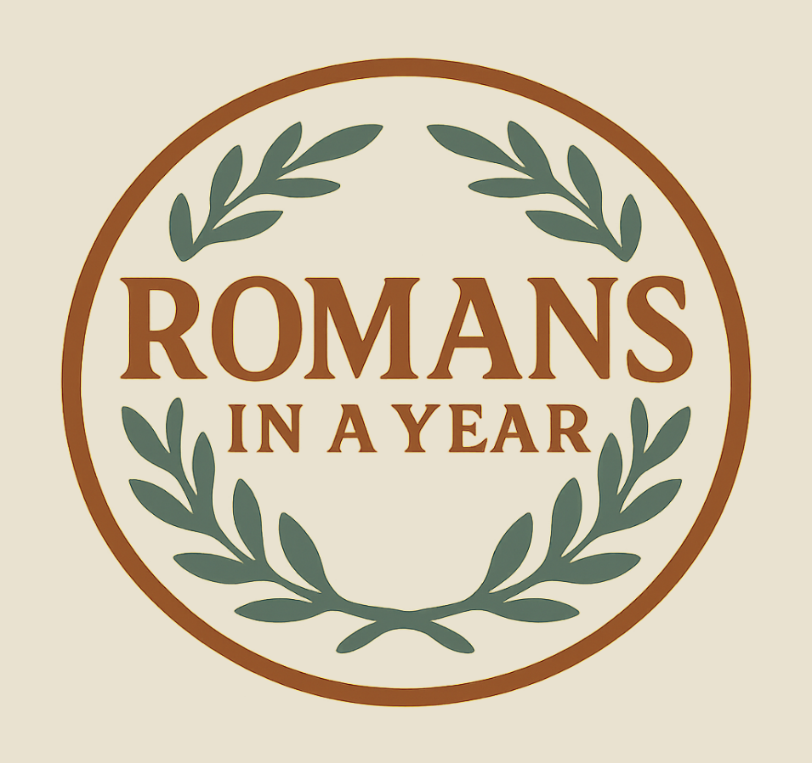

This is an “overview” of the book of Romans. (Example: The Ford and Henry)

The Purpose of This Series: To establish us in the foundation of the Mystery—to the end that—we may know God better and embrace the awesome work which the Lord Jesus Christ accomplished for us and in us, and thereby walk effectively with him.

Questions are welcome, as well as your input. Please write down any questions you may have, and we can discuss them at the end or in between each session, or you may call 425-677-5360 or e-mail steve@romansinayear.com or mail: 36311 SE Isley St. Snoqualmie WA 98065.

Introduction

Romans: The Foundation of the Mystery

In the beginning, God made the universe for the earth, the earth for man, and man to fellowship with Him. Why? Because… He wanted a family.
- Then, Adam and Eve sinned and things changed.
- God had a plan to redeem mankind, but the details of this promised plan was a secret. Genesis 3:15 Ephesians 3:3-6

When Jesus read the scroll from Isaiah, he stopped at a certain point and put away the scroll. That comma was an apparent “hole” in scripture. Luke 4:16-21; Isaiah 61:1, 2
- Why did God keep it a secret? It was “unto our glory”. I Corinthians 2:7, 8
- “The grace that should come unto you” 1 Peter 1:10-12

A prophet who enquired—Moses. Exodus 33:11, 18-19
- “glory” – the appearance of a person or a thing which attracts attention and denotes its inherent quality or splendor, i.e. “Show me your best.”
- “face” – FOS (condescension) and Orientalism (cultural: “My intimate best”).
- “the right hand” – the hand of blessing; the left hand was the hand of cursing.

Exodus 33:21-23 What did Moses see? 34:28—The Law.
- Did it depress Moses? No.
- Was he “dirty”? No, he glowed!—34:29, 30; the shine on his face frightened Israel.

II Cor.3:7-8 The administration of death! 2.5 million people were protected and fed in
the wilderness for 40 years. God personally fought for Israel time after time. They won battles without touching a weapon. Yet, what God says we have “much more exceeds in glory”. Where’s the glow today? To a large extent, Satan has re-obscured the mystery and stolen our glow. Too many Christians are living under a cloud instead of glowing. This is God’s will for us, His best.

II Corinthians 4:6 What Moses asked for, the glory of God, was denied him, but given to
us! It’s the best that God has. The church epistles declare “the face” of Jesus Christ”. Eph. 3:11 calls the Mystery “the purpose of the ages”. It’s so big and wonderful that most people’s minds almost blow a fuse it’s so huge. What unfathomable grace! Our purpose is to regain the biblical knowledge and glow.

“All Scripture is given by inspiration of God, and is profitable for doctrine, for reproof, for correction, for instruction in righteousness:” II Timothy 3:16

Each of the Church Epistles fall into one of three categories: doctrine, reproof or correction.

Romans is the first century Foundational Class:
- Chapters 1-8 are “Right Doctrine”
- Chapters 9-15 are “Right Practice”
- RE: What Christ has done for us and what he is in us.
- (God establishes “know why” before “know how”.)

Ephesians is the first century Advanced Class:
- Chapters 1-3 are “Right Doctrine”
- Chapters 4-6 are “Right Practice”
- RE: What we are in Christ’s body, and that we are seated with him in the heavenlies.

Thessalonians is the first century Special Study Class.
- RE: Christ coming back for us and with us.

Note: It’s all about Christ.

Spoken Word > Written Word > Living Word (Christ) > The Word - God
It’s all about knowing and walking with Christ and God.

Corinthians REPROVES practical error that crept into the Church as a result of not adhering to the “right practice” laid out in Romans, chapters 12-15.
It corrects our practice.

Galatians CORRECTS doctrinal error that crept into the Church as a result of not adhering to the “right doctrine” laid out in Romans, chapters 1-8.
It corrects our thinking.

Philippians REPROVES practical error that crept into the Church as a result of not adhering to the “right practice” laid out in Ephesians, chapters 4-6.
It corrects our practice.

Colossians CORRECTS doctrinal error that crept into the Church as a result of not adhering to the “right doctrine” laid out in Ephesians, chapters 1-3.
It corrects our thinking.

Note: The order of the seven Church Epistles never varies in the ancient texts.

The book of Romans is first; it eases from natural knowledge and the law to spiritual knowledge and practice.

The book of Ephesians comes next for “the faithful” in Christ Jesus. (The faithful are those who have been faithfully living Romans through Galatians).

The book of Romans reveals the redemptive blessings and focuses on the individual.

The book of Ephesians reveals all spiritual blessings and focuses on the body of Christ.

The rest of the N.T. Timothy, Titus and Philemon – Church Leadership
Hebrews, James, Peter, John, Jude – to those still zealous for the law
Revelation – future history (of which we have a part.)

There are TWO future returns of Christ:
- One for us – I Thessalonians 4:14, 17 regarding “feet in the air”.
- One with us - Zechariah 14:1, 3, 4a regarding “feet on the mount of Olives”.

Do you believe that we shall “…ever be with the Lord”?
Read Revelation 19:11-15… No more “comma”!

Revelation 19:19—Some teachers have asked, “Can you endure the Beast in that day?” and “Will you be able to endure the Anti-Christ for Jesus’ sake?” Verse 20 says they’ll have to try and endure us! But they will not succeed. Is this too good to be true? Is this some obscure, weird teaching?

Read I Corinthians 6:2, 3—Yes, that’s what it says… we will judge the world and angels! Who do you think has obscured the Mystery and the “face” of Christ? Let’s burn through the spiritual haze together.

In all the annals of grace and glory, the unmatched, the unequalled, the unparallel calling of the Church of Grace to which you and I belong is the greatest thing God has ever done at any time.

For more info see:
- The Mystery: Secret Truth Revealed by E.W. Bullinger

Questions for Discussion

- Why did God make the universe and everything in it?

- Why didn’t Jesus read the whole verse from Isaiah 61:1-2?

- What are doctrine, reproof and/or correction?

- How many returns of Christ are in the future?

- When will we be separated from Christ after he returns for the Church of Grace?

- Who beats the Beast?

