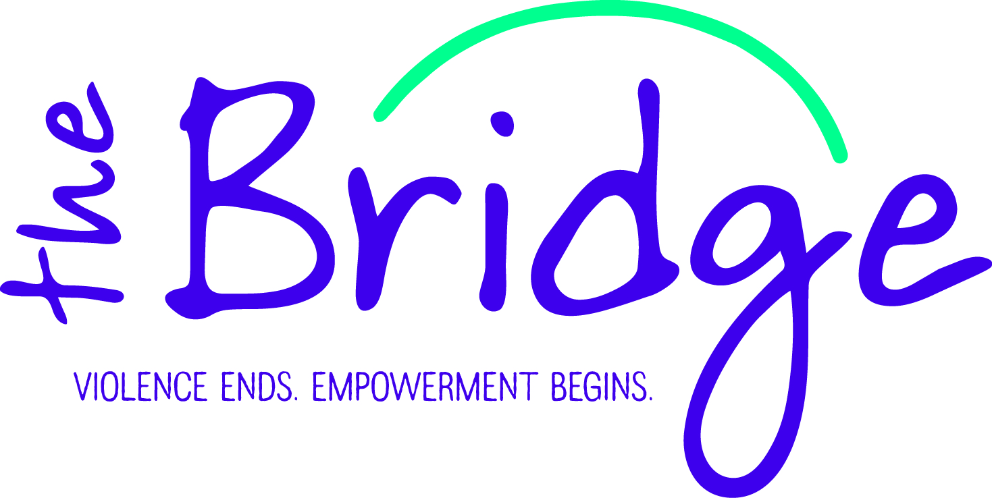
Volunteer Application

PLEASE PRINT AND COMPLETE THE APPLICATION IN FULL DATE:_____________________
Name: _________________________________________________________________________________
(First) (Middle) (Last)

______________________________________________________________________________________
Address City State County Zip Code

Email Address: ________________________________________________ DOB: ______/______/______

Best Contact Phone #: _(______)________________________________________

Work Experience
Organization | Position | Began/Ended

Volunteer Experience
Organization | Position | Began/Ended

Educational Background
_________________________________________________________________________________________

_________________________________________________________________________________________

Personal References
Name | Address | Phone

Have you ever been convicted of a misdemeanor? __________ If so, what? ____________________________
___________________________________________________________________________________________
Have you ever been convicted of a felony? __________ If so, what? __________________________________
___________________________________________________________________________________________
Do you speak any other languages? If yes, which languages and how fluent are you? ___________________________________________________________________________________________
___________________________________________________________________________________________
Why do you want to become a volunteer for The Bridge?
___________________________________________________________________________________________
___________________________________________________________________________________________
___________________________________________________________________________________________
Please explain your understanding and feelings regarding domestic violence: ___________________________________________________________________________________________
___________________________________________________________________________________________
___________________________________________________________________________________________
___________________________________________________________________________________________
Please explain your understanding and feelings regarding sexual assault: ___________________________________________________________________________________________
___________________________________________________________________________________________
___________________________________________________________________________________________
___________________________________________________________________________________________
Have you or a family member or a friend ever been a victim of domestic violence or sexual assault?:
___________________________________________________________________________________________
___________________________________________________________________________________________
___________________________________________________________________________________________
___________________________________________________________________________________________
Because the information throughout training can be graphic and sometimes uncomfortable to talk about, if you are a survivor or close to a survivor, training may trigger some strong emotions within you. Because of this, together we may have to evaluate and decide if volunteering in our program is a good option for you at this time.
Volunteer Interests:
- CRISIS LINE
We can use your listening skills! You can provide a first response to our crisis calls right from your own phone. The crisis line volunteers will be trained to answer crisis calls during non-business hours. These are 8 or 12 hour flexible shifts based on your availability which is communicated with the Volunteer Coordinator. Volunteers will also be trained to provide adequate advocacy to survivors or victims of domestic violence and sexual assault. You will provide support, resources, referrals, and information to callers. Resource materials are provided to each volunteer. Staff back up will always be available. You must be 19 years old and must complete training and background check.

- ENHANCED ADVOCACY/WEEKEND ADVOCATE
Our weekend advocates are on call from Friday at 4 p.m. until Sunday at 4 p.m. There is always a staff member available for back-up and it pays $50/weekend. Duties include receiving direct phone calls from law enforcement and hospital personnel in order to speak to or meet in person with victims of domestic violence and sexual assault. This can entail having to respond in person to a hospital or police station in order to meet with the victim. It also includes making arrangements for victims to be placed in hotels in our service area as needed/appropriate. Our weekend advocates are back-up to the crisis line volunteers for the weekends, and may also have to handle some crisis line calls if the volunteer misses them or if we were unable to have shifts covered on the weekends. This opportunity is available after some crisis line experience.

- OUTREACH
Volunteers assist staff with manning and tearing down booths at county fairs, health fairs and other community outreach events. Distribute brochures, tear-offs, and flyers provided by the Bridge.

- OFFICE ASSISTANCE
Activities may include shredding, copying and assembling packets. Also may include folding brochures and cutting school presentation supplies.

- FUNDRAISING
Help with annual fundraising events (Festival of Hope, Mother’s Day Flowers, etc

- CHILDCARE
The Bridge provides childcare for evening support groups. Childcare volunteers supervise children during meetings and activities, maintaining an atmosphere of non-violence while allowing children to express themselves in a healthy, safe, engaging environment.

- OTHER NEEDS
Mowing, yard upkeep, office cleaning, scoop snow.

What days/times would you be available? _________________________________________________________________________________________
_________________________________________________________________________________________
__

Volunteer Agreement:
- I agree to keep up-to-date on policies and procedures to the best of my ability.
- I agree to be responsible for my shift and find a replacement or contact the volunteer coordinator as soon as possible.
- I will be responsible for reading monthly mailings and be aware of information needed in order to serve effectively on the hotline.
- I will not be under the influence of alcohol or drugs on the day of my shift.
- I will complete necessary forms in a timely manner and turn these forms into The Bridge office as soon as possible after my shift.
Signature: ____________________________________ Date: ________________________
Witness: _____________________________________ Date: ________________________

Confidentiality Agreement
I,________________________________________________, agree to serve as a volunteer for The Bridge and agree to the following:
- The names and specific circumstances of all persons who utilize The Bridge services will be kept confidential. I agree to keep confidential the names and case information of all contacts and to discuss these only with staff, volunteers, and members who assist the client.
- I understand information subpoenaed by the courts is exempt from confidentiality but all subpoenas will be handled by the Executive Director.
- Any information received pertaining to children such as suspected child abuse, neglect or sexual abuse is exempt from confidentiality and should be immediately reported to Child Protective Services and/or law enforcement.
- Any information received regarding threat of harm to oneself or others is exempt and will be reported to appropriate authorities.
- Any breach of confidentiality will result in the immediate dismissal of the violating person.
Signature: ____________________________________ Date: ______________________________
Witness: _____________________________________ Date: ______________________________
- The Bridge reserves the right to release a volunteer from out program at anytime.

