3 Reasons Why Your Firm Needs a Podcast
Profit from the Power of Podcasting

Written by Artie Ruderman, CEO, InnovativeGrowthSolutions

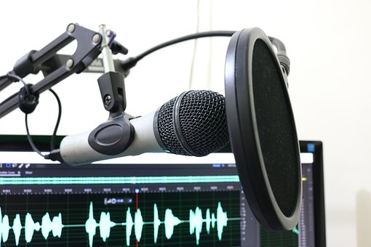
1 We are in the Age of Content: Be Heard & Establish Your Brand
Do You Have a Growing Problem?
Most businesses depend on new business from existing clients and need to acquire additional clients to thrive. Aggressive marketing along with advances in technology and innovation has enabled competition to encroach upon your company’s product and service offerings making developing new business more challenging.

Value-Based Selling
Best practices for developing business has evolved; 82% of shoppers conduct online research before buying.¹ Unlike the two traditional sales methodologies, ‘Selling’, where a salesperson tries to push prospects to make a purchase or ‘Marketing’ which tries to pull prospects to make a purchase, ‘Value-Based Selling’ attracts purchasers by imbuing the reasons your company’s products and services are valuable to them.

Podcasting Establishes Your Business has Value
A podcast with compelling content triggers three purchaser qualifiers: ‘Know - Like – Trust’. A podcast that offers solutions to a prospect’s business issues or enhances their lives connects your company to its target market, increases brand recognition, develops a relationship and establishes your brand as an industry authority.

Interesting Facts
- Podcasting started in the 1980’s and was known then as ‘audioblogging’
- In 2004, the term ‘Podcasting’ started as a blend of iPod and broadcasting

2 Podcasting Levels the Competitive Playing Field
Podcasting is Easy and Economical
Recording a podcast is less complicated and less expensive than producing a video. You can simply talk into a smart phone and upload it to You Tube. If you would like to have a professional production, consider recording at a podcast studio that can enhance the sound quality and provide studio services such as editing – voice overs – jingles and more.

Be Heard & Increase SEO
In addition to posting your podcasts on your website and LinkedIn company profile, expand your connections by linking your podcasts on popular listening networks like, Stitcher - iTunes - Spotify & Google Podcast. To increase opportunities to be heard, ask a podcast studio if they can distribute your podcasts on syndicated channels like IHeartRadio.

A Primer for Producing Your Own Podcast
- Craft Content of interest to your Target Market
- Your Podcast is your firm’s Digital Voice – Imbue it with your company’s personality
  - It can be formal or folksy like Southwest Airlines
- Tips for Professional Production:
  - Editing & individual microphone sound enhancement
  - Voice overs / intros – outros / jingles
- Have a show host & guests who are clients, prospects, industry executives & authorities…
- Distribute to networks to be heard by prospects outside your connections

3 Podcasting is the Media of Choice Today
The Age of Content
Anywhere you are out and about, the chances are you will see people interacting with their smart phones. Just as you are reading this article to leverage what you can learn about podcasting; they are also seeking content to learn or be entertained.

You Can Listen to a Podcast
There is a plethora of marketing options on the internet: email blasts / blogging / videos / vlogging, however, they all demand your visual attention. You can listen to a podcast anytime and anywhere; in a coffee shop or performing a multitude of pursuits; driving, running, walking the dog, mowing the lawn…

- Statistics Worth Knowing*:
- 62 million people listen to podcasts weekly, a 17% increase in 2018 over 2017*
- Facebook had 15 million fewer users in 2018 than in 2017
- 45% of monthly podcast listeners have household income over $75K
- 27% of US podcast listeners have a 4-year college degree vs 19% for US population

*2019 Podcast Stats & Facts posted by Podcast Insight with credit to: Updated stats: Edison Research Infinite Dial 2019 released March 6, 2019. Q1 2018 report from Nielsen, March 20, 2018.

1: As reported in Forbes: New Research Shows Growing Impact of Online Research on In-Store Purchases, by John
Ellett, Feb 8, 2018 credits report from The ROBO Economy (Research Online Buy Offline).

A Podcast based on this article can be heard at ProBusinessChannel.com. To learn more about podcasting or booking a studio visit: www.GlobalPodcastStudios.com.

Artie Ruderman is the CEO of InnovativeGrowthSolutions, a fractional corporate & business development company and Business Director at Pro Business Channel, an internet broadcast network & parent company of Global Podcast Studios

