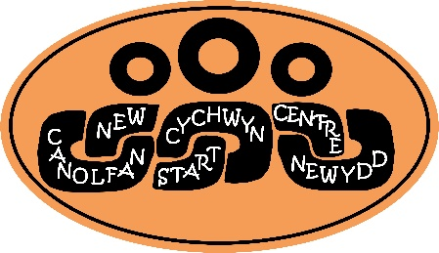
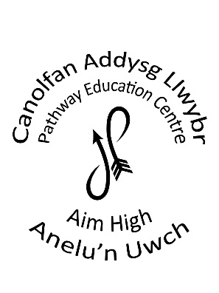
Management Committee Annual Report to Parents and Carers
1.9.2022 - 31.8.2023
Executive Headteacher: Jamie Yorath
Chair of Management Committee: Mr John Mitson

The Management Committee End of term of office
John Mitson November 2026
Simon Anderson September 2025
Gavin Randell July 2027
Angharad Bryn-Jones February 2027
Karen Jenkins February 2027
Joy Jones December 2025
Matthew Dorrance December 2025

Clerk to the Governors: Zoe Burgess
Contact details: Tel. 01597 826402
email: zoe.burgess@powys.gov.uk

Dear Parents and Carers

I am pleased to be writing to you to introduce the Management Committee’s Report for the last school year 2022/23 and hope you will be interested in reading about the continuing progress of both The Pathway Centre (Newtown PRU) and the New Start Centre (Brecon PRU). The PRUs continue to go from strength to strength and has had a number of really positive school visits with the School Improvement Adviser.
This year has seen some changes being made within the leadership of the PRUs, but thankfully through your support and the dedication and hard work of both staff and pupils any impact to the day to day activities of both PRU has been negligible.
The Management Committee would like to thank all the PRU community- all staff, pupils and families for their unprecedented support throughout. Feedback received from all Stakeholders regarding self-evaluation of school was positive with many commenting on the effective communication systems, how well led the school is, the welcome received, the commitment and dedication of staff and the regular updates provided. The staff at both PRUs continue to go above and beyond in all thinks for the pupils and their families.
The School Improvement Plan (SIP) was regularly reviewed to reflect any changing conditions and the following objectives were the focus for the year :
Pupil Referral Units School Improvement Plan 2022 - 2023
Pathways Centre | New Start Centre

We want to thank all our parents and carers for their continued support and commitment to the PRUS and proud that staff will continue to do their best to ensure the finest possible education for all our children and that you will continue to be kept up to date with all new developments. I hope you will find our report of interest. This report always follows the Welsh Government format If you wish to have any further information or to have a meeting with the management Committee, please contact John Miston who is the Chair of the Management Committee.

Context
The PRU comprise of two centres. One located in Newtown, to the North of Powys and the Second located in Brecon to the South of Powys. Both the Newtown PRU – Pathways Education centre and the Brecon PRU – The New Start Centre are forward -looking schools that provide high quality specialist education for pupils aged 5 – 16 with a rage of social, emotional and behavioural difficulties, including those who are medically unfit to attend mainstream education. The Pathways Education Centre is located in the Old Collage adjacent to the Newtown train station. The New Start Centre is situated in the old St. Jospeh’s school building. Both PRUs are run by the Local Authority. The integrated facilities provide pupils with the very best learning opportunities, experiences and resources which support the school as a centre of excellence.

Our Vision
Create a stimulating environment in which all pupils are valued, encouraged and their futures brightened.

Our Mission
Provide a happy environment in our Centre that is caring, nurturing and supportive.
Treat everyone as individuals and encourage them to be ambitious and determined to realise their full potential.
Provide a curriculum that allows our young people to develop skills that allow them to lead responsible lives.
Show young people how to live in a safe way - to develop good social skills and an understanding of others.
Teach our young people what it is to be reliable and trustworthy.

We are fully committed to providing a caring, stimulating and vibrant environment where everyone is encouraged to reach their full potential. We strongly believe in working in close partnerships with parents and carers, the community, children’s services, health professionals and other agencies to support all aspects of a child’s development. Our curriculum is tailored to meet the needs of pupils, with the emphasis upon next steps. Both Centres are English medium schools although all pupils are taught Welsh as a second language at a level appropriate to their abilities through immersive experiences. Some Welsh speaking staff are able to support pupils whose home/first language is Welsh.
In 2022-23 pupils were grouped in each PRU across five classes.. Each class can have up to eight pupils with one teacher and allocated teaching assistants depending on individual needs within the classes. The centre’s also saw the opening of its first KS2 provision at the New Start Centre, with the one in Pathways due to open in September 2023. This includes one class with one teacher and allocated teaching assistants based on need. Admission to the KS2 provision is the same as admission to the PRUs as a whole. The PRUs operates the same school term dates as other Powys local authority schools. Dates can be found on the Powys County Council website: www.powys.gov.uk and on the school website: www.newstartcentre.co.uk or www.pathwayeducationcentre.co.uk
The School Curriculum
The curriculum in Wales is changing. All pupils access a broad and balanced curriculum and this will continue to evolve as the new curriculum is rolled out (September 2023). All of our pupils will continue to access the Digital Competency Framework(DCF) and Areas of Learning and Experience. The curriculum will continue to be modified to meet individual needs. Pupils aged 5 – 14 will follow the new Curriculum for Wales (CFW).
There are four core purposes (underpin the design & development for Curriculum Wales 2022):
Healthy, confident individuals, ready to lead fulfilling lives as valued members of society
Enterprising, creative contributors, ready to play a full part in life and work
Ethical informed citizens of Wales and the world
Ambitious, capable learners, ready to learn throughout their lives
There are six Areas of Learning and Experience (AoLEs):
Expressive Arts
Health and Well-being
Humanities
Languages, Literacy and Communication
Mathematics and Numeracy
Science and Technology

Pupils aged 14 – 16 will continue to follow the current GCSE setup completing qualification in:
- English
- Maths
- Numeracy
- Science
- Welsh Baccalaureate
- PE
- Btec Sweet
- Agored PSE
- Agored Work Related Experience
- Lessons in Financial Education
Policies
Statutory policies are available through either Centre and many can be accessed through the documents library on the school website (see above). They are reviewed regularly.

Destinations of School Leavers
In July 2023 there were 12 leavers across both Centres
Provision | Male | Female
Collage (Brecon) | 3 | 0
Collage (Newtown) | 1 | 3
Collage (Outside of Brecon) | 2 | 0
Work Place | 3 | 0

Attendance:
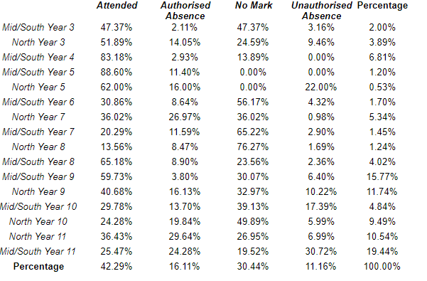
Staff Professional Development
Staff attended a range of whole school and individual courses; access included in-house training, courses hosted by external providers and also on-line virtual work streams and training opportunities:
Topic | No. of staff
People Handling Refresher Training  Wales Safeguarding Procedures  Cyber security and GDPR online training (mandatory training)  Office Health and Safety for office based staff (mandatory training)  Fire awareness training  VAWDASV (mandatory training)  Prevent (mandatory training)  Attention Autism  Forest Schools leader training  Agored Cymru training online  Mental Health Training online  Emotion coaching  RSE Statutory Framework  MELSA online  Team Teach refresher training  IOSH Health and Safety  First Aid Mental Health  Thrive CPD  Mental Health Awareness  Functional Behaviour  MISP  .Breathe  Paws B  .B | Numerous (as identified)

Community Links
The management Committees are fully supportive of both PRUs and their links with their respective local communities. From May 2022 there have been occasional visits from the police who support aspects of the curriculum.
During the summer term 22 off-site visits were able to commence. One class visited Powys Castle and others visited the local community to eat out. It is anticipated in September 2023 that community links will be strengthened. The PRU does look to plan to increase Expressive Arts opportunities for pupils and it is hoped that external providers e.g. musicians, artists etc...will be able to come in and deliver workshops to cohorts of pupils. This will be a really exciting step forward.

Special Education Needs (SEN)/Additional Learning Needs (ALN)
All pupils’ have School IDPs and those with LA IDPs are reviewed annually. All pupils have their ALN needs met through the provision of trained staff, specialist resources, and differentiated curriculum. Close working partnerships with other agencies support improved pupil outcomes and wellbeing.
A few pupils may be considered as More Able and Talented in relation to the majority of pupils with ALN in both PRUs; these pupils may show greater ability in one subject area or they may show talent artistically, in sport or in performance. We aim to support pupils where we can with these skills and talents through links with mainstream schools and through in-house additional provision.
During the academic year of 2022/23 and now onwards in line with the ALN Act and ALN Transformation pupils with Statements, or are School Action Plus will be transferring over to Individual Development Plans which will be an online plan accessible to all professionals working with pupils with ALN. This is through a platform called TYFU. All in the PRUs have a profile on the newly implemented Tyfu platform. The aim being to store information in one central place that is accessible to those permitted access. The PRUs will provide you with updates as these are published.

Strategic Equality
Both Pathways Education Centre and New Start Centre continues to be committed to ensuring equality of education and opportunity for all pupils, staff, parents and carers receiving services from the school, irrespective of disability, race, gender, age, sexual orientation, religion or belief, gender reassignment, pregnancy & maternity, marriage and civil partnership. The PRUs promotes a culture of inclusion and diversity in which all those connected to the school feel proud of their identity and able to participate fully in school life.

The achievement of pupils continues to be monitored and data captured is used to support pupils, raise standards and ensure inclusive teaching. The PRUs tackle discrimination by the positive promotion of equality, challenging bullying and stereotypes and creating an environment which champions respect for all. At the PRUs diversity is a strength, which should be respected and celebrated by all those who learn, teach and visit here.

