


New Start Centre
(PRU South)
Silver Street,
Brecon,
Powys
LD3 8BL
Pathway Education Centre
(PRU North)
The Old College
Off Station Road
Newtown
Powys
SY16 1BE
Powys pupil referral service
CCTV Policy

1. PURPOSE
The Purpose of this policy is to regulate the management, operation and use of the CCTV system (Closed Circuit Television)
CCTV systems are installed in premises for the purpose of enhancing security of the building and its associated equipment as well as creating a mindfulness among the occupants, at any one time, that a surveillance security system is in operation within and/or in the external environs of the premises during both the daylight and night hours each day.
CCTV surveillance at both Pathway Centre (Newtown Pupil referral unit) and New Start Centre (Brecon Pupil Referral Unit) is intended for the purposes of:
- protecting the centres buildings and centre assets, both during and after centre hours;
- promoting the health and safety of staff, pupils and visitors as well as for monitoring student behaviour;
- preventing bullying;
- reducing the incidence of crime and anti-social behaviour (including theft and vandalism);
- supporting the police in a bid to deter and detect crime;
- assisting in identifying, apprehending and prosecuting offenders; and
- ensuring that the Centre rules are respected so that the Centre can be properly managed.
The system does not have sound recording capability.
The CCTV system is owned and operated by the Centre, the deployment of which is determined by the Centre’s leadership team.
The introduction of, or changes to, CCTV monitoring will be subject to consultation with staff and members of the Centre management committee.
The Centre’s CCTV is registered with the Information Commissioner under the terms of the Data Protection Act 2018 and the General Data Protection Regulation (GDPR) 2016/679.
All authorised operators and employees with access to images are aware of the procedures that need to be followed when accessing the recorded images. All operators are made aware of their responsibilities in following the CCTV Code of Practice. All employees are aware of the restrictions in relation to access to, and disclosure of recorded images.

2. SCOPE
This policy relates directly to the location and use of CCTV and the monitoring, recording and subsequent use of such recorded material. The Centre complies with the Information
Commissioner’s Office (ICO) CCTV Code of Practice to ensure it is used responsibly and safeguards both trust and confidence in its use.
CCTV warning signs will be clearly and prominently placed at the main external entrance to the Centre. Signs will contain details of the purpose for using CCTV.
In areas where CCTV is used, the Centre will ensure that there are prominent signs placed within the controlled area. The planning and design have endeavoured to ensure that the system will give maximum effectiveness and efficiency, but it is not guaranteed that the system will cover or detect every single incident taking place in the areas of coverage.
CCTV monitoring of public areas for security purposes will be conducted in a manner consistent with all existing policies and related legislation. Video monitoring of public areas for security purposes within centre premises is limited to uses that do not violate the individual’s reasonable expectation to privacy. Information obtained in violation of this policy may not be used in a disciplinary proceeding against an employee of the Centre or a student attending the Centre. All CCTV systems and associated equipment will be required to be compliant with this policy following its adoption by the Centre.
CCTV monitoring will never be used in any observing or monitoring a member of staff’s performance.
Recognisable images captured by CCTV systems are ‘personal data’. They are therefore subject to the provisions of the General Data Protection Regulation and Data Protection Act 2018

3. LOCATION OF CAMERAS
The cameras are sited so that they only capture images relevant to the purposes for which they have been installed (as described above), and care will be taken to ensure that reasonable privacy expectations are not violated. The Centre will ensure that the location of equipment is carefully considered to ensure that the images captured comply with the legislation. The Centre will make every effort to position the cameras so that their coverage is restricted to the Centre premises, which includes both indoor and outdoor areas.
CCTV will NOT be used in classrooms but in limited areas within the Centre that have been identified by staff and pupils as not being easily monitored.
Members of staff will have access to details of where CCTV cameras are situated.
CCTV Video Monitoring and Recording of Public Areas may include the following:
- Protection of centre buildings and property: The building’s perimeter, entrances and exits, lobbies and corridors, special storage areas, cashier locations, receiving areas for goods/services
- Monitoring of Access Control Systems: Monitor and record restricted access areas at entrances to buildings and other areas
- Verification of Security Alarms: Intrusion alarms, exit door controls, external alarms
- Video Patrol of Public Areas: Parking areas, Main entrance/exit gates, Traffic Control
- Criminal Investigations (carried out by the police): Robbery, burglary and theft surveillance

5. ACCESS TO CCTV IMAGES
Access to recorded images will be restricted to the staff authorised to view them and will not be made widely available. Supervising the access and maintenance of the CCTV System is the responsibility of the Headteacher. The Headteacher may delegate the administration of the CCTV System to another staff member. When CCTV recordings are being viewed, access will be limited to authorised individuals on a need-to-know basis.

6. SUBJECT ACCESS REQUESTS (SAR)
Individuals have the right to request CCTV footage relating to themselves under the Data Protection Act and the GDPR.
All requests should be made in writing to the Data Protection Officer. Individuals submitting requests for access will be asked to provide sufficient information to enable footage relating to them to be identified. For example: time, date and location.
The applicant may view the CCTV footage if available.
The Centre will respond to requests within 30 days of receiving the request.
The Centre reserves the right to refuse access to CCTV footage where this would prejudice the legal rights of other individuals or jeopardise an on-going investigation.

7. ACCESS AND DISCLOSURE OF IMAGES TO THIRD PARTIES
There will be no disclosure of recorded data to third parties other than authorised personnel such as the Police.
If an order is granted by a Court for disclosure of CCTV images, then this should be complied with. However, very careful consideration must be given to exactly what the Court order requires. If there are any concerns as to disclosure, then the Data Protection Officer should be contacted in the first instance and appropriate legal advice may be required.
Requests for images should be made in writing to the Data Protection Officer.

8. RESPONSIBILITIES
The Headteacher will:
- Ensure that the use of CCTV systems is implemented in accordance with this policy.
- Oversee and co-ordinate the use of CCTV monitoring for safety and security purposes within the Centre.
- Ensure that all existing CCTV monitoring systems will be evaluated for compliance with this policy.
- Ensure that the CCTV monitoring is consistent with the highest standards and protections.
- Review camera locations and be responsible for the release of any information or recorded CCTV materials stored in compliance with this policy.
- Maintain a record of access (e.g. an access log) to or the release of tapes or any material recorded or stored in the system.
- Ensure that monitoring recorded tapes are not duplicated for release.
- Ensure that the perimeter of view from fixed location cameras conforms to this policy both internally and externally.
- Give consideration to both students and staff feedback/complaints regarding possible invasion of privacy or confidentiality due to the location of a particular CCTV camera or associated equipment.
- Ensure that all areas being monitored are not in breach of an enhanced expectation of the privacy of individuals within the Centre and be mindful that no such infringement is likely to take place.
- Ensure that external cameras are non-intrusive in terms of their positions and views of neighbouring residential housing and comply with the principle of “Reasonable Expectation of Privacy”
- Ensure that monitoring tapes are stored in a secure place with access by authorised personnel only
- Ensure that images recorded on tapes/DVDs/digital recordings are stored for a period not longer than 31 days and are then erased unless required as part of a criminal investigation or court proceedings (criminal or civil).
- Ensure that camera control is solely to monitor suspicious behaviour, criminal damage etc. and not to monitor individual characteristics.
- Ensure that camera control is not infringing an individual’s reasonable expectation of privacy in public areas.

9. DATA PROTECTION IMPACT ASSESSMENTS AND PRIVACY
CCTV has the potential to be privacy intrusive. The Centre will perform a Data Protection Impact Assessment when installing or moving CCTV cameras to consider the privacy issues involved with using new surveillance systems to ensure that the use is necessary and proportionate and address a pressing need identified.

10. POLICY REVIEW
The Data Protection Officer is responsible for monitoring and reviewing this policy. This policy will be reviewed annually. In addition, changes to legislation, national guidance, codes of practice or commissioner advice may trigger interim reviews.

New Start Centre - Brecon PRU Camera locations.

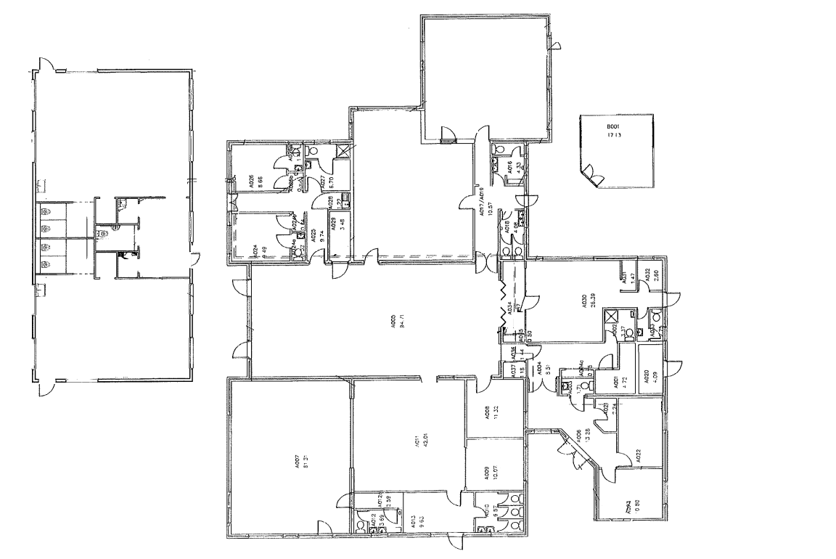

Pathway Centre – Newtown PRU Camera locations
