AddThis Sharing Buttons
Share to FacebookShare to TwitterShare to EmailShare to More

The Price is Right
In this Sunday school game, children guess the price of several items and discover the real price for Heaven.

TOPICS:
Heaven, Salvation

MATERIALS:
8 small items (see below)
1 Bible, 10 large index cards
1 heaven poster (Create)
Tally sheet for each team or child (create)
Treats (optional)

DURATION:
Approximately 15 minutes

PREPARATION:
Purchase 8 items, or find inexpensive items from around the house, like a bottle of lotion, mirror, sponge, candy bar, box of soap, etc. Give each item a value (price) close to the actual cost and write it down in black ink on one side of a large index card. On the other side in red ink, write down an estimated amount that is either slightly higher or slightly lower than the actual price. Try to have about half of the estimated amounts higher, and half lower. Fold the index cards into tents so the red estimated amounts are showing.
Make a card for the Bible also, with the actual value being what the Bible may have actually cost, and the estimated amount slightly higher. Then make a card for the heaven poster, with the actual value being $0 and the estimated amount $10,000.
Display all 10 items in a row on a table with the Bible in the 9th spot and Heaven in the 10th spot as shown in the following example:
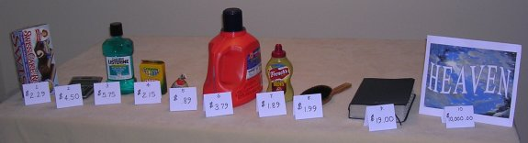

WHAT YOU WILL DO:
Pair up the kids, or make small teams and give each team a tally sheet. (You can also do this individually, but the kids will have more fun working together) As you point to the first item, have the kids decide if the price shown is higher or lower than the actual price. Have them check the box accordingly on their tally sheet. Once they have made their choice, turn over the card to show the actual price and see if they got it right. Do the same for the rest of the items, one by one, as the kids keep score. Ham it up as a game show host might do, describing each item, etc.
Have the kids guess if the actual price of the Bible is higher or lower, but before revealing the actual price, stop to see how well the kids are doing so far. Ask if any team got eight correct, seven, six, etc. Then turn over the Bible price. Whether the kids said the actual price is higher or lower doesn’t really matter. Explain that even a Bible has a price, and can be bought.
Last, have them guess if the actual price for Heaven is higher or lower than $10,000. The price of Heaven is important. Tell the children not to consider only the poster, but Heaven being the real thing. Most likely, some of the teams will guess that the price of heaven is higher, much higher than $10,000. Some adults may too. As you turn over the card to reveal the actual price of $0, explain how Heaven is absolutely free. Not even one hundred thousand million dollars can buy Heaven. Did anyone get that right? Give a special treat to anyone who did.

