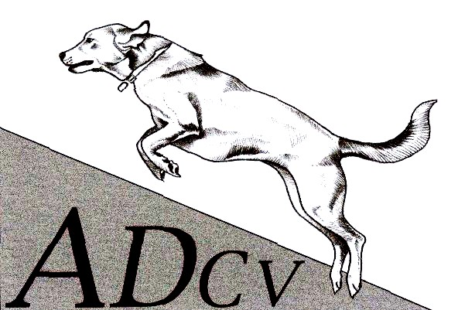
AGILITY DOG CLUB OF VICTORIA Inc.
ACN A00334935
P.O. Box 1141, Altona Meadows 3028
Joining & Membership Renewal Form 

Welcome to the Agility Dog Club of Victoria
In order to protect your dog, it must be vaccinated. Evidence of vaccinations or Titre test results must be provided for viewing. All dogs must be registered with your local Council.
Agility Dog Club of Victoria Inc. Fee Schedule
Annual Membership (Pro-rata for 6 mths.) |  | New Members * | *Joining fee waived for Foundation Course members. | Dog Training Fee
Annual Fee: |  |  |  | First Dog Fee: | $nil
VCA Member Fee: | $50.00 | Joining Fee: | $40.00 | Each Additional Dog Fee: | $5
Non VCA Member Fee: | $58.00

Member’s Contact Details |  |  |  | ADCV Bank Account Details
First Name: |  |  |  | Bank: | Bendigo Bank
Surname: |  |  |  | Name: | Agility Dog Club of Victoria
Postal Address: |  |  |  | BSB: | 633-000
Email Address: |  |  |  | No.: | 127479723
Facebook Email:
Age if under 18: |  |  |  | Emergency Contact’s Details
Phone/Contact: |  |  |  | Name:
Accept Contact | Use my contact details to advise me  of club news or for notifications | Yes |  | Phone:

Information About Your Dog(s)
 | First Dog Included | Second Dog $5 | Third Dog $5
Dog’s Name:
Date of Birth: | / / | / / | / /
Breed Description:
Colour:
Vaccination Next Due: | / / | / / | / /

Affiliate Information
Are you a current financial member of the Victorian Canine Association (VCA)? | Yes, Membership No.  No – Additional VCA Insurance Fee $8 Per Year
Are you a member of another VCA Affiliated Club? | Yes No
If yes, do you wish to nominate ADCV as your primary* club?  *Note it is necessary to nominate ONE dog club affiliated with the VCA as your primary club. | Yes No
Do you hold a current Level 2 First Aid Certificate? | Yes No

Declaration | Signature
I have read and hereby agree to abide by the attached Rules and Regulations of the Club.

Office Use
Starting Date: | / / | Membership Class:
 | Member database | Receipt | Vaccination confirmed

