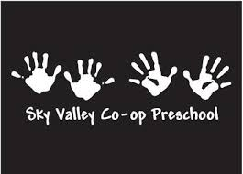
Our Preschool, at a Glance

Our cooperative preschool program is operated by a group of parents who have taken an active role in their child’s first educational experience. The philosophy behind our school is that young children learn best through active exploration in an age-appropriate environment. Recent studies of child brain development have indicated children learn best through experimental, child-directed play. Sky Valley Cooperative Preschool offers a classroom rich in activities that support this philosophy.

The size of the 3-5 group shall be limited to a maximum of 16 students per class session. The toddler group shall be limited to a maximum class size of 12.

Parent requirements are as follows:
- Stay current with monthly tuition and annual dues.
- Attend mandatory parent meetings (monthly for the 3-5 class, quarterly for the toddler class).
- Participate in parent education (typically held in conjunction with parent meetings).
- Actively participate within the classroom one day per week per child for the 3-5 class, or once weekly for the toddler class.
- Provide snack on a rotating basis.
- Participate in fundraising activities planned by the preschool (typically our annual auction, held in the spring).
- Participate in classroom set up prior to the beginning of the school year as needed and in pack-out at the end of the year.
- Assist in cleaning the classroom on a rotating basis.
- Serve on a parent committee (3-5 class only).

Sky Valley Cooperative Preschool
www.skyvalleypreschool.com
skyvalleypreschool@gmail.com
PO Box 691 – Sultan, WA 98294

