**Sales Booklet**

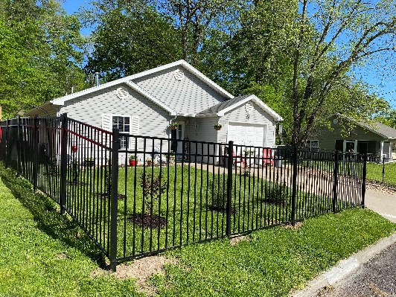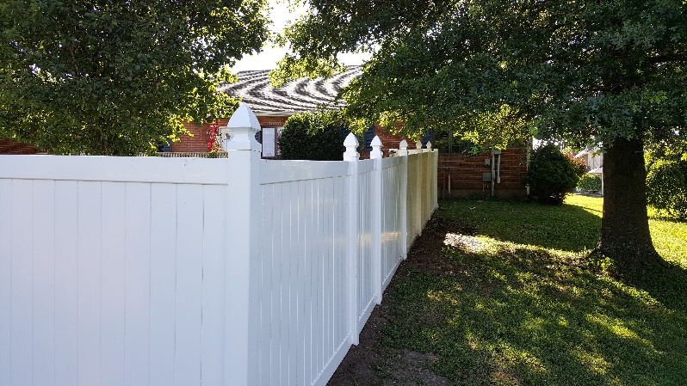

**(877) 366-2340 or (816) 622-3398 https://GetYourFenceOn.com**

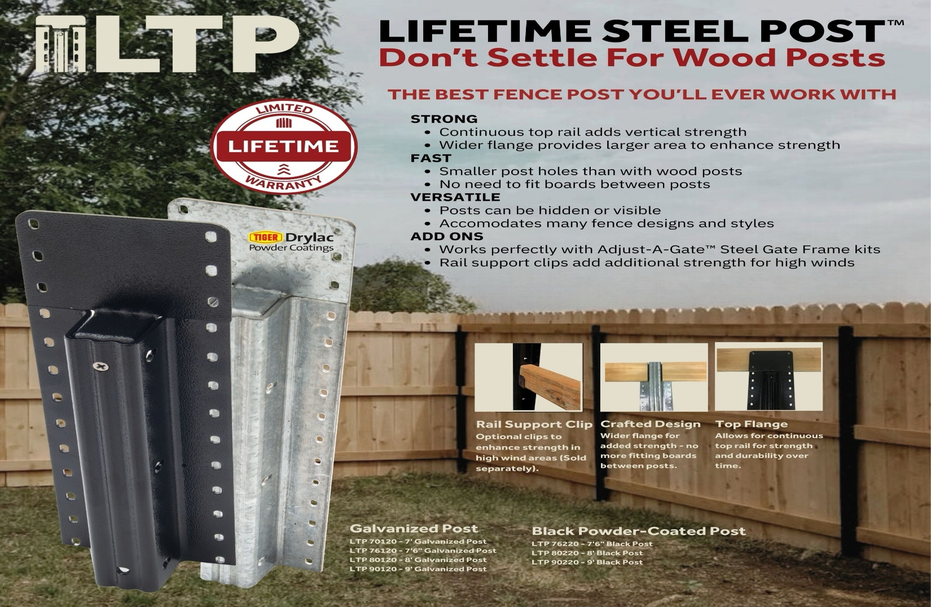

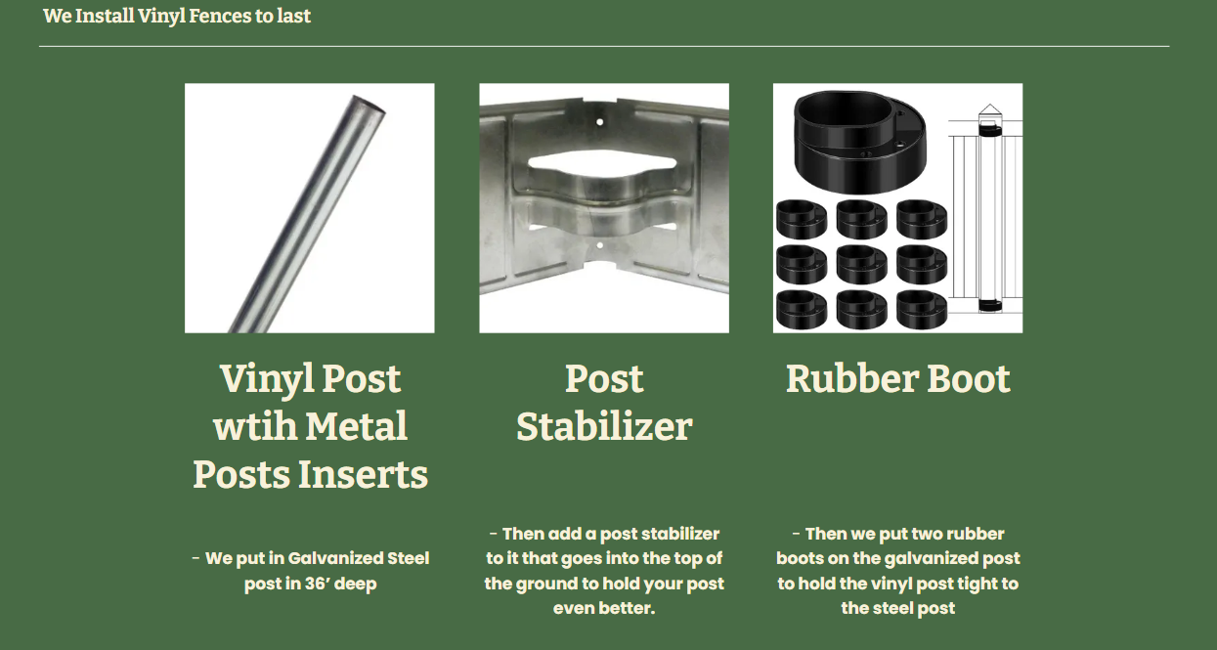

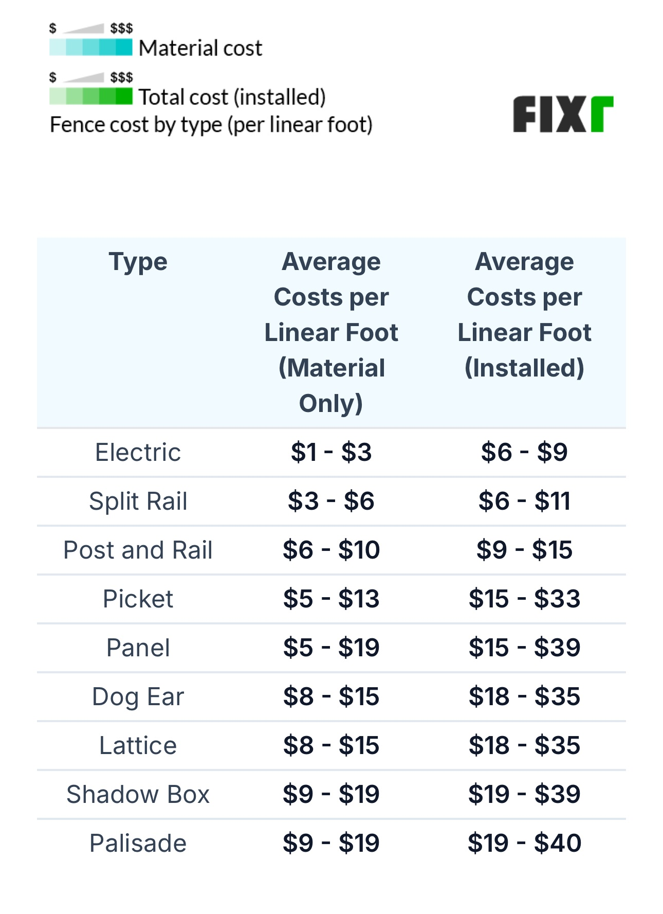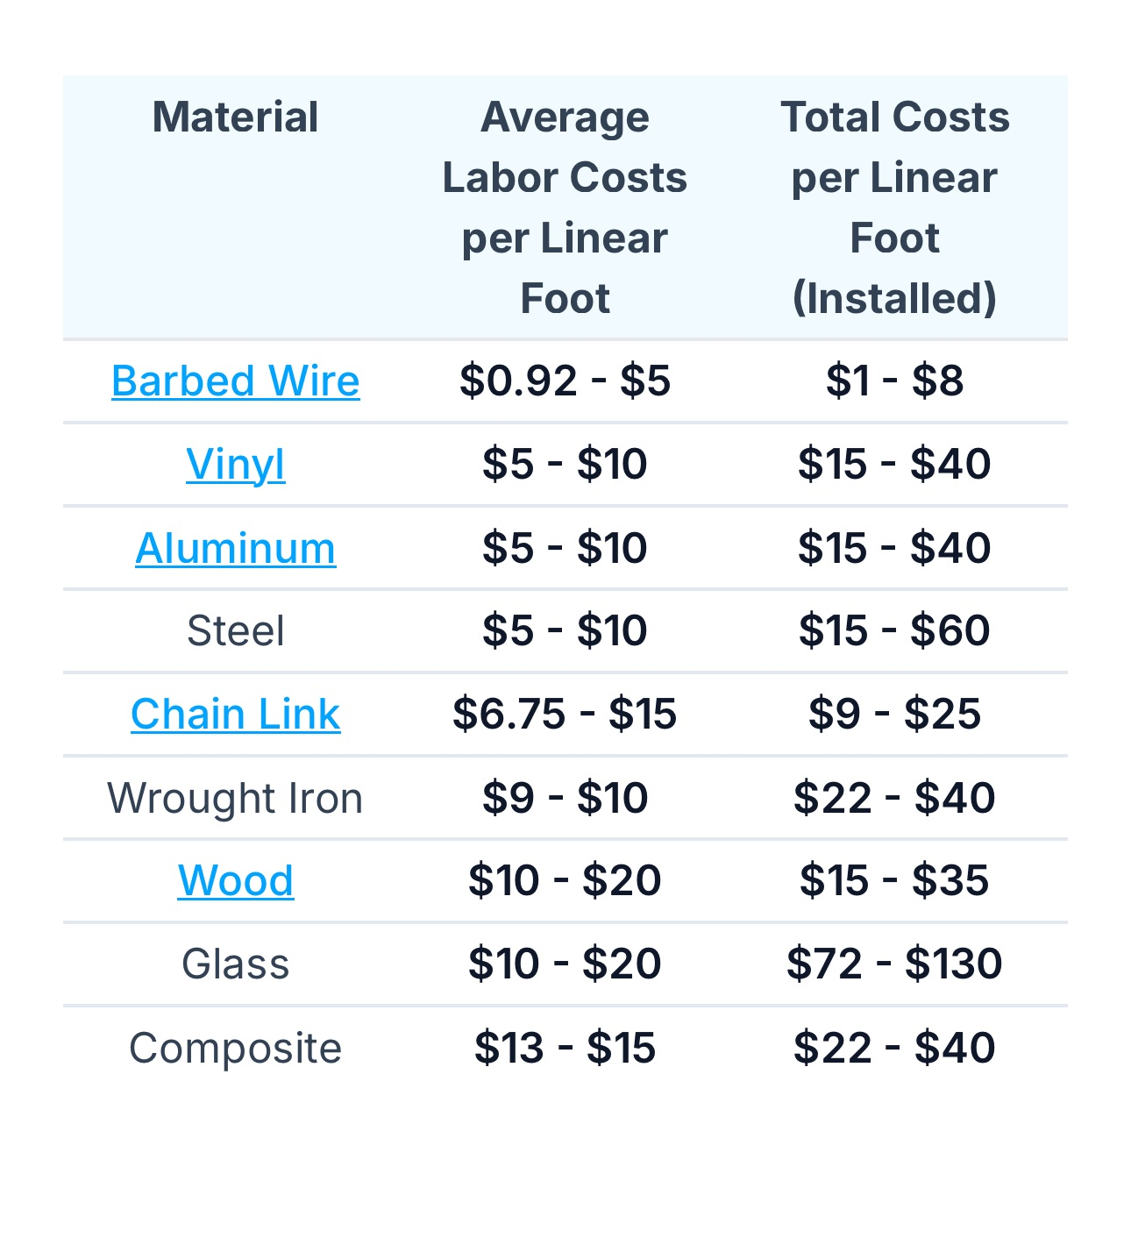

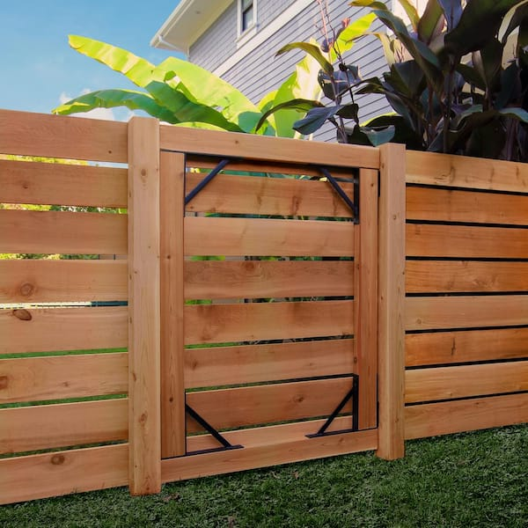

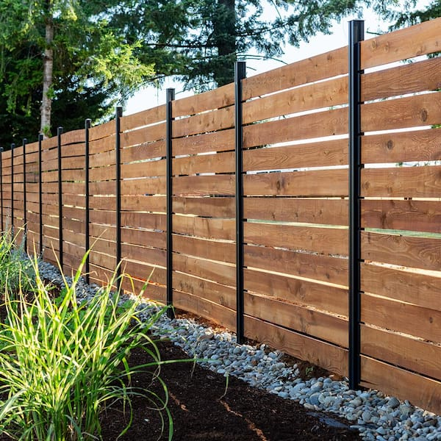

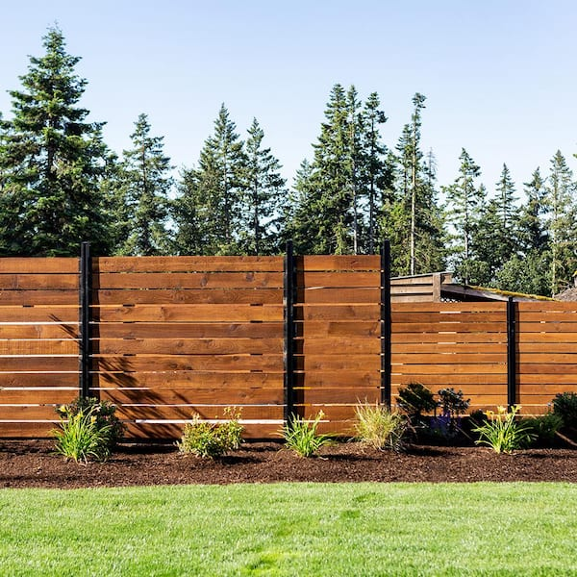

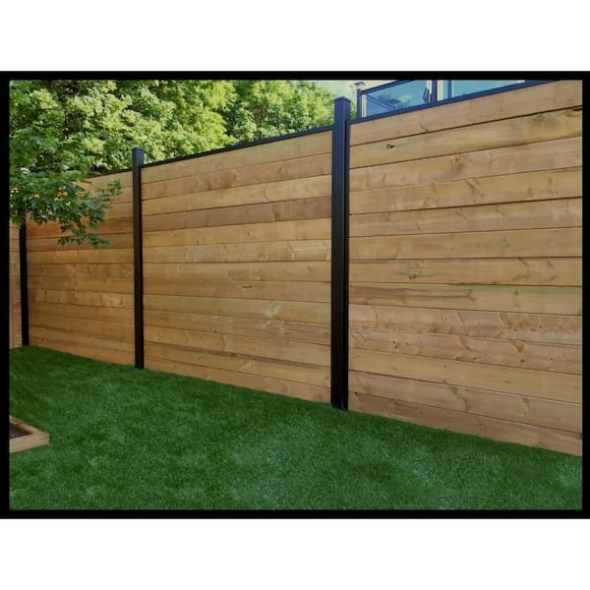

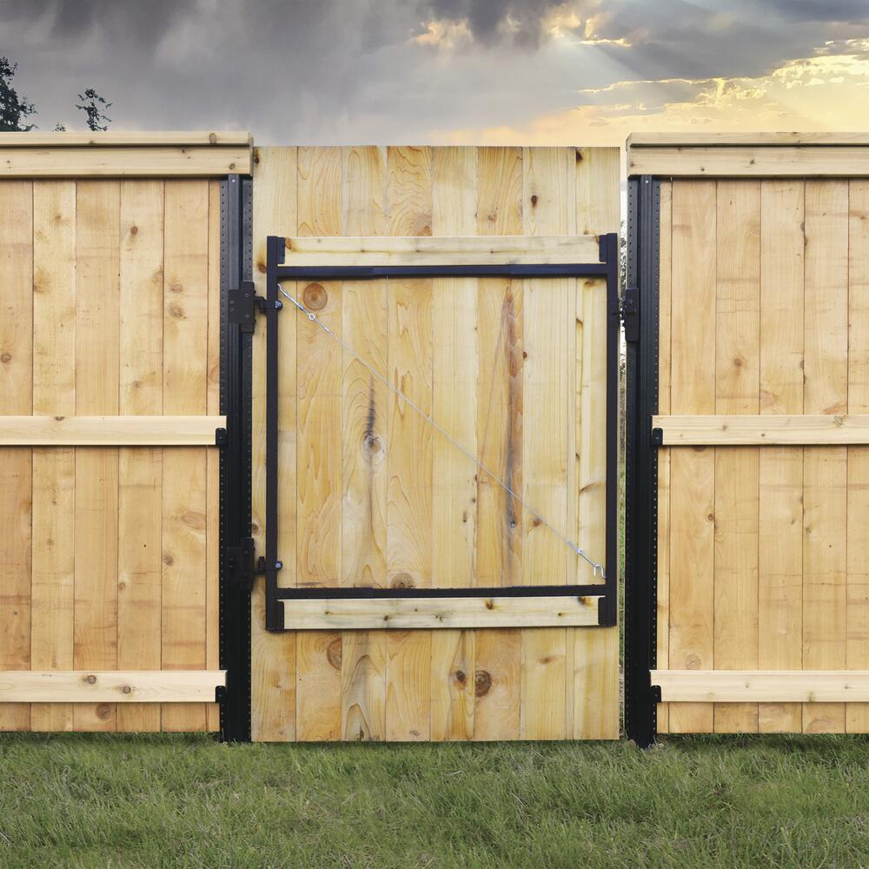

**Severe Weather Pressure Treated Southern yellow pine Dog ear Fence Picket**

**“Lowe’s”**

**5/8 x 5 ½ x 6’ # 202922 $ 1.90**

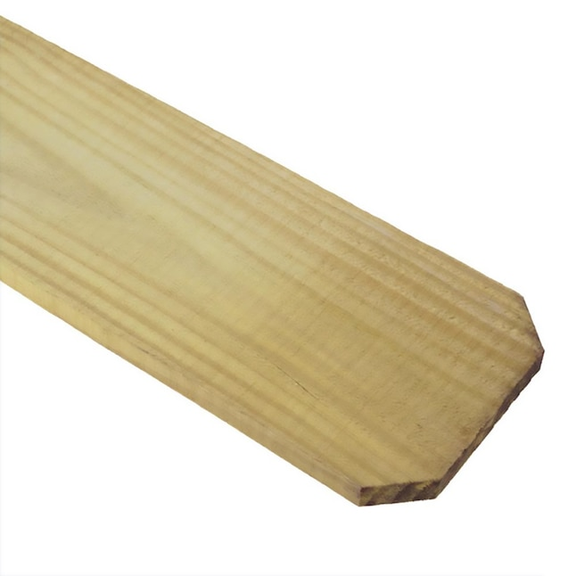

**Western red cedar Dog ear Fence Picket**

**“Lowe’s”**

**1x4x4’ # 1718 $ 1.98**

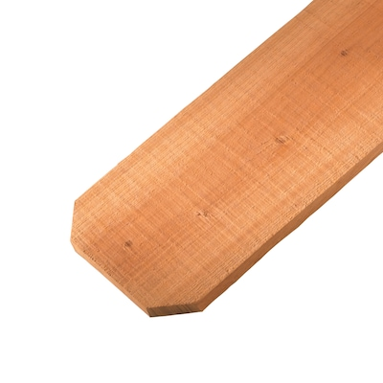

**Cedar Dog ear Pickets**

**“Lowe’s”**

**1x6x6’ # 74422 $ 3.58**

**1x6x8’ # 635506 $ 4.37**

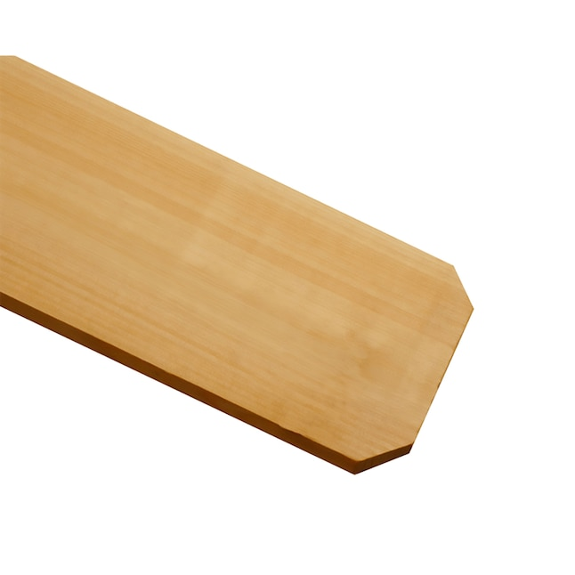

**AC2 Dog Ear Fence Picket**

**“Menards”**

**1x6x4 # 1732156 $ 1.89**

**1x6x6 # 1732157 $ 2.08**

**1x6x8 # 1732158 $ 4.98**

**Cedar Pickets Dog Ear**

**“Menards”**

**1x6x4 # 1731252 $ 2.98**

**1x6x6 # 1731257 $ 3.58**

**1x6x8 # 1731259 $ 4.78**

**Red Cedar Pointed Fence Picket**

**“Menards”**

**1x4x4 # 1731394 $ 2.19**

**Cedar French Gothic Fence Picket**

**“Menards”**

**1x4x6 # 1731417 $ 4.19**

**Treated Green Pressure Treated Boards**

**“Menards”**

**5/4x6x4’ # 1110290 $ 2.99**

**5/4x6x6’ # 1110300 $ 4.49**

**5/4x6x8’ # 1110313 $ 5.99**

**5/4x6x10’ # 1110326 $ 8.79**

**5/4x6x12’ # 1110339 $ 11.61**

**5/4x6x16’ # 1110355 $ 16.39**

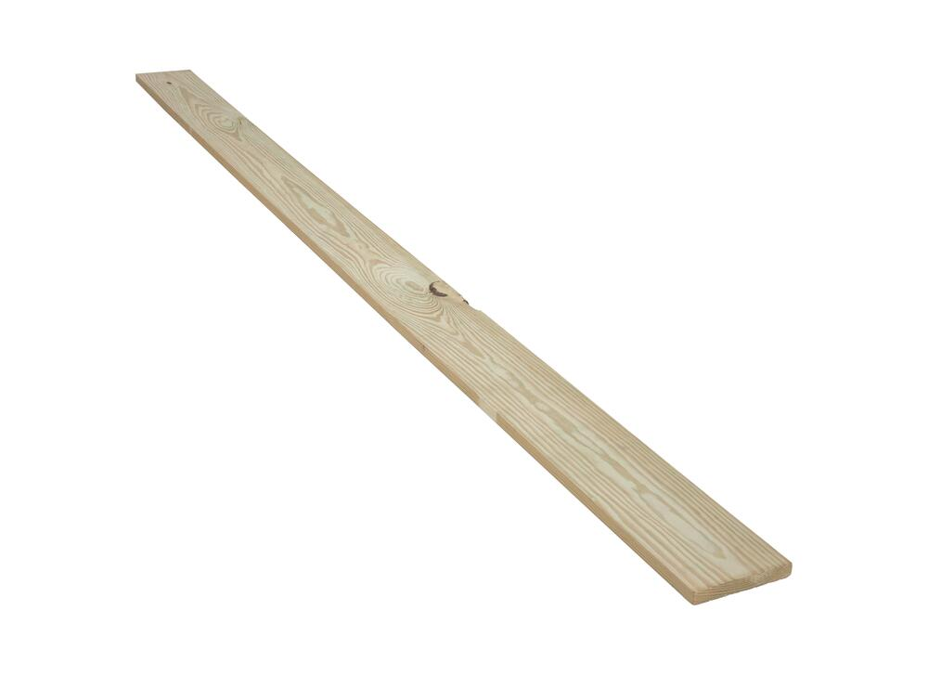

**Premium Furring Strips**

**“Lowe’s**

**1 x 4 x 8’ #4510 $ 2.12**

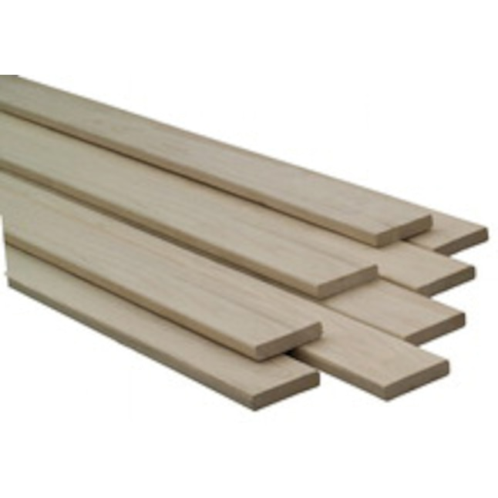

**AC2® CedarTone Premium Dog Ear Fence Picket**

**“Menards”**

**1x6x6’ # 1732160 $3.89**

**1x6x8’ # 172299 $ 4.99**

**Composite Fencing Boards**

**Peruvian Teak Composite Fence Pickets**

**“Home Depot”**

**1/2x6x6 # 1010270857 $16.48**

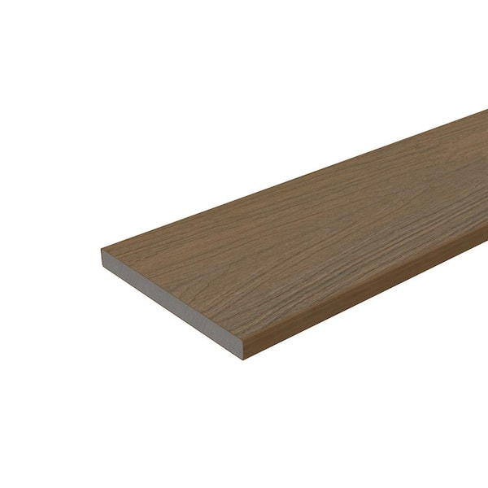

**UltraDeck 6’ Composite Fence Picket Hickery**

**“Menards”**

**3/8 x 5 1/8 x 6’ # 1727002 $9.99**

**3/8 x 5 1/8 x 8’ # 1727011 $ 12.99**

**UltraDeck® 2 x 4 x 67-3/4"Composite Fence Rail Sleeve**

**“Menards”**

**2 x 4 x 67 ¾ # 1727020 $ 11.99**

**Infinity Euro Black Rose Composite Fence Picket**

**“Lowes”**

**5x6 ítem #636800 $ 34.57**

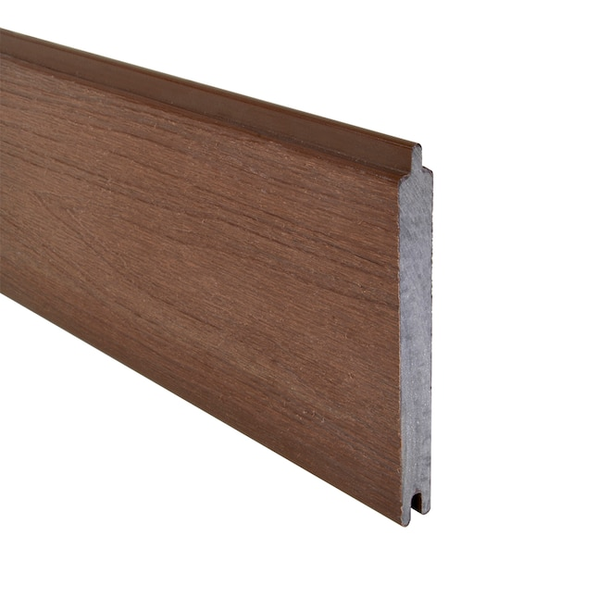

**Infinity Euro Black Aluminum Composite Fence Picket**

**“Lowes”**

**6x6 item #636795 $ 56.53**

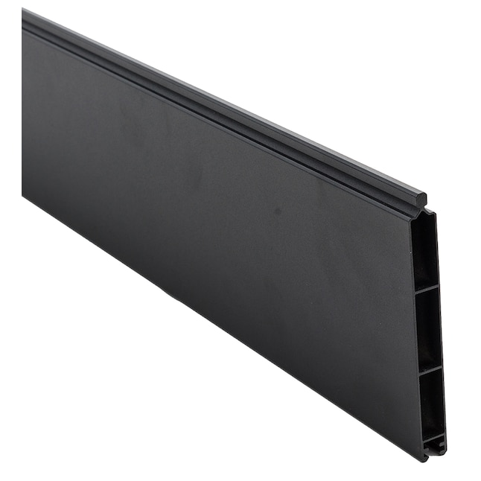

**Infinity Euro Oxford Grey Composite Fence Picket**

**“Lowes”**

**6x6 item #66798 $ 37.04**

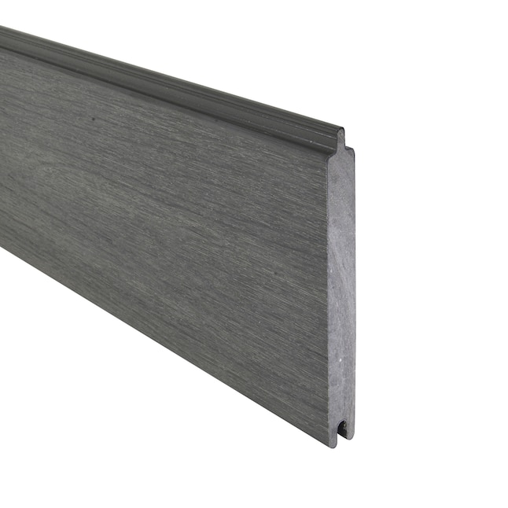

**Infinity Euro King Cedar Composite Fence Picket**

**“Lowes”**

**6x6 item #636799 $ 34.57**

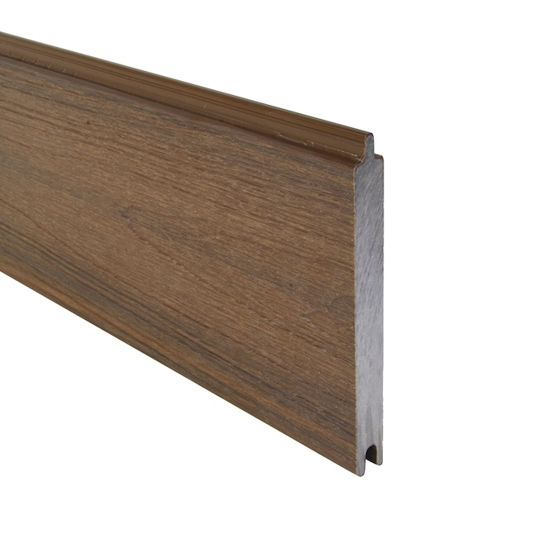

**Infinity Euro King Cedar Composite Fence Gate**

**“Lowe’s”**

**6x4 Item # 5285462 $ 784.81**

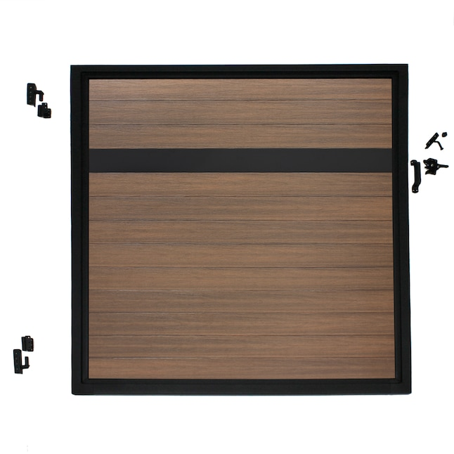

**Infinity Euro Black Metal Line Fence Mounting Bracket for Composite fence**

**“Lowe’s”**

**71” Item #636804 $ 51.35**

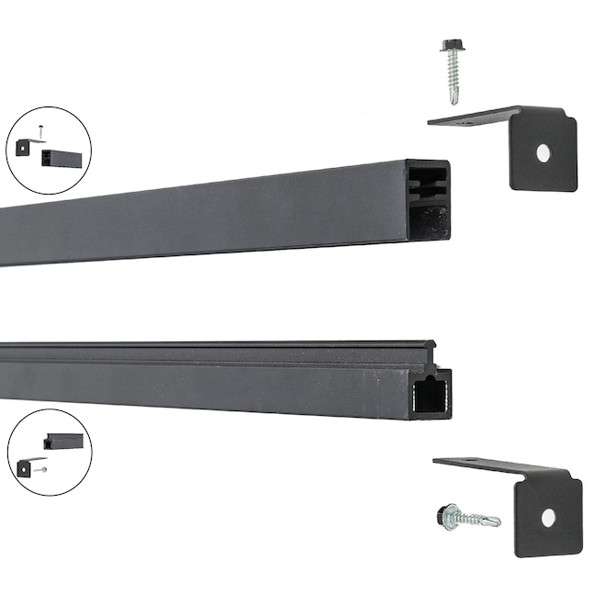

**Infinity Euro King Cedar Privacy Composite Fence Panel**

**“Lowe’s**

**6x6 Item # 5285443 $520.52**

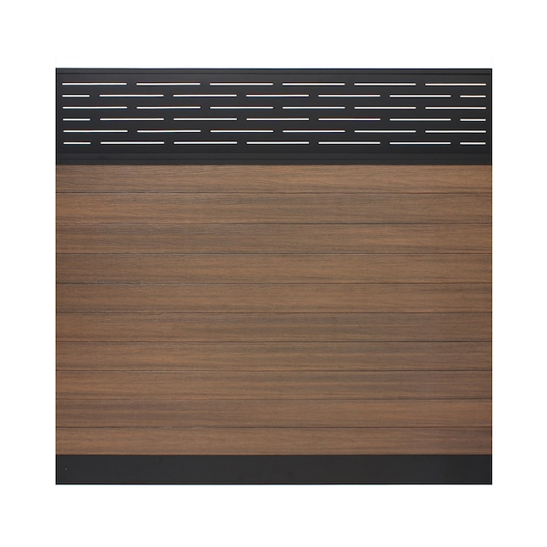

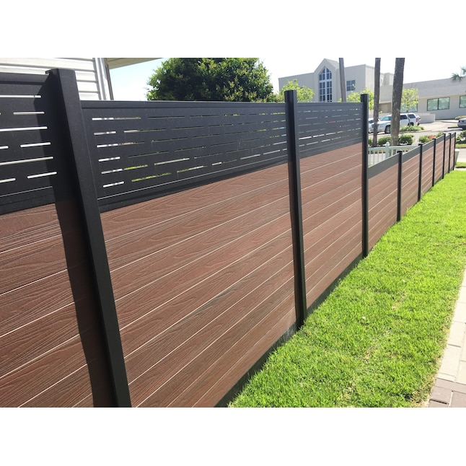

**Infinity Euro King Cedar Privacy Composite Fence Panel**

**“Lowes”**

**6x6’ Item # 5285458 $ 387.10**

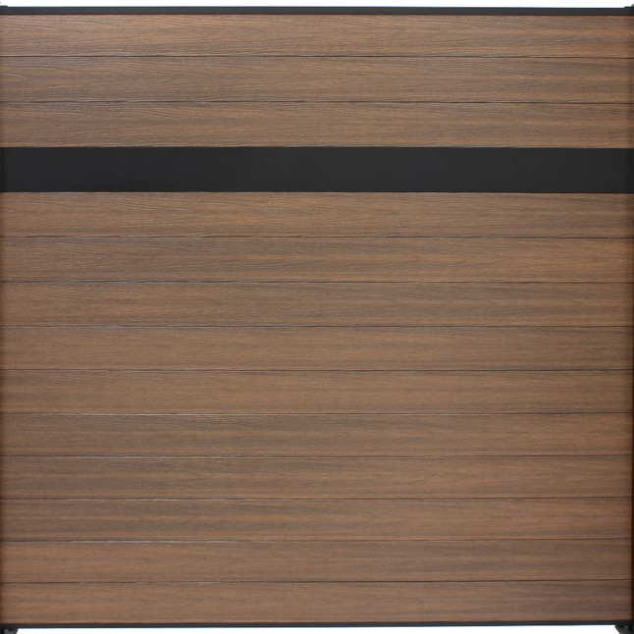

**Vinyl Fencing**

**Belmont Vinyl Fence Panel**

**“Menards”**

**White 6x6’ # 1728601 $ 79.68**

**Tan 6x6’ # 1728701 $ 89.99**

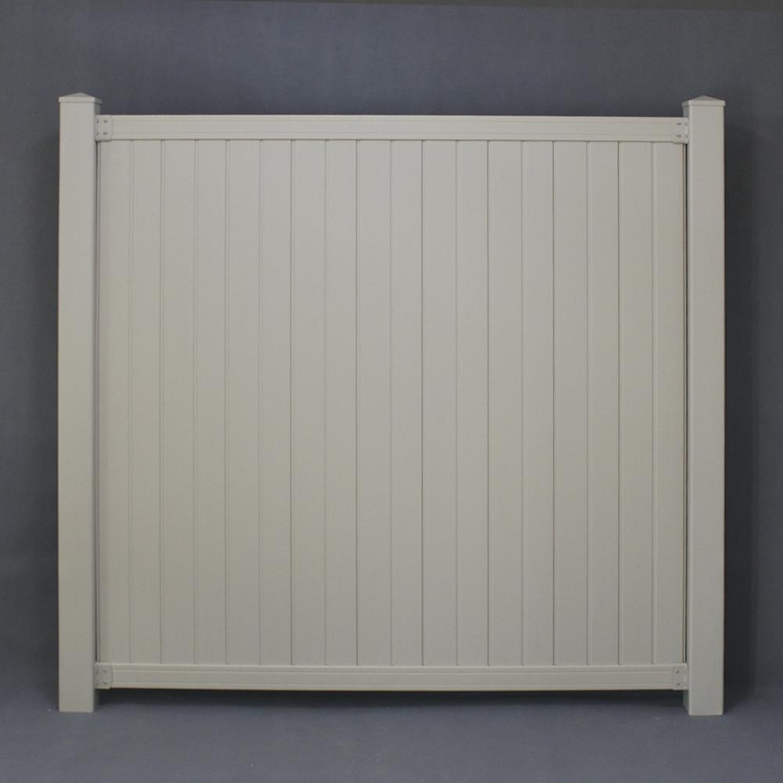

**Richmond White Vinyl Fence Panel**

**“Menards”**

**6x8 # 1728651 $ 119.00**

**Yardworks Belmont White Lattice Top Vinyl Fence Panel**

**“Menards”**

**6x6” # 1728615 $ 89.99**

**Yardworks White Vinyl Cape Cod Picket Fence Panel**

**“Menards”**

**4 x 6’ # 1728220 $ 49.99**

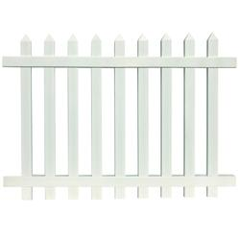

**Freedom Emblem Vinyl Flat-top Fence Panel**

**“Lowe’s”**

**White 6 x 8’ # 12092 $ 99.00**

**Sand 6 x 8’ # 546550 $ 168.76**

**Clay 6 x 8’ # 5277907 $ 180.81**

**Gray 6 x 8’ # 5277943 $ 180.81**

**White Rail/Sand panel 6 x 8’ # 5277943 $ 180.00**

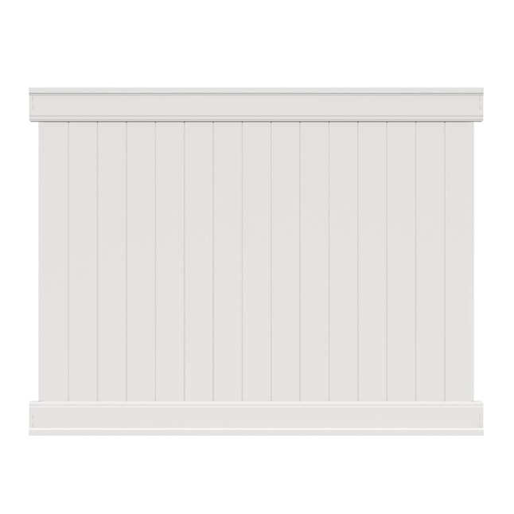

Sand Clay Gray White Rail/Sand Infill

**Aluminum Fencing**

**Yardwork’s Asbury Black 3-Rail Aluminum Fence Panel**

**“Menards”**

**4’6” x 6’ # 1716720 $ 82.98**

**4’ x 6’ # 1716620 $ 76.98**

**5’ x 6’ # 1716630 $ 85.88**

**Legacy2 Black Aluminum Fence**

**“Menards”**

**4’ x 6’ # 1714122 $ 129.99**

**Williams Aluminum Fencing™ 48" x 6' Pro Series Bronze Aluminum Fence Panel**

**“Menards”**

**Bronze 48’ x 6’ # 1716837 $ 169.99**

**Black 48’ x 6’ # 1716806 $ 169.99**

**White 48’ x 6’ # 1716817 $ 169.99**

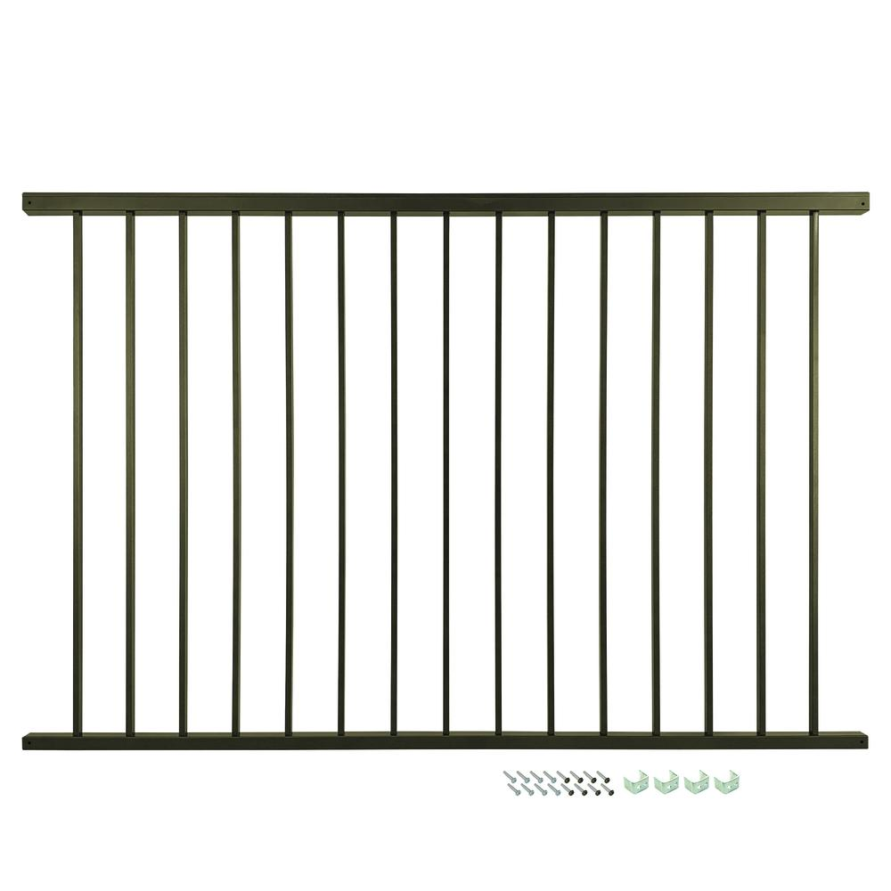

**Williams Aluminum Fencing™ Pro Series Black Aluminum Fence Panel**

**“Menards”**

**Bronze 54’ x 6’ # 1716836 $ 239.99**

**White 54’ x 6’ # 1716816 $ 239.99**

**Black 54’ x 6’ # 1716807 $ 239.99**

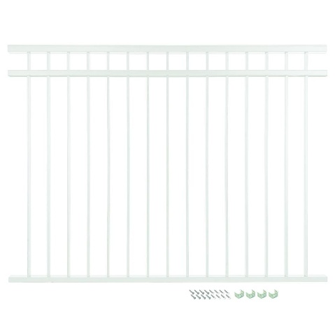

**Yardworks Columbia 5’x6” Black 3-Rail**

**“Menards”**

**5 x 6’ # 1716800 $ 94.99**

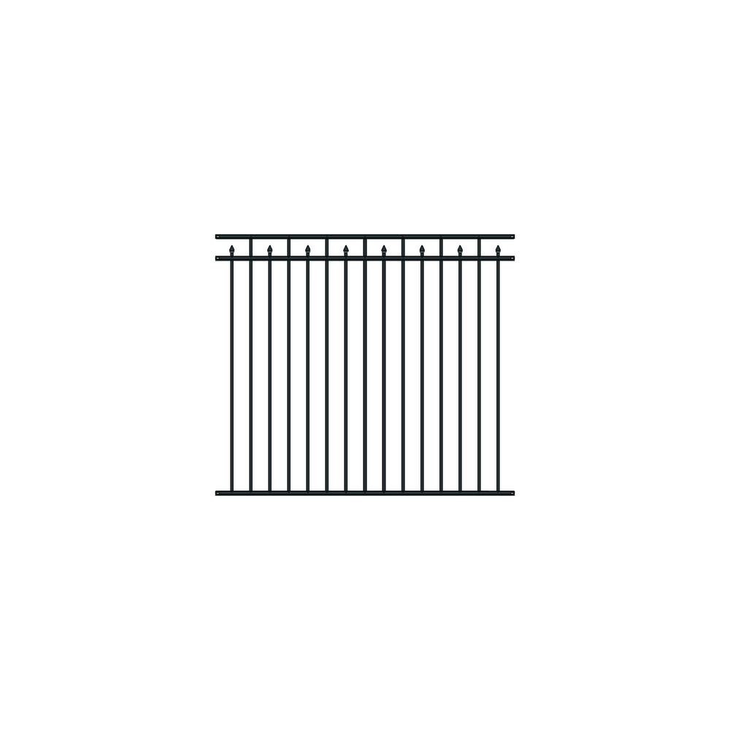

**Chain Link Fence 4’ / 5’ / 6’ Fence**

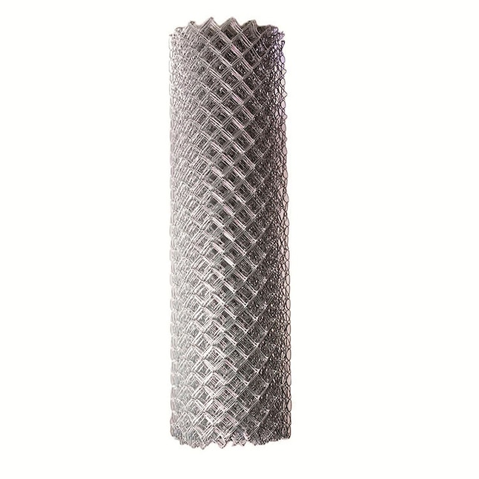

**Black Chain Link Fence 4’ / 5’ / 6’ Fence**

