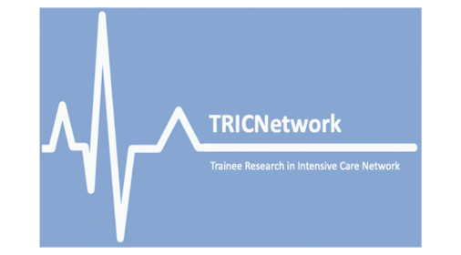

**Submission Guidance TRIC Network Trainee Project**

1. Project expected to be QI / audit or research that has an active time (i.e. data collection period) of no more than 4 weeks
2. Must be a Resident doctor project, designed and led by them, not a project being run for a consultant/ senior researcher
3. Must have a local consultant supervisor that is prepared to support the project through to its completion and strongly engaged with the project.
4. TRIC committee members with a direct involvement in an application will abstain from the voting and selection process
5. Members of the selection panel will not have an established relationship to members of the shortlisted bids
6. Canvassing of TRIC committee or selection panel is not permitted
7. The deadline for submission is Wednesday 30th April 2025 at 17:00. No late submissions will be considered.
8. Short-listed participants must be available to present their proposal at Birmingham ICS SOA 2025.