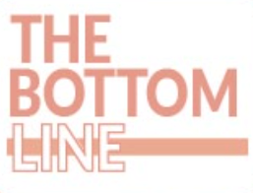
TBT Honorary Digital Editor – Application form

Name:
GMC Number:
Employer:
Grade:
Training programme (if applicable):

Please attach to the application: CV and responses to the shortlisting questions below.

Please kindly answer the following short-listing questions (max 500 words per question):
- What barriers exist between evidence generation and its application in clinical practice, and how might they be overcome?

- Why are you interested in contributing to The Bottom Line, and what do you hope to gain from this collaboration?

- Describe an occasion where you have used evidence or research to change or inform your clinical practice?

- What makes an effective summary of a clinical trial or paper?

