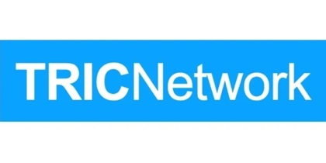

Submission Guidance TRIC Network Trainee Project
- Project expected to be QI / audit or research that has an active time (i.e. data collection period) of no more than 4 weeks
- Must be a Resident doctor project, designed and led by them, not a project being run for a consultant/ senior researcher
- Must have a local consultant supervisor that is prepared to support the project through to its completion and strongly engaged with the project.
- TRIC committee members with a direct involvement in an application will abstain from the voting and selection process
- Members of the selection panel will not have an established relationship to members of the shortlisted bids
- Canvassing of TRIC committee or selection panel is not permitted
- The deadline for submission is Friday, 1st May 2026 at 17:00. No late submissions will be considered.
- Short-listed participants must be available to present their proposal at Birmingham ICS SOA 2026.

