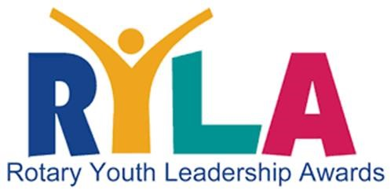
2026 District 6510 RYLA Camp
WHEN: April 17 (Friday evening) – April 19 (Noon – 1:00 PM)
WHERE: Camp Hope / 16322 Camp Hope Road / Ewing, IL 62836
COUNSELOR APPLICATION DEADLINE: ASAP.

We are looking for 6-10 RYLA Camp Graduates to serve as Student Camp Counselors. Current High School Seniors may only have one last opportunity to serve as a RYLA Camp Counselor, but we urge everyone to apply.

RYLA Camp – Student Counselor (who Will Assist RYLA Camp)
Student Full Name:
High School:
Rotary (Interact) Club:
Home Address:
City, State, and Zip:
Cellular / Phone #:
Driver’s License (if driving)
Email Address:
Employment (and Title):
RYLA Permission | May RYLA share your contact information? YES __________ NO __________

In Case Of Emergency (Quick Guide)
Full Parent Name:
Relationship to Student
Cellular / Phone #:
Email Address:
Signature of Parent:
Date:

RETURN ASAP: CarlThomasBerry@gmail.com

2026 District 6510 RYLA Camp
WHEN: April 17 (Friday evening) – April 19 (Noon – 1:00 PM)
WHERE: Camp Hope / 16322 Camp Hope Road / Ewing, IL 62836
COUNSELOR APPLICATION DEADLINE: ASAP.

RYLA Camp – Student Counselor (who Will Assist RYLA Camp)
STUDENT NAME:

WHY do you want to be a RYLA Camp student Counselor? Please explain.
1.

WHAT “skills/talents” will you bring and share with the new RYLA Campers?
2.

WHAT “significant contribution” will you bring to the overall RYLA experience?
3.

Please list three (3) personal references (not related to you):
4. | 1.  Name:  Address:  Phone #:  2.  Name:  Address:  Phone #:  3.  Name:  Address:  Phone #:

RETURN ASAP: CarlThomasBerry@gmail.com

