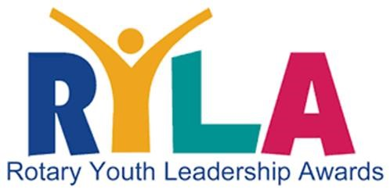
2026 District 6510 RYLA Camp
WHEN: April 17 (Friday evening) – April 19 (Noon – 1:00 PM)
WHERE: Camp Hope / 16322 Camp Hope Road / Ewing, IL 62836
APPLICATION DEADLINE: April 11, 2026.

Student Application (To Attend 2026 District 6510 RYLA Camp)
Student Full Name:
Cellular / Phone #:
Email Address:
Age & Grade:
High School Name

For The Sponsoring Rotary Club
Club President’s Name:
Rotary Club:
Cellular / Phone #:
Email Address:
Signature of President:
Date:

In Case Of Emergency (Quick Guide)
Full Parent Name:
Relationship to Student
Cellular / Phone #:
Email Address:
Signature of Parent:
Date:
2026 District 6510 RYLA Camp
WHEN: April 17 (Friday evening) – April 19 (Noon – 1:00 PM)
WHERE: Camp Hope / 16322 Camp Hope Road / Ewing, IL 62836
APPLICATION DEADLINE: April 11, 2026.

STUDENT NAME:

WHY do you want to attend the RYLA Camp? WHAT do you hope to learn?
1.

WHAT does “leadership” mean to YOU? HOW do YOU define “leadership”?
2.

WHAT “service project” have you ever participated in? Please describe it.
3.

Describe a time in which you had to work with someone different than you.
4.

WHAT are you most passionate about? Please explain WHY.
5.

WHAT is one personal habit/skill you would like to change or improve? WHY?
6.

WHAT are 3 words that BEST describe you? Please explain.
7.

RETURN BY: April 11, 2026. TO: … WE NEED CENTRAL EMAIL THAT EVERYONE HAS ACCESS TO, PASSWORDS, ETC.

