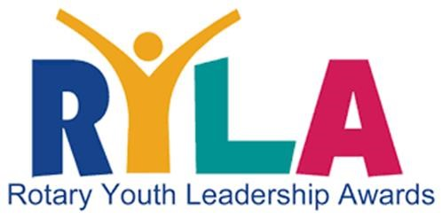
2026 District 6510 RYLA Sponsorship
District 6510’s RYLA Program needs your help! RYLA Campers,
Mini-RYLA events, Adult volunteers, Student Counselors, etc.!

First, thank you to ALL clubs who sponsored RYLA Campers in 2025! We could not have relaunched our RYLA Program without ALL of your help. The positive feedback and stories we have heard from past 2025 RYLA Camp graduates – is evidence enough that RYLA Program can change lives.

Second, one of our goals is to build on the success of our RYLA Program. Since our District relaunch, we have not only trained 34+ students at last year’s Summer 2025 RYLA Camp, as well as 75+ more students in our Mini-RYLA’s (full/half-day LeaderShops) throughout District 6510, including Junior High students!

Did you know that very few school districts in District 6510 know anything about Rotary, much less our Interact and RYLA programs? To change this fact, I decided to travel throughout District 6510 in the past 2-3 years to bring our Rotary message to the schools and FREE leadership training to the students! My goal is not only to rebuild our District 6510 RYLA Program, but to create such a remarkable program that one day District 6510 will be known for having “one of the best” RYLA Programs in the world!

Third, last year Rotary Clubs that “nominated” / “sponsored” RYLA Campers paid: $250.00 per student.
To continue to expand the RYLA Program, we lowered the cost from $250.00 to $150.00 per student!!! Now Rotary Clubs can now send two (2) students to the RYLA Camp for only $50.00 more!

Fourth, one problem that has NEVER been addressed in past fees is the added costs of our Adult/Rotary Volunteers (i.e., chaperons) and RYLA Student Camp Counselors (i.e., our past RYLA Camp graduates) – in terms of food, lodging, T-Shirts, and so on. District 6510 needs your help in “sponsoring” BOTH RYLA Camp students and our volunteer staff who are essential for RYLA’s success. We need your help!

Fifth, we have already planned two (2) RYLA Camps problem for 2026, not to mention several Mini-RYLA’s. Please “Save the Dates” for the below 2026 Spring and 2026 Fall RYLA Camps below:

Session: | Friday April 4/17 — Sunday April 4/19 | Friday Oct. 10/9 — Sunday Oct. 10/11

Sixth, we also want to plan a few different District 6510 RYLA and Youth Services fundraisers so we can reach Junior High/High School students as possible in the next 3-5 years.

Finally, to continue to expand the success of our RYLA Program, especially at the Junior High level, please consider sponsoring and hosting your own Mini-RYLA (full/half-day LeaderShop) in YOUR city, town, and school district! We have developed a successful “turn-key template” of activities, games, and materials for Junior High/High School students as well as the school administrators and teachers who chaperone!

Carl Thomas Berry
District 6510 RYLA Chair
Lebanon Club President
Professional Speaker
618.581.3596 (Cell)
www.CarlThomasBerry.com
CarlThomasBerry@gmail.com

