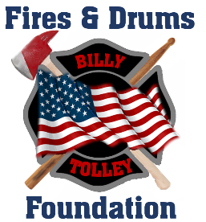

Dear Sir/Ma’am,
On April 20, 2017, I lost my best friend, my brother FDNY Firefighter William Tolley, who died while fighting a fire in Brooklyn. William was a 14-year veteran of the department, and left behind a wife and 9-year-old daughter.
The Fires & Drums Foundation was created to honor my brother, and continue his legacy of service to others. The Foundation provides support to the families of fallen First Responders and Military members who suffer a tragedy as our family has. We provide direct financial support to these families to help cover costs and provide immediate relief to help alleviate any hardships as a result of their loss. We have already provided support to multiple first responder families.
To further our efforts, we are conducting a fundraising event on July 13, 2020. This will be the third year we are conducting the fundraiser. The previous events were a great success, and we anticipate record participation for the next one as well. It is this event for which I am extending a request for your assistance. We are soliciting businesses to sponsor the event, and/or provide items for the auction we are conducting that day as well. Should your organization see fit to provide any type of support, we would be extremely grateful. All donations are tax-deductible.
Thank you in advance for considering our request for support in this endeavor. I look forward to speaking with you again in the near future.
Respectfully,

Robert Tolley
Fires & Drums Foundation
1 Pauline Drive
Farmingdale, NY 11735
(516) 293-3448
www.firesanddrums.org
robert.tolley@firesanddrums.org
A registered 501(c) (3) nonprofit

