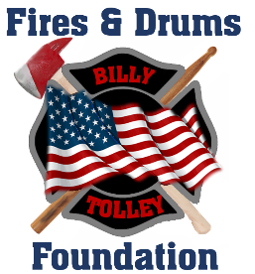

Dear Sir/Madam,
On April 20, 2017, I lost my best friend, my brother FDNY Firefighter William Tolley, who died while fighting a fire in Brooklyn. William was a 14 year veteran of the department, and left behind a wife and 9 year old daughter.
The Fires & Drums Foundation was created to honor my brother, and continue his legacy of service to others. The Foundation provides support to the families of fallen First Responders and Military members who suffer a tragedy as our family has. We provide direct financial support to these families to help cover costs and provide immediate relief to help alleviate any hardships as a result of their loss. We have already provided support to multiple families.
To further our efforts, we are extending a request for your assistance. In order to provide support to these families, we are in critical need of donations. Although we conduct fundraising efforts via shirt and coin sales, there remains a significant gap. Should your organization see fit to provide any type of support, we would be extremely grateful.
Thank you in advance for considering our request for support in this endeavor. I look forward to speaking with you in the near future.
Respectfully,

Robert Tolley
Fires & Drums Foundation
1 Pauline Drive
Farmingdale, NY 11735
(516) 293-3448
www.facebook.com/firesanddrumsfoundation
firesanddrumsfoundation@outlook.com
A registered 501(c) (3) nonprofit

