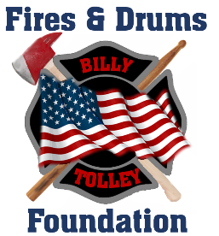

To whom it may concern,

On April 20, 2017, I lost my best friend and my brother, FDNY Firefighter William Tolley, who tragically passed away while bravely battling a fire in Brooklyn. A 14-year veteran of the department, William left behind a wife and a 9-year-old daughter. His sacrifice continues to inspire our family and community.

In his honor, I founded the Fires & Drums Foundation, an organization dedicated to continuing his legacy of service by supporting the families of injured and fallen First Responders and Military personnel. Like our family, these families face unimaginable hardships in the wake of tragedy. The Foundation provides immediate, direct financial assistance to help cover costs and ease the burdens they face, ensuring they are not alone in their grief.

Since our inception, we have proudly supported many families in their time of need. As we continue this vital work, we are preparing for our 8th Annual Fundraising Event, scheduled for June 6, 2025. The success of past events has been overwhelming, and we anticipate an even greater turnout this year.

We are reaching out to generous businesses like yours to help make this event a success. We are seeking sponsors to support the event, as well as donations for our auction. Your involvement will directly benefit those who sacrifice everything to protect and serve our communities. All contributions are tax-deductible.

Your support will make a meaningful difference in the lives of these families, and we would be deeply grateful for any assistance you can provide. I look forward to discussing how we can partner together in this important mission.

Thank you for considering this opportunity to support those who give so much for us.

Warm regards,

Robert Tolley

1 Pauline Drive

Farmingdale, NY 11735

(516) 293-3448

[www.firesanddrums.org](http://www.firesanddrumsfoundation.org)

robert.tolley@firesanddrums.org

A registered 501(c) (3) nonprofit