21st Century Community Learning Centers

Summative Evaluation Report

Boys & Girls Clubs of the CSRA

GREAT Futures Thomson

Grant Year 2

2020-2021



Boys & Girls Clubs of the CSRA

McDuffie County

21 Pecan Ave.

Thomson, GA 30824

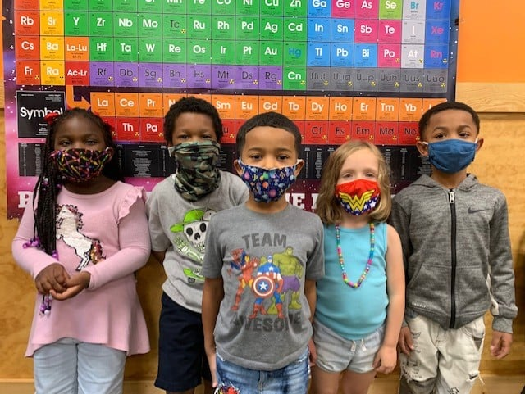

An Independent Evaluation

Prepared by Andra Syms

Submitted: June 11, 2021

Per US Department of Education Office of Elementary and Secondary Education’s 21st Century Community Learning Centers Non-regulatory Guidance: Each grantee must undergo a periodic evaluation to assess its progress toward achieving its goal of providing high-quality opportunities for academic enrichment. This summative evaluation will be used to refine, improve, and strengthen the program and to refine the performance measures. This summative evaluation contains observational qualitative information, quantitative objective assessment, and recommendations for improvement.



21st Century Community Learning Centers Evaluation Report

*McDuffie County*

# 

# 

# Executive Summary

Boys & Girls Clubs of the CSRA program provides a comprehensive youth development approach to improving academic achievement. Program components include daily homework help, individual and group tutoring, supplemental instruction, academic enrichment, career and entrepreneurial exploration, technology, economic literacy, youth leadership, character education, life skills, drug and alcohol prevention, pregnancy prevention, fitness and recreation, mentoring, the arts, and family involvement activities. The program partners with Thomson Elementary, Maxwell Elementary, Norris Elementary, Thomson-McDuffie Middle, and Thomson High School and targets 75 at-risk youth in grades Pre-K through 12th grade.

## Overall Findings

Boys & Girls Clubs of the CSRA (BGC) implemented the 21st Community Learning Centers grant program as designed. As a result of procedures put into place by the state of Georgia due to COVID-19, all clubs offered a virtual program in addition to the regular face to face option. The program director and BGC staff worked exceptionally well to develop a club program the students could experience from the safety of their home. In addition, they continued to work in collaboration with local schools to maintain the quality of programming.

Overall, BGC successfully implemented two out of four academic achievement objectives, one of two healthy lifestyles objectives, two of three good character and citizenship objectives and one out of two parental involvement objectives. Overall, six objectives were met, one was unable to be measured due to pre/post assessment issues, one was unable to be measured because the curriculum was not presented to the students, two were unable to be measured due to the fact that a large number of students opted out of taking the GA Milestones test, and one was not met.

## Looking Forward

BGC has established a strong program framework for the academic, healthy lifestyle, good character and citizenship, and parental involvement components. This framework was based on a continuous improvement model. Program delivery and staff training was continuously refined based on regular assessments that illuminated the needs of students and opportunities to strengthen the program. Moving forward the program director should assign a specific curriculum to each goal/objective and communicate this to club directors and staff. BGC staff should be trained on each curriculum and the correlation between the goal/objective and the curriculum should be clearly communicated. Programs that require a pre/post test should be closely monitored throughout the year. It is important to pre-test new members as they enter the program as well as posttest the students (when applicable) who may leave throughout the year. In addition, pre and post tests should be planned at the beginning of the year. These test dates should be shared with the club directors and the staff members administering the curriculums. BGC should also continuously monitor data, using the information to guide program needs. In addition, collaborating with parents and families encourages participation/volunteering and is necessary for the success of the students and should therefore be a priority.

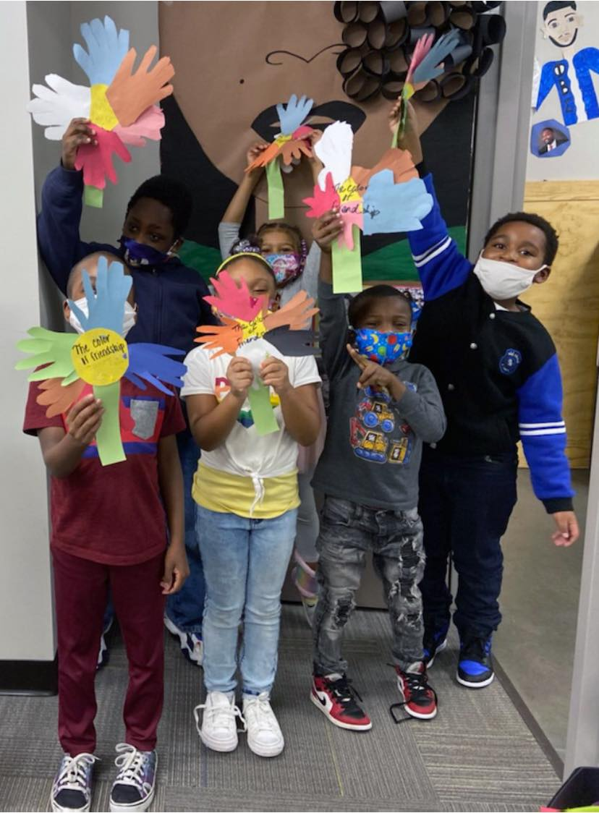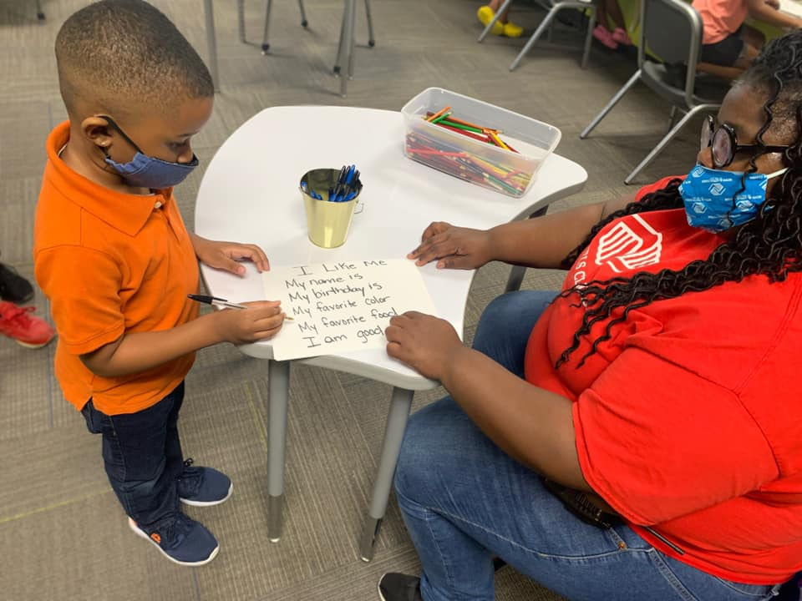

# Program Impact

|  |
| --- |
| 68% of regularly attending participants maintained an A or B or improved their grade in reading. |
| 70% of students increased their civic engagement by volunteering in the community. |



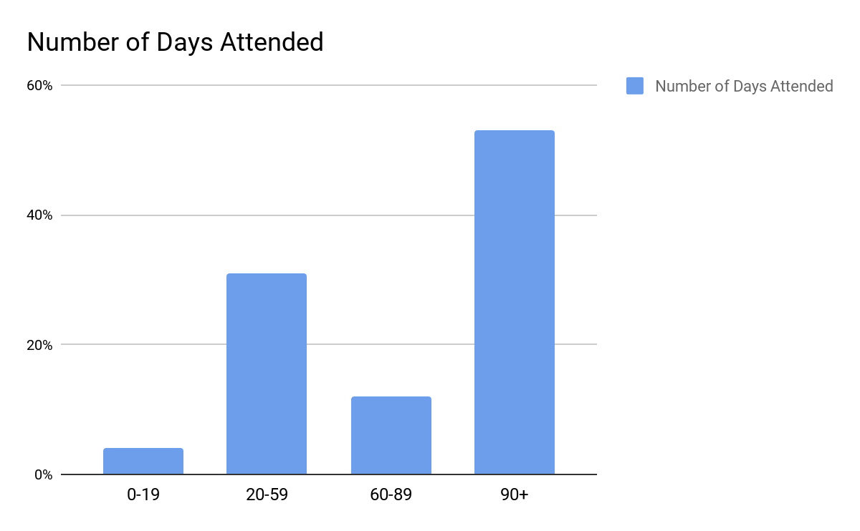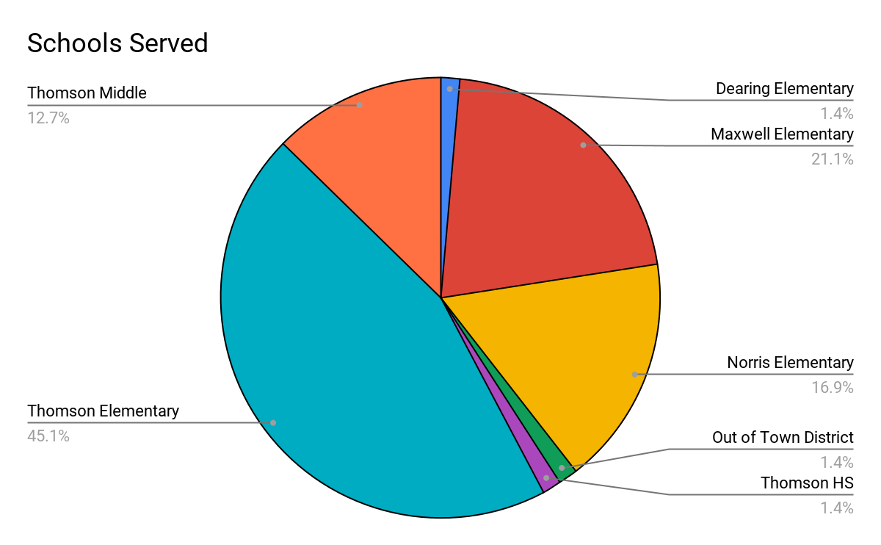

What Students Are Saying!

|  |
| --- |
| “We do our homework here so our families can do what they need to do and we have more time with them when we go home.” -4th grade male |
| “I’ve been in this club since first grade, I love coming here!” -6th grade male |
| “We learn that drugs are not good and you can not share your medicine.” -2nd grade female |
| “This place makes a better experience in my life.” -11th grade male |
| “It keeps us energetic. I would be bored at home and would be on my phone.” -7th grade female |
| “I like the activities here and I get a jump start on my homework. I really like Spanish.” -8th grade male |

What Parents Are Saying!

|  |
| --- |
| “I like to know my children can get help (with schoolwork) and they have someplace safe to go after school.” - Parent of 3rd & 4th grade females |
| “I bring my child here because he’s an only child. It’s great child care and he is safe.” Parent of a 5th grade male |
| “He’s my fourth child that has come to BGC. He enjoys coming because the staff is interactive...He loves the staff here.” Parent of 2nd grade male |

What BGC Staff are Saying!

|  |
| --- |
| “It’s so rewarding watching them enjoy learning something they had trouble with!” |
| “I want to give them my best...to make them the best.” |
| “I see different characteristics in the students that I had when I was their age. I can help them because I have been there.” |
| “I love noticing the growth you didn’t expect to see. Some of the students gravitate towards me. It’s nice to be a part of that.” |

# Table of Contents

**Executive Summary** **4**

Overall Findings 4

Looking Forward 4

**Program Impact** **6**

**Table of Contents** **8**

**Introduction** **10**

Program History 10

Program Overview 11

Program Model 12

Formula for Impact 13

**Program Implementation** **14**

Student Attendance and Enrollment 14

Participant Demographics 14

Student Recruitment Strategies 15

Student Recruitment 16

Retention Strategies 16

Average Daily Attendance 17

**Program Operations** **18**

Hours of Operation 18

Quality of Staffing 18

Observations 18

Professional Development 20

Professional Development and Training Topics 21

**Objective Assessments** **22**

Evaluation Design 22

Data Collected 23

Response Rate 24

Limitation of Data 25

**Program Impact** **26**

Goals and Objectives Overview 26

**Goal 1: Improve Academic Achievement** **28**

Objective 1.1: 50% of regularly participating students (attending the program 30 days or more) will meet or exceed state standards in reading. 28

Objective 1.2: 50% of regularly participating students (attending the program 30 days or more) will improve grade or maintain and “A” or “B” in reading on their report card. 29

Objective 1.3: 50% of regularly participating students (attending the program 30 days or more) will meet or exceed state standards in math. 30

Objective 1.4: 50% of regularly participating students (attending the program 30 days or more) will improve grade or maintain and “A” or “B” in math on report card. 30

Goal 1 Findings and Recommendations 31

**Goal 2: Increase Knowledge of Healthy Lifestyle Choices** **32**

Objective 2.1: 65% of regularly participating students will increase their knowledge of healthy eating habits and cardiovascular fitness. 32

Objective 2.2: 65% of regularly participating students will increase their knowledge of avoidance of risk-taking behaviors. 32

Goal 2 Findings and Recommendations: 33

**Goal 3: Improve Social, Emotional, and Life Skills for Positive Youth Development** **34**

Objective 3.1: 65% of regularly participating students will increase knowledge of conflict resolution techniques. 34

Objective 3.2: 75% of regularly participating students will increase civic engagement. 34

Objective 3.3: 65% of regularly participating students will increase their knowledge and ability to exercise self and social management. 34

Goal 3 Findings and Recommendations: 35

**Goal 4: Increase Parental Engagement/Involvement in Students’ Educational Process** **36**

Objective 4.1: 65% of regularly participating students’ families participate in at least one parental involvement activity offered monthly. 36

Objective 4.2: 50% of regularly participating students’ families will volunteer at the program at least one time annually. 36

Goal 4 Findings and Recommendations: 37

**Observations** **38**

**Success Story** **39**

**Progress Toward Sustainability** **40**

**Final Recommendations** **41**

# Introduction

## Program History

Since 1951, Boys & Girls Clubs of the CSRA (BGC) has provided youth development programs. Over the last 69 years, the organization has grown from one site to six sites. BGC is an autonomous organization governed by a local Board of Directors and affiliated with the Boys & Girls Clubs of America (BGCA), a national organization with 4,738 clubs that serve 4.6 million members across the United States, Puerto Rico, and military bases around the world.



In 2019, Consumer Reports named Boys & Girls Clubs of America one of the “Best Charities for Your Donations.” Charity Navigator has given BGCA a 4-star rating in each of the last five years.

The clubs provide a safe place for youth to learn, grow, and have fun. Club programs offer young people opportunities to build new skills and knowledge that raise each child’s belief that he or she can succeed. The programs constitute a clearly planned, systematic curriculum promoting development towards a successful, productive future. Ongoing relationships with caring adults and connections to new friends in a positive environment provide a sense of belonging, civility, and responsibility.

BGC has successfully administered 21st Century Community Learning Centers funded programs since 2009. The organization currently manages 5 separate grants targeting 405 youth and totalling $1,668,280.00 in Federal 21st CCLC funding. The Richmond County J. Hebbard Club was established in 2019. Previously the BGC South Augusta Club was located at the Henry Brigham Center. This is the first year of the FY20 grant and the 9th year that BGC South Augusta has received 21st CCLC program funding.

## Program Overview

The purpose of Georgia’s Title IV, Part B, 21st Century Community Learning Centers Program is to provide federal funds to establish or expand community learning centers that operate during out-of-school hours and have three specific purposes:

* To provide opportunities for academic enrichment and tutorial services
* To offer students a broad array of additional services, programs, and activities to reinforce and complement the regular academic program; and
* To offer families of 21st CCLC students opportunities for literacy and related educational development.

The Boys & Girls Clubs Great Futures program is a comprehensive after school and summer youth development program that is focused on improving academic achievement. The Great Futures program is designed as a comprehensive youth development program utilizing Boys & Girls Clubs programs with the addition of intensive academic support. Program components include daily homework help, individual and group tutoring, supplemental instruction, academic enrichment, career and entrepreneurial exploration, technology, economic literacy, youth leadership, character education, life skills, drug and alcohol prevention, pregnancy prevention, fitness and recreation, mentoring, the arts, and family involvement activities. The Great Futures program also provides family involvement activities. Fun, educational field trips that are coordinated with academic topics are also a component of both the afterschool and summer programs. All activities are aligned to the Georgia Standards of Excellence, have evaluations demonstrating improved student achievement, and utilize evidence based practices.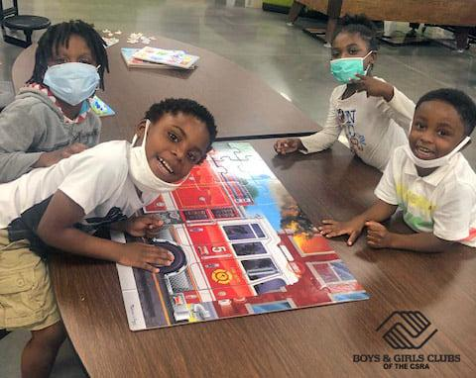

The Great Futures Program meets the educational needs of at-risk students by assessing each student’s academic strengths and weaknesses and developing a plan for improvement by collaborating with parents, regular school day teachers, and academic after school professionals. Certified teachers are responsible for implementing the instructional academic activities. The program addresses the core academic areas of Reading, Math, and Science using the following curricula: DIY Stem, App Lab, Camelot Learning’s Math Intervention, Image Makers, School Beats, Money Matters, SMART programming, and Triple Play. Multiple resources are utilized to ensure students’ individual needs are met, to offer a variety of fun, experiential approaches, and to address the individual needs of the students. Multiple resources also allow integrated learning throughout the program areas.

## Program Model

The challenges faced by children living in low-income neighborhoods are greater than ever. Persistent poverty and crime rates in these areas, combines with factors such as poorly-performing public schools, cuts in education funding, the increasing presence of gangs and their recruitment of younger and younger members create critical barriers to success and quality of life. BGC clubs are strategically positioned in the most at-risk neighborhoods affected by these factors. Significant evidence suggests that quality afterschool programming leads to positive outcomes such as higher academic achievement, increased graduation rates, and a lower occurrence of juvenile crimes.

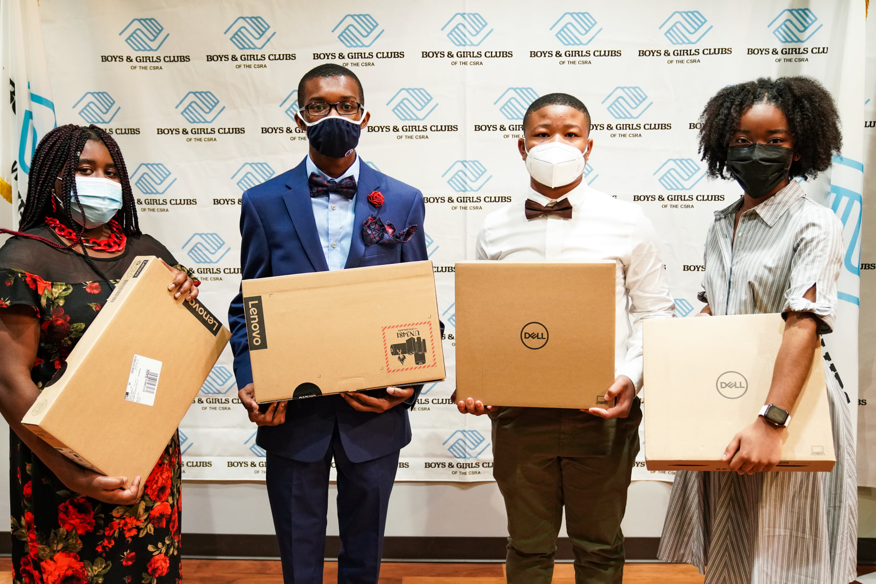

### Formula for Impact

BGC has adopted the Formula for Impact, a research based theory of change that describes how individual Clubs and the Movement as a whole can increase the impact exponentially of the young people of America.

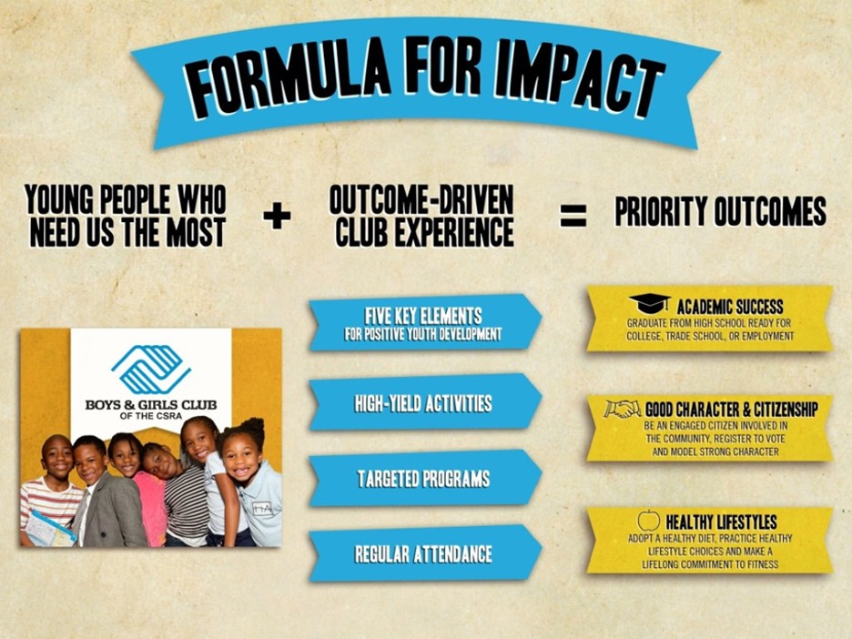

# 

# Program Implementation

## Student Attendance and Enrollment

BGC staff established attendance targets based on club size, days and hours of operation and historical attendance trends.

|  |
| --- |
| **Grant Enrollment Goal:** **75 Students** |
| **Total Number Enrolled:** **71 Students** |

## Participant Demographics

BGC McDuffie County Great Futures Thomson is located next door to Thomson-McDuffie Middle School and across the street from Thomson High School.

* 92% of regularly attending students are African-American and 8% identify as more than one race.
* The program serves 65% males and 35% females.

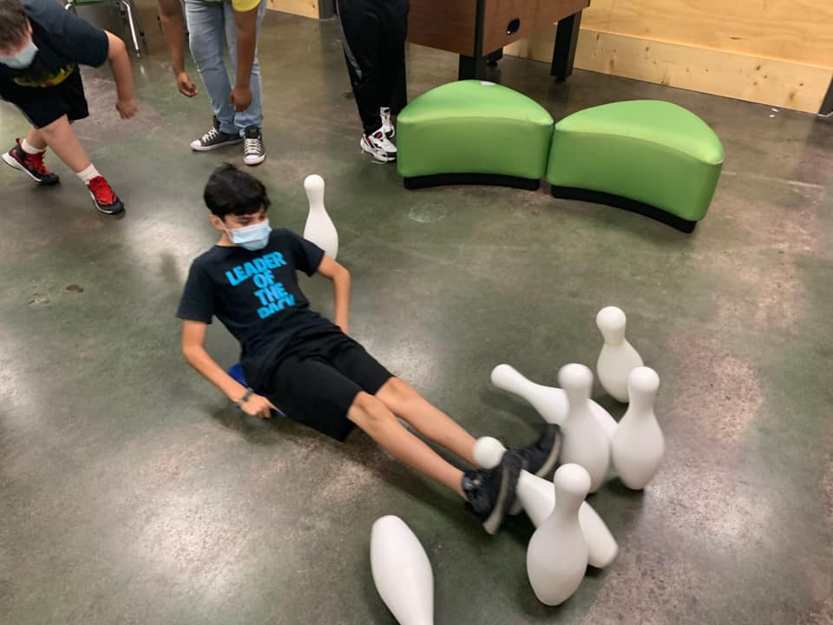

Participant Grade Level

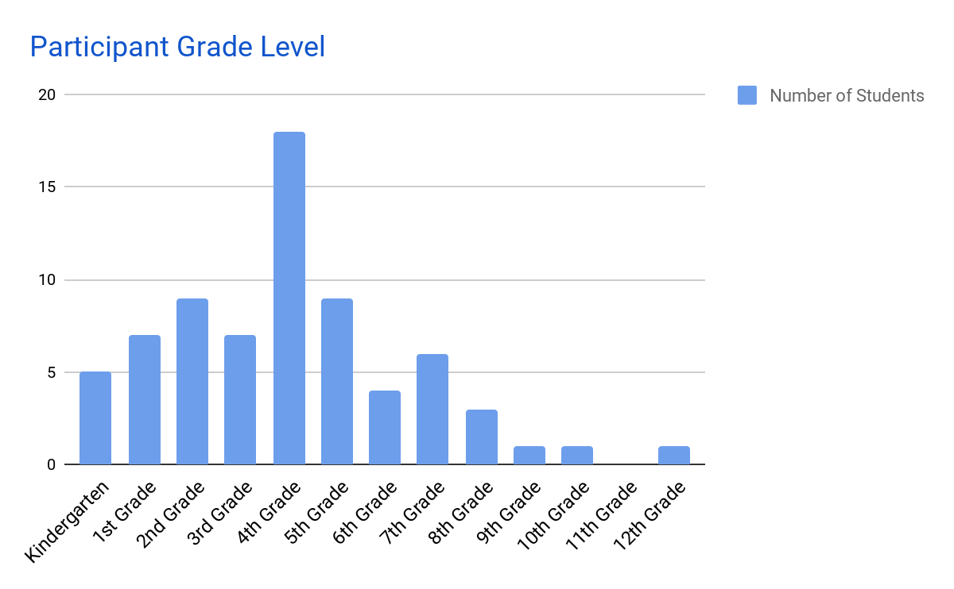

## Student Recruitment Strategies

BGC implemented a multi-tiered strategy for recruitment including outreach through communication with the schools, referral from school teachers, direct community outreach, and advertising.

* The club director met with the principals at the beginning of the year.
* The Executive Director and Program Director built a strong relationship with the Superintendent.
* The BGC held an information session at targeted schools for all eligible participants.
* The Club Director attended registration and or Open Houses at targeted schools.



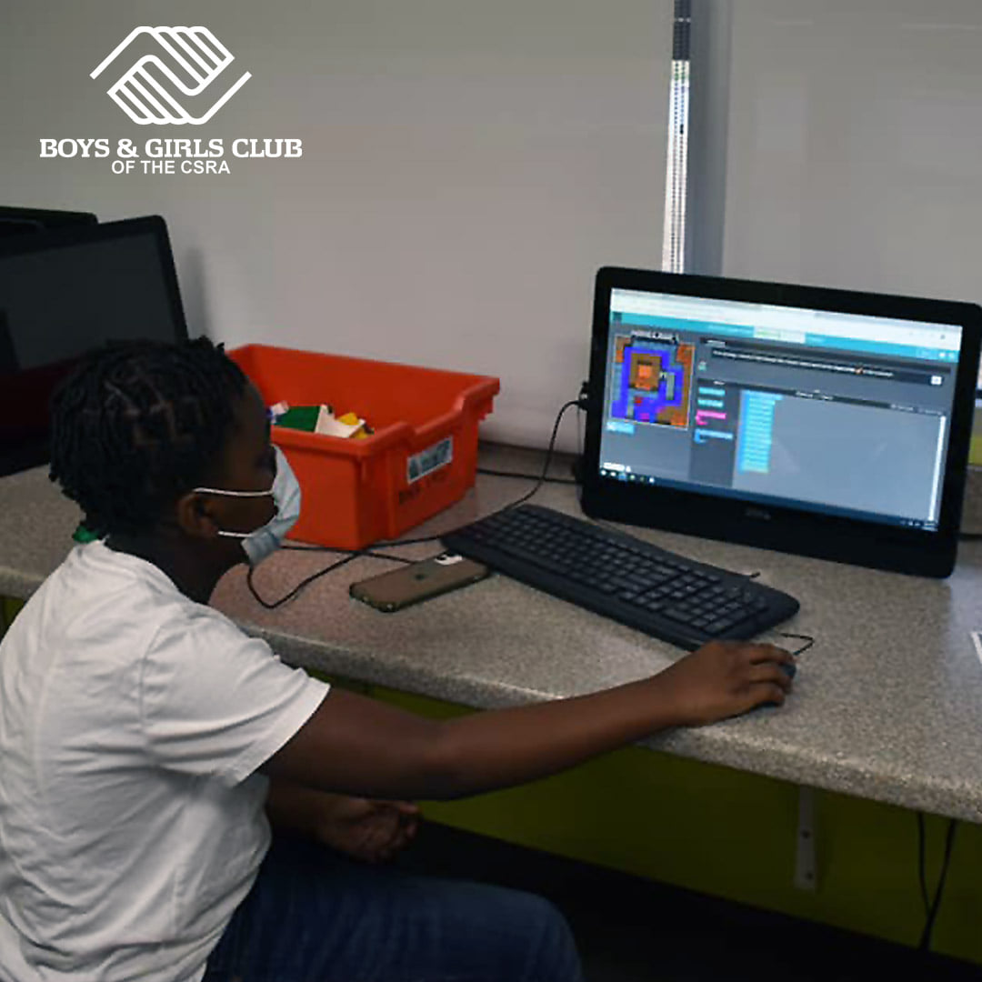

## Student Recruitment

Research shows the amount of time youth spend at Clubs is a determining factor in the depth of impact the Club experience has on young lives. Specifically, a 2009 third-party study by Private/Public Ventures found that frequency of attendance is directly tied to the following positive changes for Club participants:

* Higher levels of community service involvement
* Decreased levels of aggression
* Increased school effort
* Increased academic confidence
* Lower likelihood of starting to carry a weapon, smoke marijuana, and have sexual intercourse

The greatest impact was noted for youth who attended the Club at least one time per week, and higher levels were evident among those who attended 104 or more times per year (twice per week). BGC experienced similar results with the Great Futures Program.

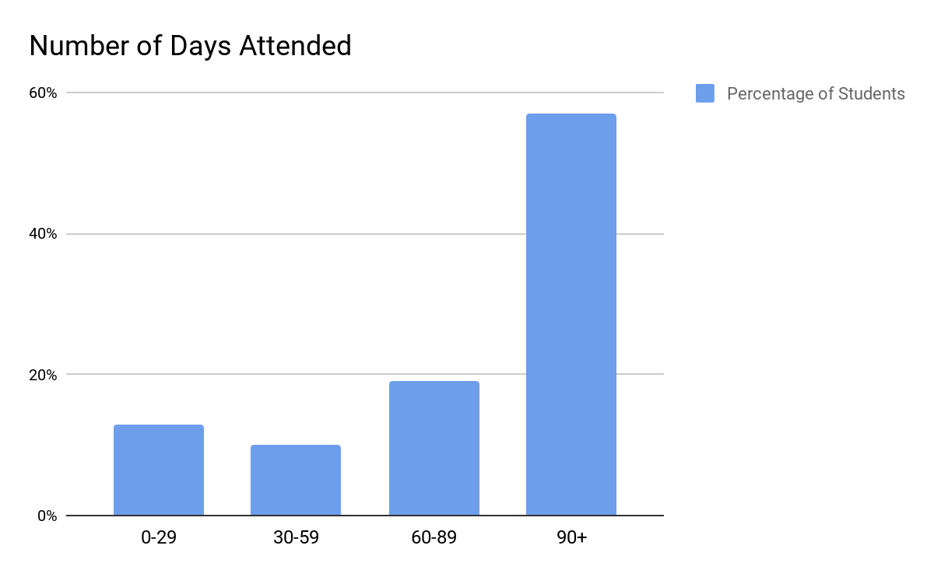

## Retention Strategies

BGC believes the most effective retention strategy is to provide quality, interesting and fun programs by creating leadership opportunities for youth within the program, gathering and responding to youth interests, and employing adults who genuinely care and understand youth. BGC uses the five key components of youth development (a safe, positive environment, supportive relationships with caring adults, fun opportunities and expectations, and recognition), closely monitors attendance, and provides follow-up to also promote regular attendance.

## Average Daily Attendance

Average daily attendance represents the average number of participants on a given day attending the program.

|  |  |
| --- | --- |
| **After School Program Dates:**  **August 12, 2020 - May 21, 2021**  21st CCLC Total Enrollment: 71  21st CCLC Enrollment Goal: 75  21st CCLC Average Daily Attendance: 25 | **Summer Program Dates:**  **Virtual Camp June 7 - July 23, 2021**  21st CCLC Total Enrollment: 109  21st CCLC Enrollment Goal: 75  21st CCLC Average Daily Attendance: 82 |

Recommendations for Maintaining High 21st CCLC ADA include:

* Closely monitor attendance and ADA and follow up with individual students' families.
* Closely monitor attendance and waiting list to quickly move students from the waiting list into the program when spots become available.
* Enroll all target grade level students into the Great Futures program and fully execute the retention plan.

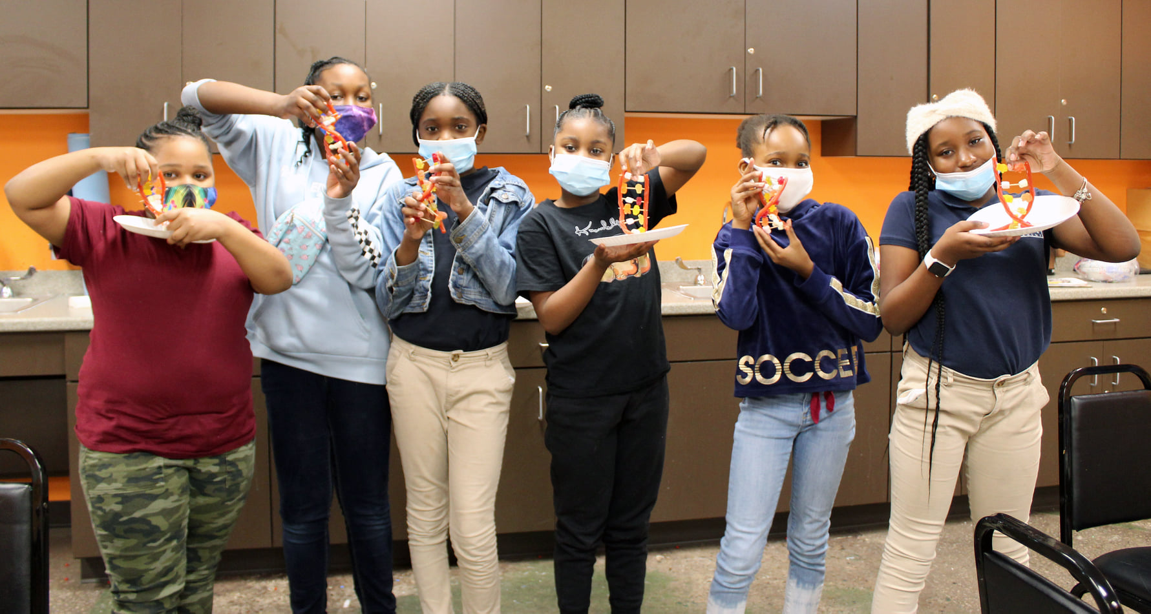

# 

# Program Operations

## Hours of Operation

21st CCLC requires a minimum of 12 hours of operation weekly. The Great Futures Program operates a minimum of 15 hours per week for 38 weeks during the school year. A full day program is offered on most school holidays, intersession, and summer. In addition, students whose families chose remote learning for their school day option had the opportunity to attend the Boys & Girls Clubs during the school day to get help with their school work. The 6-week summer program offers adapted program components using a weekly thematic approach.

|  |  |
| --- | --- |
| **After School Program**  **Hours of Operation**  Monday - Friday 3:15 - 6:15 pm | **Summer Program**  **Hours of Operation**  Monday - Friday 9:00 am – 2:00 pm |

## Quality of Staffing

The staff at BGC is composed of high quality individuals who strive to improve the education and lives of the students attending the Clubs. Certified teachers are used for the academic components of the program.

## Observations

The evaluation visits to the club site included interviews with club directors, staff, students, and parents as well as classroom/activity observations using a standard assessment form to assess program delivery and student engagement. See Appendix A or observation form used. The evaluator used the goals and objectives to guide observations and report strengths and weaknesses in the program. The observations were discussed with the club director and the program director.

**During club observations the grant evaluator consistently found:**

* Activities were fun and engaging and were in line with the lesson plan posted outside of each area.
* Students were having a good time and were engaged in the activities.
* Staff members were energetic, positive, and were willing to discuss the activities and share information about the 21st CCLC Great Futures Program.
* Students were happy and the classes were full.

**BGC staff consistently reported to the grant evaluator:**

* Making a difference in the lives of young people was important.
* Working for BGC was satisfying and fun.
* Watching students grow and learn is rewarding.
* Knowing students have the opportunity to change their future is uplifting.

## 

## Professional Development

Each year BGC offers a variety of professional development opportunities for their staff members. These trainings are offered throughout the year and training topics are determined by the varying needs of the staff. BGC demonstrated a strong commitment to professional development for each staff member outlined in the original grant application professional development plan.



### 

### Professional Development and Training Topics

Training was provided in the following areas. The facilitating entity for each training is listed in parenthesis.

* New and Continuing Sug-Grantee Training (21st CCLC)
* County Staff Training Georgia Alliance (BGC)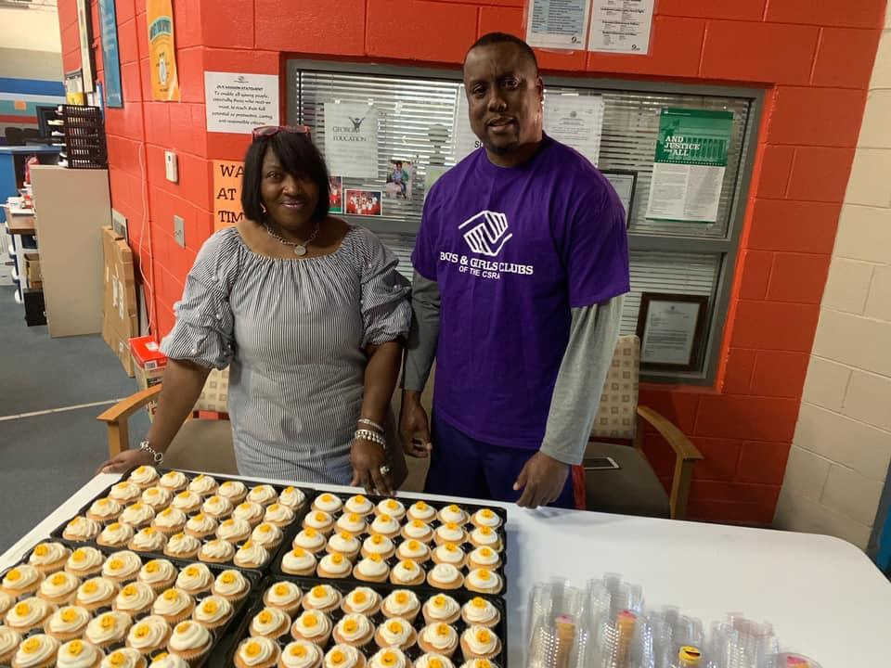
* Mandated Reporter Training (BGC)
* Lead Teacher Training (BGC)
* Driver Training (BGC)
* Membership Clerk Training (BGC)
* Family Liaison Training (BGC)
* SMART Moves Curriculum Training (BGC)
* BGC Southeastern Leadership Training (BGC)
* BGC National Conference - Virtual (BGC of America)
* Summer Camp Training (BGC)
* Building Community Training (BGC)
* Active Learning Training (BGC)
* Cooperative Learning Training (BGC)
* Child Safety Training (BGC)
* Infectious Disease Training (BGC)
* Structure and Clear Limits Training (BGC)
* Re-framing Conflict Training (BGC)
* Program Basics Training (BGC)
* Beyond School Hours (21st CCLC)
* Club Directors Academy Training (BGC of America)

# 

# Objective Assessments

## Evaluation Design

The evaluation plan is based on a continuous improvement model that includes defining goals, ongoing monitoring, and timely adjustments. The evaluation design contains both formative (ongoing to monitor progress toward objectives) and summative (annually to assess impact) components. Quantitative data includes student demographics, program participation, curricula pre and post tests, report card grades, and Georgia Milestones test results. Qualitative data is also collected to monitor progress and guide program adjustment. Qualitative data includes program staff site visit checklists, evaluator observations, Boys & Girls Clubs of America Youth Outcomes survey, and 21st CCLC parent, student, and teacher satisfaction surveys.

## 

## Data Collected

|  |  |  |
| --- | --- | --- |
| ***Indicator*** | ***Frequency*** | ***Source*** |
| Report Cards | Every 9 weeks | Collected from students/Requested from School District |
| Georgia Milestones Test Scores | Annually | Requested from School District |
| Pacer Test | Beginning and End of Program | BGC Administered |
| Nutrition Survey | Beginning and End of Program | BGC Administered |
| SMART Moves Assessment | Beginning and End of Program | BGC Administered |
| Parent Involvement | Monthly | BGC Sign-In Sheets |
| Parent Volunteers | Daily | BGC Sign-In Sheets |
| Teacher Survey | Annually | School Day Teachers |
| Student Survey | Annually | Students |
| Parent Survey | Annually | Parents |
| Program Attendance | Daily | Kid Trax/A+(Cayen) Data Management Systems |
| Member Demographics | Annually | Membership Application |

## 

## Response Rate

A total of 71 students were enrolled in the program. 49 students were regularly attending at 30+ days. However, due to issues caused by the COVID-19 pandemic, students who attended 20+ days were considered regular attendees. Therefore, 47 students were regularly attending at 20+ days. For each objective, data sets were analyzed using the total number of regularly participating students with complete data for the set (i.e. pre and post tests, second and third 9 weeks report cards). “N” denotes the number of regularly participating students who had complete data sets for which objective measures were calculated.For each objective, data sets were analyzed using the total number of regularly participating students with complete data for the set (i.e. pre and post tests, second and third 9 weeks report cards). “N” denotes the number of regularly participating students who had complete data sets for which objective measures were calculated.

The collection rate for report card grades for regularly participating students was 51% (n=25) in reading and 47% (n=23) in math. Report cards were collected from participants as well as requested from schools. Report card grades from the 2nd and 3rd nine weeks were compared.

BGC administered the required 21st CCLC teacher surveys. The response rate from the surveys was 157%, (*n=*77). This is much higher than last year’s results which were 56%. There are currently no results for the parent and student surveys for the 2020-2021 school year.

The collection of the required 21st CCLC parent and student surveys may have been a challenge due to the club restrictions caused by the COVID-19 pandemic.

A pre/post test assessment method was utilized to track participant progress toward meeting the objectives under the Healthy Lifestyles Goal. For the increased knowledge of risk taking behaviors and increased knowledge of healthy eating habits students took a pre-assessment (knowledge checklist) at the beginning of the course and a post assessment (knowledge checklist) after completion of the course. The PACER test, used to measure physical fitness levels, was administered in the fall (2020) and again in the spring (2021).

|  |
| --- |
| ***Recommendations for Increasing Response Rates Include:***   * *Contact school day teachers at the beginning of the school year and let them know the students that are in the program and that there will be a survey for them to fill out at the end of the school year. Provide a copy of the survey so they know what to focus on.* * *Have surveys available at the monthly family events starting in February.* * *Develop an incentive plan (such as a gift card drawing or drawing for an Ipad or tablet) to motivate parents and school day teachers to remember to complete the survey.* * *Build a relationship with the school day teachers so that they are familiar with the program, the student in the program, and the importance of the survey.* |

## Limitation of Data

Data collected for this review has a few limitations. Academic data for students’ performance as demonstrated on report cards is limited in its validity and reliability due to a lack of inter-rater reliability and subjectivity issues with multiple teachers reporting across multiple grade levels and school sites. Survey data is similarly limited due to possible respondent bias/prejudice. In addition, some pretest/posttest data results are limited due to the small number of students completing both assessments.

# 

# Program Impact

## Goals and Objectives Overview

**Goal 1: Improve Academic Achievement**

|  |  |
| --- | --- |
| **Objective 1.1:** 50% of regularly participating students (attending the program 30 days or more) will meet or exceed state standards in reading. | Unable to measure objective. |
| **Objective 1.2:** 50% of regularly participating students (attending the program 30 days or more) will improve grade or maintain an “A” or “B” in reading on report card. | Objective was Met at 68% |
| **Objective 1.3:** 50% of regularly participating students (attending the program 30 days or more) will meet or exceed state standards in math. | Unable to measure objective. |
| **Objective 1.4:** 50% of regularly participating students (attending the program 30 days or more) will improve grade or maintain an “A” or “B” in math on report card. | Objective was Met at 70% |

**Goal 2: Increase Knowledge of Healthy Lifestyle Choices**

|  |  |
| --- | --- |
| **Objective 2.1:** 65% of regularly participating students (attending the program 30 days or more) will increase their knowledge of healthy eating habits and cardiovascular fitness. | Objective was Not Met. |
| **Objective 2.2:** 65% of regularly participating students (attending the program 30 days or more) will increase their knowledge of avoidance of risk-taking behaviors. | Objective was Met at 93%. |

**Goal 3: Improve Social, Emotional, and Life Skills for Positive Youth Development.**

|  |  |
| --- | --- |
| **Objective 3.1:** 65% of regularly participating students (attending the program 30 days or more) will increase their knowledge of conflict resolution techniques. | Objective was Met at 91%. |
| **Objective 3.2:** 75% of regularly participating students (attending the program 30 days or more) will increase civic engagement. | Objective was MET at 82%. |
| **Objective 3.3:** 65% of regularly participating students (attending the program 30 days or more) will increase their knowledge and ability to exercise self and social management. | Objective was Not Met. |

**Goal 4: Increase Parental Engagement/Involvement in Students’ Educational Process.**

|  |  |
| --- | --- |
| **Objective 4.1:** 65% of regularly participating students (attending the program 30 days or more) families participate in at least one parental involvement activity offered monthly. | Objective was Not MET at 60%. |
| **Objective 4.2:** 50% of regularly participating students (attending the program 30 days or more) families will volunteer at the program at least one time annually. | Objective was MET at 60%. |

# 

# Goal 1: Improve Academic Achievement

Beginning in the 2017-2018 school year the McDuffie County School System switched to a standard based report card system for Kindergarten through 3rd Grade. The purpose of the standards based system is to provide parents, teachers, and students a more detailed and accurate report about the student’s progress toward meeting standards. The system uses a 1 through 4 grading scale: 1-Beginning Learner, 2-Developing Learner, 3-Proficient Learner, and 4-Distinguished Learner. In order to be promoted to the next grade level a student must have a minimum score of a 2-Developing Learner in both math and ELA. In order to incorporate the standards based report card information into the grant objective a conversion scale developed by the Georgia Department of Education was used.

**The conversion scale is as follows:**

|  |  |
| --- | --- |
| **1-Beginning Learner 0-67** | **2-Developing Learner 68-79** |
| **3-Proficient Learner 80-91** | **4-Distinguished Learner 92-100** |

## **Objective 1.1:** 50% of regularly participating students (attending the program 30 days or more) will meet or exceed state standards in reading.

The data shows that 37% (n=11) of regularly participating students scored as Developing, Proficient, or Distinguished Learners in Reading on the Georgia Milestones assessment, n=27.

The objective could not be measured due to the number of program students opting out of taking the Milestones test this year.

## 

## **Objective 1.2:** 50% of regularly participating students (attending the program 30 days or more) will improve grade or maintain and “A” or “B” in reading on their report card.

The data shows that 28% (n = 7) of regularly attending students maintained an “A” or “B” grade in reading on their report card, and 40% (n = 10) improved their grade for a total of 68% maintaining an “A” or “B” or improving their grade in reading. This objective was met.

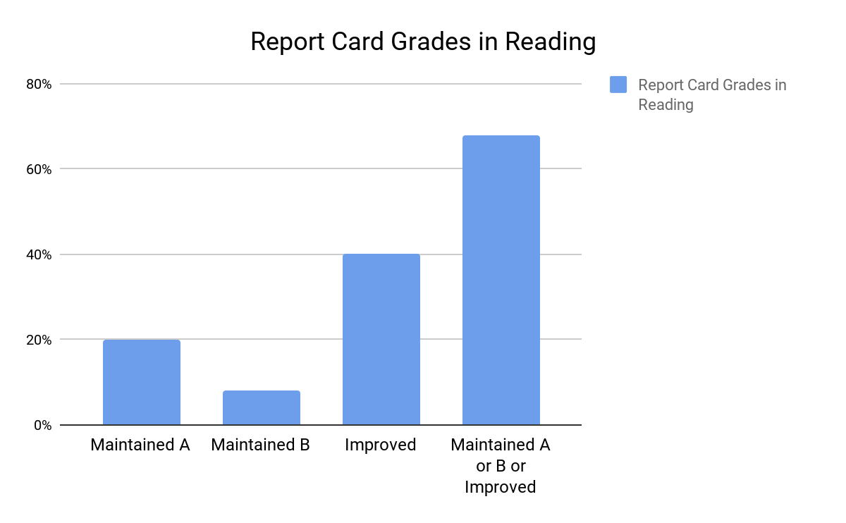

## 

## **Objective 1.3:** 50% of regularly participating students (attending the program 30 days or more) will meet or exceed state standards in math.

The data shows that 59% (n=16) of regularly participating students that chose to take the Georgia Milestones test scored as Developing, Proficient, or Distinguished Learners in Math on the Georgia Milestones assessment, n=27. The objective could not be measured due to the number of program students opting out of taking the Milestones test this year.

## **Objective 1.4:** 50% of regularly participating students (attending the program 30 days or more) will improve grade or maintain and “A” or “B” in math on report card.

The data shows that 43% (n = 10) of regularly attending students maintained an “A” or “B” grade in math on their report card, and 26% (n = 6) improved their grade for a total of 70% maintaining an “A” or “B” or improving their grade in math. This objective was met.

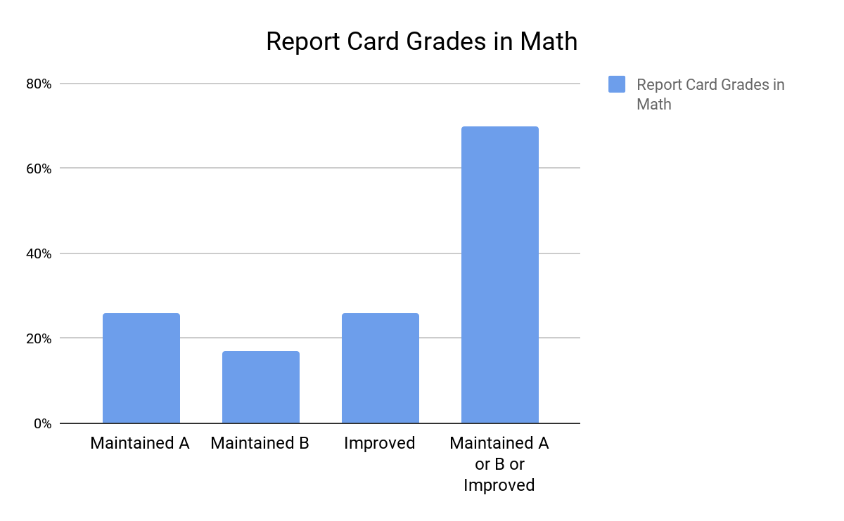

## 

## Goal 1 Findings and Recommendations

Objectives 1.1 and 1.3 (Georgia Milestones Test results) could not be measured due to the number of program students opting out of taking the Georgia Milestones tests.

The data collected shows that the report card objectives were met. This is the 2nd year in a row that both report card objectives were met. Although the percentage is higher this year for both ELA and Math, last year’s percentages were based on a higher number of report cards collected. It is recommended that the BGC Great Futures Program incentivise report card collection in an effort to increase the number of report cards collected. In addition, the BGC Great Futures Program should continue to cultivate the relationship with the school day teachers and continue to strengthen the partnerships with school level and district level administration. It is suggested that the program continue to use the district level pacing guides and teacher communications to guide the afterschool curriculum. Finally, the BGC Great Futures Program should continue to assess staff needs to provide quality, relevant professional development.

# 

# Goal 2: Increase Knowledge of Healthy Lifestyle Choices

## **Objective 2.1:** 65% of regularly participating students will increase their knowledge of healthy eating habits and cardiovascular fitness.

The PACER pre-test was administered to all students at the beginning of the school year (fall 2020) in order to determine prior cardiovascular fitness levels. The PACER (Progressive Aerobic Cardiovascular Endurance Run) is a multistage fit­ness test adapted from the 20-meter shuttle run test published by Leger and Lambert (1982) and revised in 1988 (Leger et al.). The PACER post test was given in the spring (2021). Out of the 23 students that participated in the Fitnessgram program there were 21 students that completed both the pre and post test. The results show that 81% increased their cardiovascular fitness (N=17).

A Healthy Habits pre-test was administered to all students at the beginning of the school year (Fall 2020) in order to determine prior nutritional knowledge. Students participated in weekly nutrition education classes in an effort to improve student’s knowledge of healthy eating habits. A posttest was given in the Spring (2021). Unfortunately the pre and post tests were not properly labeled with the date and students name so it is unclear the number of students who took both assessments. The total number of students that participated in the program was 44. This objective was unable to be measured so it was not met.

## **Objective 2.2:** 65% of regularly participating students will increase their knowledge of avoidance of risk-taking behaviors.

A SMART Moves pre-test was administered to all students at the beginning of the school year (Fall 2020) in order to determine prior knowledge of avoidance of risk-taking behaviors. Clubs worked with students to increase their knowledge of risk-taking behaviors through the implementation of SMART programs, Triple Play Mind, Body and Soul activities, and group discussions. A post test was administered in the Spring (2021) to measure knowledge growth. There were 28 students that completed both the pre and post test. The results show that 93% (n=26) increased their knowledge of risk-taking behaviors. This objective was met.

## Goal 2 Findings and Recommendations:

Many students in the state of Georgia lack sufficient nutrition which often leads to diseases related to obesity and malnutrition. Through its programming, BGC addresses this issue in order to empower youth to make healthy choices. Pre and post tests are used to determine which students will participate in the programs that address healthy eating habits and knowledge of risk taking behaviors. Students that score low on the pre tests participate in the SMART Moves and Healthy Habits, Too programs. This process allows the students that need more guidance in these areas to get the information they need. Since fitness levels are constantly changing and must be practiced on a regular basis to be beneficial, all students participate in the cardiovascular fitness level activities. Both the PACER test and BMI measurements are used to determine whether students are in a healthy fitness zone (HFZ). The PACER test and BMI measurements were taken at the beginning of the school year (Fall 2020) and again at the end of the school year (Spring 2021). 



It is recommended that the BGC continue to include training in the area of fitness, healthy eating habits, and healthy lifestyles each year to keep staff updated on changes in curriculum and updated on new findings. When providing training, it is recommended that staff are given the pre and post tests to make sure they understand the information they are teaching. It is also recommended that a calendar that includes pre and post test dates for all programs is set early in the year. Pre testing packets that include all pre tests from all programs should be created and included with the membership paperwork so that all students are included in the data.

# Goal 3: Improve Social, Emotional, and Life Skills for Positive Youth Development

## **Objective 3.1:** 65% of regularly participating students will increase knowledge of conflict resolution techniques.

This year BGC switched to the B. A. Star program for conflict resolution because it was more in depth and was full of engaging videos and activities for the students. Unfortunately there was not a pre and post assessment included in the curriculum. Therefore, increased knowledge was based on attendance. Students that attended 50% of the classes or more were considered to have an increased knowledge of conflict resolution techniques. Out of the 35 students that participated in the B. A. Star Bullying program, 91% (n=32) attended 5 or more classes.

This objective was met.

## **Objective 3.2:** 75% of regularly participating students will increase civic engagement.

Each of the students contributed a minimum of 1hour of volunteering. Eleven hours of volunteer opportunities were offered. The data shows that 82% (n = 40) of regularly attending students increased their civic engagement. This objective was met.

## **Objective 3.3:** 65% of regularly participating students will increase their knowledge and ability to exercise self and social management.

The Passport to Manhood and SMART Girls Curriculum was not presented this school year. Therefore, there is no data for this objective. This objective was not met.

## 

## Goal 3 Findings and Recommendations:

Empowering students to take control of their emotions and actions can have a long term impact on their future. BGC uses the research based Boys & Girls Clubs of America SMART Programs to introduce topics such as assertiveness, resilience and refusal skills, strengthening decision making skills, and analyzing media and peer influence through role-playing and discussion. Assessing everyone at the beginning of the school year helps BGC staff to determine the students that will benefit from the program. This allows for small groups to participate in hands-on lessons that encourage positive decision making in tough situations. Empowering students to take control of their emotions and actions can have a long term positive impact on their future. The awareness and development of social-emotional skills is an important building block for success. Learning self-awareness, self-control, and interpersonal skills gives students strategies to be successful in school, work, and life. In addition, students who volunteer and give back to the community learn that they can make a difference in their community which leads to an increase in self-confidence, pride, and social awareness. It allows students to experience the world through hands-on activities that help others. It is also linked to academic gains. It is recommended that the program director and club director be more intentional with the pre and post assessments and the administration of each required curriculum. Since the B.A. Star Bullying program does not have a pre/post assessment, it is recommended that the BGC create an assessment to use so that increased knowledge can be measured more efficiently in the future. In an effort to make monitoring easier for the program director and club director, all pre and post surveys should be administered through Google Forms so that results do not have to be tallied by hand. Pre and post test dates should be determined during the beginning of the year planning session. In addition, the staff members in charge of teaching the curriculum should be made aware of the importance of the pre and post assessment data and they should be made aware of the pre/post assessment dates. Also, incorporating a pre and post assessment for instructors at the yearly professional development training will determine if the staff has the appropriate understanding of the curriculum. In addition, pre surveys should be included for all programs in the application packet for members that start the program later in the year. 

# Goal 4: Increase Parental Engagement/Involvement in Students’ Educational Process

## **Objective 4.1:** 65% of regularly participating students’ families participate in at least one parental involvement activity offered monthly.

In an effort to increase parental involvement, a variety of family activities were offered each month. Times and topics were varied in an attempt to accommodate a variety of interests and schedules. The data shows that there were 40 families of regularly attending students and 60% (n = 24) of the students’ families participated in an activity.

## **Objective 4.2:** 50% of regularly participating students’ families will volunteer at the program at least one time annually.

Data from the Great Futures program indicates that there are 40 families of regularly attending students and 60% (n = 24) of the families volunteered at the program during the 2020-2021 school year. This objective was met.

## 

## Goal 4 Findings and Recommendations:

Research shows that when parents are involved in their children’s education, the children perform better in school and in life. The BGC works to increase parental engagement on several levels including: 

* Parental involvement in their child’s education.
* Participation in club and school activities.
* Advocacy for child and education issues.

The program offered monthly parental engagement activities and actively sought parents to volunteer at the club. In addition, BGC hired a part-time family liaison; a designated staff member who communicates directly with caregivers and family members to invite their involvement and participation in the Great Futures program. The data shows that although the parent participation goal was not met both parent participation and parent volunteering increased from last year. In an effort to keep the students and staff safe from the spread of the COVID-19 virus, parents were not permitted in the clubs like they were in the past. This may have been a factor in the low number of parent participants and volunteer opportunities.

It is recommended that the BGC continue to offer monthly opportunities for parental engagement and volunteering activities. Lower-income families face greater challenges to participation than their middle-income counterparts and have significantly lower rates of participation. It should be noted that BGC serves a high concentration of low-income, minority students. In an effort to accommodate the needs of the families, BGC should continue to monitor the needs and schedules of the families. In addition, continuing to seek out partnerships with targeted schools to offer family activities or volunteering opportunities will help parents become more familiar with their child’s school and strengthen the relationship between school and community.

All of the parents interviewed during the evaluation visits were very pleased with the program. It is suggested that the clubs continue to incorporate programs that are relevant and make the parents feel comfortable, welcome, and informed. By administering a survey that inquires about interests and time choices, the clubs can use the survey results to drive parental involvement programs and volunteer opportunities.

# Observations

The evaluation visits included interviews with club directors, staff, students, and parents/caregivers as well as classroom/activity observations using a standard assessment form to assess program delivery and student engagement. The evaluator used the 21st CCLC grant goals and objectives to guide observations and report strengths and challenges in the program. The observations were discussed with the club director and the program director.

|  |
| --- |
| ***Club site observations included:***   * Lesson plans were posted outside each classroom and near open areas such as the gym. * Lesson plans were in line with the 21st CCLC Great Futures Goals and Objectives. * Activities were offered that addressed physical, social, and academic needs. * The designated space for each activity was appropriate. * Students were aware of the club rules and followed them. * Students were provided a healthy snack. * A healthy dinner was served to students. * Students appeared to be having fun! |

# 

# Success Story

**Member:**  Jykeem

**School:** Thomson Elementary

**Grade:** 3rd Grade

**Jykeem’s Story**

Jykeem is a 3rd grader at Thomson Elementary. He has been a member of the Thomson Boys & Girls Club for three years where he attends regularly with his two older brothers. His favorite club activity is anything happening in the gym.

When Jykeem first came to the club he was very disrespectful to the staff and did not get along with his peers. He would get upset over the smallest things. In addition, he was not applying himself at school and his grades were not very good. The staff at the Thomson club worked with Jykeem giving him support and encouragement through mentoring and tutoring. In addition he participated in the SMART Moves programs as well as OJP where he learned how to deal with conflict, how to correctly assert himself and how to be a leader. He is now a confident, helpful club member that enjoys helping the staff and gets along well with his peers.

**Member:** Bruce

**School:** Thomson Elementary

**Grade:** 2nd Grade

**Bruce’s Story**

Bruce is a 2nd grader at Thomson Elementary where he makes very good grades. He has been a member of the Thomson Boys & Girls Club for two years. He lives with his mother and in his free time he loves to play basketball and football.

Although Bruce is a good student academically, he has struggled with his behavior at school and at the club. He was disruptive, disrespectful and would often get into physical fights with his peers. The staff at the BGC worked with Bruce through mentoring and leadership classes such as SMART Moves. In addition, he was given chores to do around the club. The BGC staff also worked with Bruce on working through his conflicts. His behavior has improved tremendously. He now talks through his problems calmly and even helps his peers with their homework.

# 

# Progress Toward Sustainability

The Boys & Girls Clubs of the CSRA Great Futures Program has made progress towards sustainability over the 2020-2021 school year. The program has created 4 partnerships with a variety of agencies such as Augusta Technical College, Kiwanis Club, Patricia Stripling, and Wal-Mart. These partners have contributed $1,950 cash and in-kind donations to support ongoing work of the club.



# 

# Final Recommendations

There is a growing need for quality afterschool programs. The Boys & Girls Clubs of the CSRA have had a positive impact on the youth it serves by focusing on the academic, social, and behavioral needs of the students. BGC has implemented quality programming by aligning the afterschool program with the school day and mindfully incorporating healthy lifestyle education. Overall the 21st CCLC grant was implemented as planned up until mid-March when the COVID-19 Pandemic forced the clubs to close and continue programming virtually. BGC adapted by offering a variety of daily activities from dance to read alouds. Both parents and students reported that they were satisfied with the program.

BGC effectively implemented two out of four Goal 1 Objectives. Due to a lack of data, Georgia Milestones Tests results were unable to be measured. Both of the report card objectives were met.

|  |
| --- |
| ***In an effort to continue providing a quality program, the following is recommended.***   * Create a data team that reviews all required 21st CCLC data that meets four times a year, once after each 9 weeks. Data team should include one member of each club, club director and program director. * Continue to collaborate with superintendent, principals, and school day teachers to identify current trends in academics and behavior that need to be addressed. * Review report card data beginning each 9 weeks to monitor student progress. * Incentivize report card collection in an effort to increase the number of report cards collected. * Review the current curriculum with staff discussing successes and failures and make changes as necessary to keep activities fresh and fun. * Seek out high interest programming such as Project Based Learning activities and STEM activities and provide professional development opportunities to club directors and staff. Include pre/post surveys for staff when receiving training to check for understanding. |

BGC administered all program pre and post assessments for the Goal 2 objectives. However, assessments for Objective 2.1 were not labeled with student names, therefore, the program results could not be measured and the impact of the program is unknown. This is the 2nd year Objective 2.1 was unable to be measured. Objective 2.2 was met for the first time at 93%.

|  |
| --- |
| ***In an effort to continue implementing a successful program, the following is recommended.***   * Pre and post assessments should be administered through the Google Forms interface to make monitoring and summarizing the data easier for the program director and club director. The mandatory answer feature will ensure that assessments are labeled with individual names. * A data team should be created that includes the club director, a data clerk and the program director. This team should meet four times a year after each report card distribution. * Curriculum pre and post assessments should be scheduled early in the year at pre-planning professional development. Dates should be shared with club directors and staff. In addition, staff members should be made aware of the importance of the pre and post assessment data. * Provide professional development opportunities to club directors and staff on current healthy lifestyles trends, ways to incorporate physical fitness in the everyday routine, proper administration of the PACER test, and curriculum. Include a pre and post assessment to check for understanding. * Continue utilizing the screening process for the SMART programs in order to meet the needs of those students that need it most. Monitor students' understanding of the curriculum throughout the program and adjust information as necessary. * Incorporate healthy lifestyles information in newsletters and family activities in order to educate parents/families on the importance of incorporating healthy behaviors in everyday life. |

Two out of three Goal 3 Objectives were met. Although Goal 3 Objective 3.1 was met, BGC was unable to administer the pre and post assessments for the B.A. Star Bullying program due to the absence of such assessments in the curriculum. Therefore, the program results were based on attendance with increased knowledge being those students who attended 5 or more classes. Objective 3.2 Increase Civic Engagement was met for the first time this year. Civic engagement opportunities may not have been as readily available due to the constant restrictions on socialization due to the COVID-19 pandemic but the BGC still managed to meet this objective. Finally, there was no data available for Objective 3.3 Increased Knowledge in Self and Social Management due to the oversight of curriculum administration. This is the second year in a row that Objective 3.3 was not met.

|  |
| --- |
| ***In an effort to continue implementing a successful program, the following is recommended.***   * Program director should assign a specific curriculum to each goal/objective and communicate this to club directors. Staff should be trained on each curriculum and the correlation between the goal/objective and the curriculum should be made clear. * Review all pre and post surveys to make sure they match the curriculum being presented. If there is not a pre/post assessment then one should be designed and implemented. * Survey students to determine the community service projects that interest them. This gives students ownership of the projects and nurtures leadership skills. * Continue to offer multiple opportunities for students to volunteer throughout the year. * Curriculum pre and post assessments should be scheduled early in the year at pre-planning professional development. Dates should be shared with club directors and staff. In addition, staff members should be made aware of the importance of the pre and post assessment data. * Pre and post assessments should be administered through the Google Forms interface to make monitoring and summarizing the data easier for the program director and club director. * Monitor students’ understanding of the SMART programs curriculum, adjusting information as needed. |

BGC was able to meet one out of two Goal 4 objectives this year. This is an improvement from last year. This year Objective 4.2 was met but Objective 4.1 was not. The restrictions put in place by the clubs to keep the staff and students healthy limited parent/guardian participation. This may have had an effect on these objectives.

|  |
| --- |
| ***In an effort to continue implementing a successful program, the following is recommended.***   * Continue to survey families at the beginning of the year to find out interests and needs. Use the results to plan activities and volunteer opportunities. * Inquire about the skills/talents of the parents and family members and ask them to share at a club event. Skills such as gardening, sewing, woodworking, singing, masonry, or home repair would make a great family night presentation. * Consider offering a weekend activity or two to accommodate those parents that may be unable to attend during the week due to work schedules. * Offer programs and activities that include student participation such as musical performances, academic fairs, art shows, or talent shows. Parents/Caregivers love to see their children in the spotlight. * Offer activities that empower parents/caregivers to help their children succeed. Study skills, homework help, current math trends are all sources of frustration for many families. * Use a variety of communication methods such as newsletters, emails, Facebook and other social media platforms, text message services such as Remind, club message boards, and student made posters. * Give plenty of notice of events so that parents have time to plan and work around work schedules. * Offer meals at family events to alleviate the challenge of having to feed a family on a busy evening. * In order to make participation easier for parents with young children, BGC may want to work with older club members to offer childcare. A babysitting course could be offered to older youth for this purpose. |