**President/Commander in Chief:**

* President Joseph R. Biden Jr.

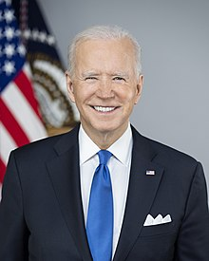

**Vice President:**

* Vice President Kamala Harris

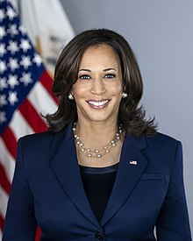

**Secretary of Defense:**

* The Honorable Lloyd Austin

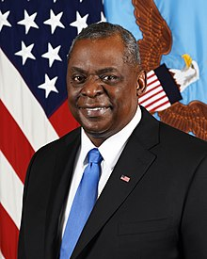

**Secretary of State:**

* The Honorable Antony Blinken

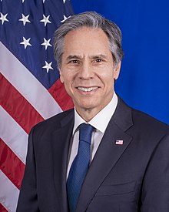

**Secretary of the Navy:**

* The Honorable Carlos Del Toro

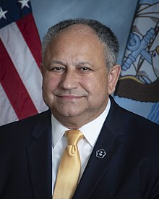

**Chairman of Joint Chiefs of Staff:**

* General Mark Milley

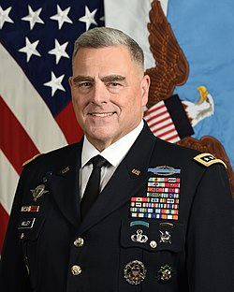

**Chief of Naval Operations:**

* Admiral Michael Gilday

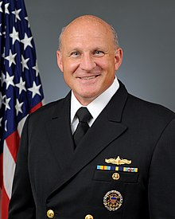

**Naval Education and Training Command:**

* Rear Admiral Upper Half Peter Garvin

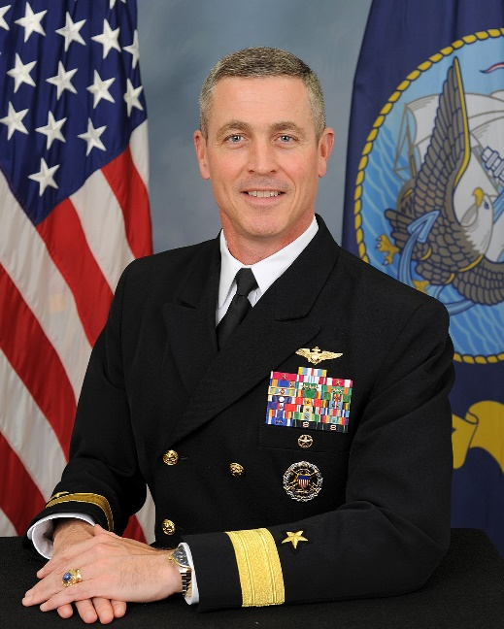

**Naval Service Training Command:**

* Rear Admiral Lower Half Jennifer Couture

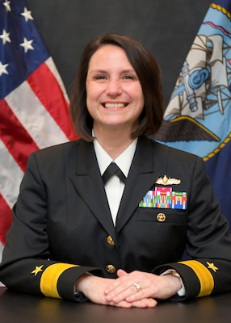

**Master Chief Petty Officer of the Navy**

* Master Chief Petty Officer Russel Smith

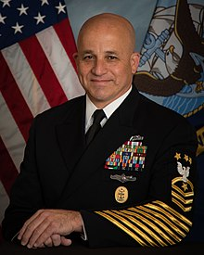

**Commandant of the Marine Corps:**

* General David Berger

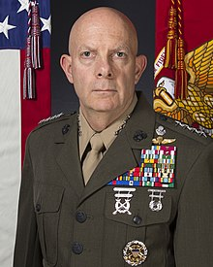

**Sergeant Major of the Marine Corps:**

* Sergeant Major Troy Black

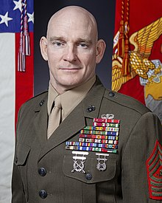

**Area 7 Manager:**

* Commander Patrick Thurman

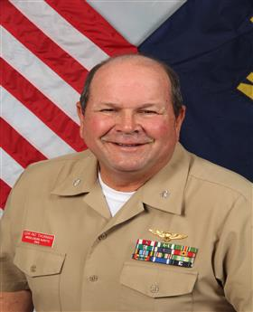

**Senior Naval Science Instructor:**

* Commander Brian McDonald

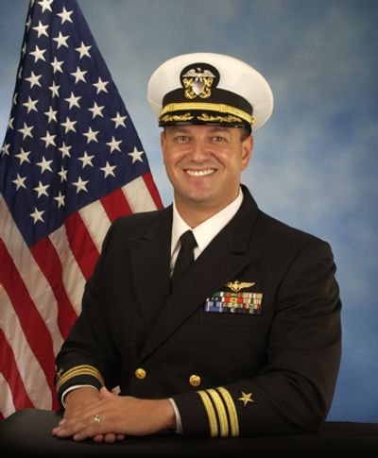

**Naval Science Instructor:**

* Master Chief Petty Officer Patrick Peterson