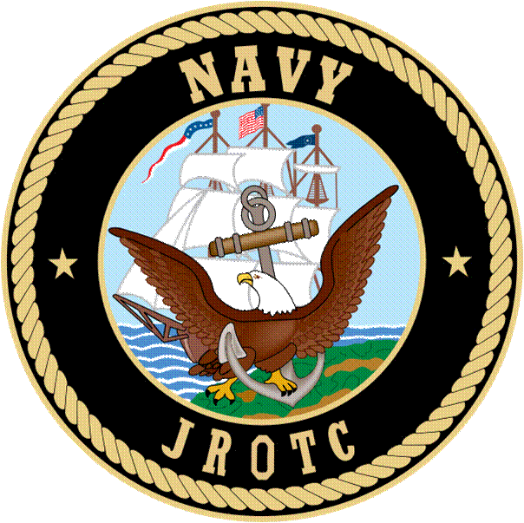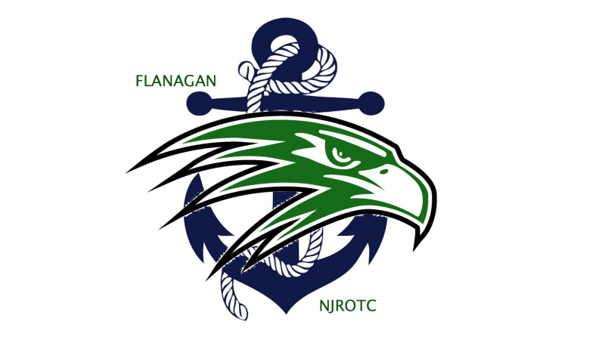
Flanagan NJROTC
UNIFORM AND GROOMING AGREEMENT

1. I understand that I MUST wear my uniform on the prescribed day(s) or as instructed by the Naval Science Instructors to pass this course! If I do not wear my entire uniform properly, I will fail the uniform inspection. I understand that if I miss just two uniform inspections I will fail the Semester.

I will be issued my first set of uniforms at the beginning of the school year. I am responsible for keeping track of these materials and if any items are lost or damaged I will be required to purchase replacements. At the end of the school year I must turn back in my uniforms or I will be required to reimburse the U.S. Government for the cost of the uniform. Replacement costs can be obtained on the JROTC website or inquiring with the Naval Science Instructors.

I acknowledge that an important part of wearing the NJROTC Uniform is meeting Navy Grooming Standards. For male Cadets, this I agree that means NO facial hair (having a clean shave) except mustaches and having a haircut that meets Navy Uniform Regulations (Cadet Field Manual pgs 7-11)
For female Cadets, this means that my hair must be pulled up off of the collar in such a fashion that it allows for proper wear of the uniform cover (hat), and NO artificial hair colors. Earrings and fingernail polish must also meet Navy Regulations. Additional details can be found in the Cadet Field Manual that is on our website or in the classroom.

I acknowledge that there are NO exceptions to this requirement. If I am out of Navy Grooming Standards I will fail the Uniform Inspection.
------------------------------------------------------------------------------------------------------------
I have received this letter and agree that I will be held responsible for the proper wear and replacement of my NJROTC uniform, and further agree to meet Navy Grooming standards at all times while in this program.

______________________________ ____________________________
Print Student Name Student Signature

______________________________ ____________________________
Print Parent/Guardian Name Parent/Guardian Signature

Date__________________________

