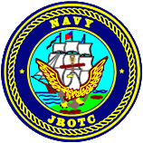 **Charles W. Flanagan Senior High School** 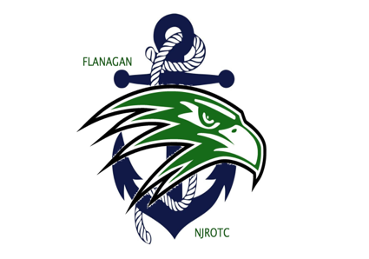

12800 Taft Street

Pembroke Pines, FL 33028

754-323-0742

Dear Parents and Cadets,

Welcome all cadets and parents to Charles W. Flanagan High School NJROTC Falcon Battalion. By enrolling in this program, you have embarked on a journey that few other high school students will ever experience. Your time in this unit will challenge you mentally, physically, and morally and allow you to develop skills in followership, teamwork, and leadership. We expect great things from you, and we are prepared to do everything possible to meet your expectations.

For those of you who are returning, congratulations on a good job this past year. Through your hard work, our unit achieved the Unit Achievement Award, and competed in several competitions finishing in the top tier of each event and placing 5th in the state in academics. You should be proud of your unit’s accomplishments! We anticipate a great year this year as we look to compete at the State and National drill competitions. We are also very excited to introduce several new after school activities to include Sea Perch (underwater robotics), Drone, Air Rifle, and Orienteering (land navigation) competitions.

Enclosed is a package of paperwork that must be read and carefully filled out, signed, and returned no later than the dates noted on the enclosures. A physical must be completed that is good for the entire school year to include a doctor’s signature. These forms must be completed in order for cadets to participate in any NJROTC regular or extra-curricular activities.

We look forward to a great year and helping your child grow in leadership and responsibilities. GO FALCONS!

Sincerely,

CDR Brian McDonald DCCM Patrick Peterson

USN (Ret.) USN (Ret.)

Senior Naval Science Instructor Naval Science Instructor