**CHAIN OF COMMAND**

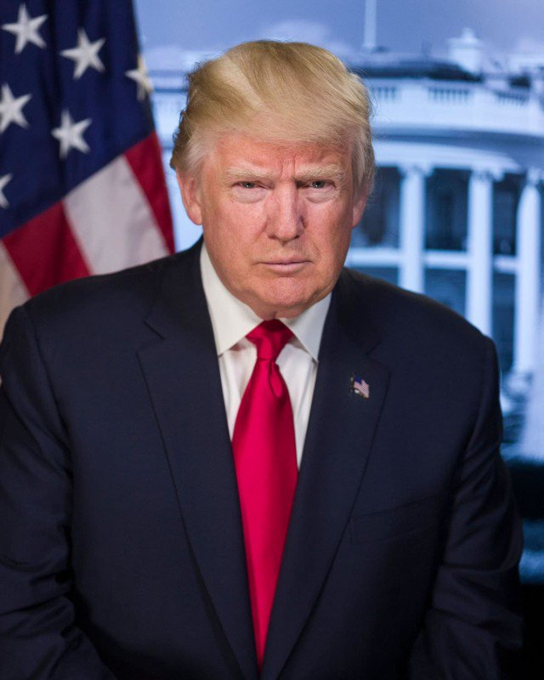

Commander in Chief/The President of the United States -  The Honorable Donald J. Trump

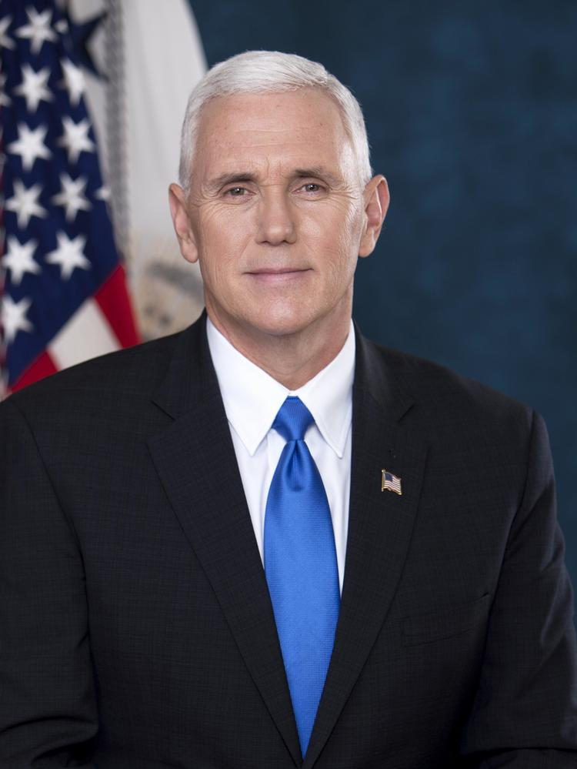

Vice President (VP)  -  The Honorable Michael Pence

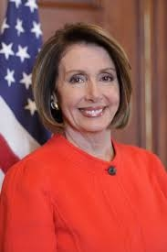

Speaker Of The House  -  The Honorable Nancy Pelosi

[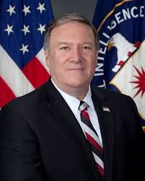](https://sites.google.com/site/coopercityhighnjrotc/chain-of-command/old.jpg?attredirects=0)

Secretary of State (SoS)  -  The Honorable Mike Pompeo

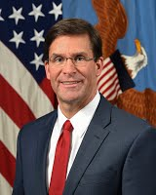

Secretary of Defense (SecDef)  -  The Honorable Mark Esper

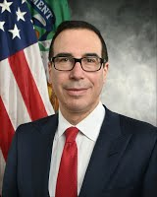

Secretary of Treasury - The Honorable Steven Mnuchin

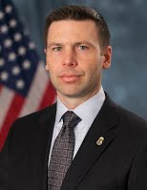

Director of Homeland Security  -  The Honorable Kevin McAleenan

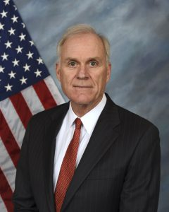

Secretary of the Navy (SECNAV)  -  The Honorable Richard Spencer

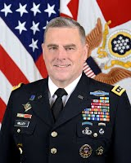

Chairman-designate of the Joint Chief of Staff  -  General Mark A. Milley

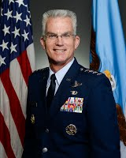

Vice-Chairman of the Joint Chief of Staff  -  General Paul J. Selva

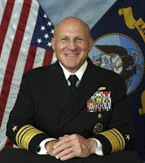

Chief of Naval Operations (CNO)  -  Admiral Michael M. Gilday

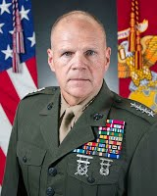

Commandant of the Marine Corps  -  General Robert B. Neller

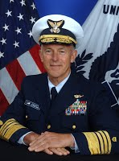

Commandant of the Coast Guard  -  Admiral Paul F. Zukunft

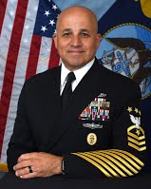

Master Chief Petty Officer of the Navy (MCPON)  -  Master Chief Petty Officer Russell Smith

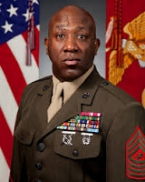

Sergeant Major of the Marine Corps (SMMC) -  Sergeant Major Ronald L. Green

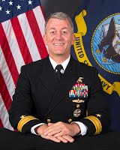

Naval Service Training Command (NSTC)  - Rear Admiral Milton J. Sands III

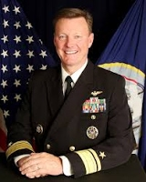

Naval Education and Training Command (NETC)  - Rear Admiral Kyle Cozad

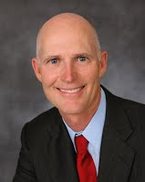

Senator of Florida - Senator Rick Scott

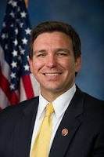

Governor of Florida  - Governor Ron DeSantis

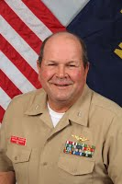

NJROTC Area 7 Manager  - Commander Thurman