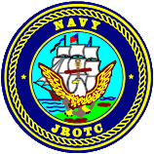
Charles W. Flanagan Senior High School 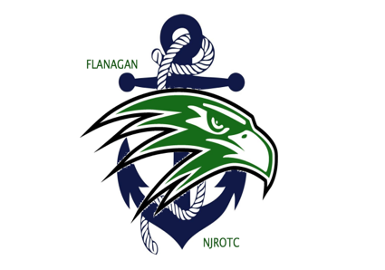
12800 Taft Street
Pembroke Pines, FL 33028
754-323-0742

NJROTC UNIFORM ISSUE AND TURN-IN PROCEDURES

Dear parents,

The following are guidelines for the initial uniform issue, and return policy:

- Upon uniform issue, each cadet will be issued a custody card to be signed by the cadetand returned to the Naval Science classroom upon uniform issue.
- All items must be turned in at the same time in order to facilitate complete and accurate accountability.
- Upon turning in uniforms, your cadet will be issued a “Custody Card Receipt” indicating a cleared NJROTC account.
- It is imperative that your cadet turns in their uniforms directly to the Naval Science Instructors in order for you to receive your Custody Card Receipt which will be your proof of a cleared NJROTC account. Turning in your uniforms to the school office WILL NOT guarantee that your account will be properly cleared.
- If your cadet’s uniforms have not been turned in, or the account is not properly cleared, his/her name will appear on the school’s “OBLIGATIONS” list the day after disenrollment. *If your cadet is a senior and has an obligation, he/she will not receive their graduation diploma*

I have read, understand and will comply with all of the above requirements and thoroughly understand that any infractions will result in appropriate disciplinary action.

____________________________ _____________________________ ___________
Cadet’s Name (Print) Cadet Signature Date

____________________________ _____________________________ ___________
Parent’s Name (Print) Parent Signature Date

