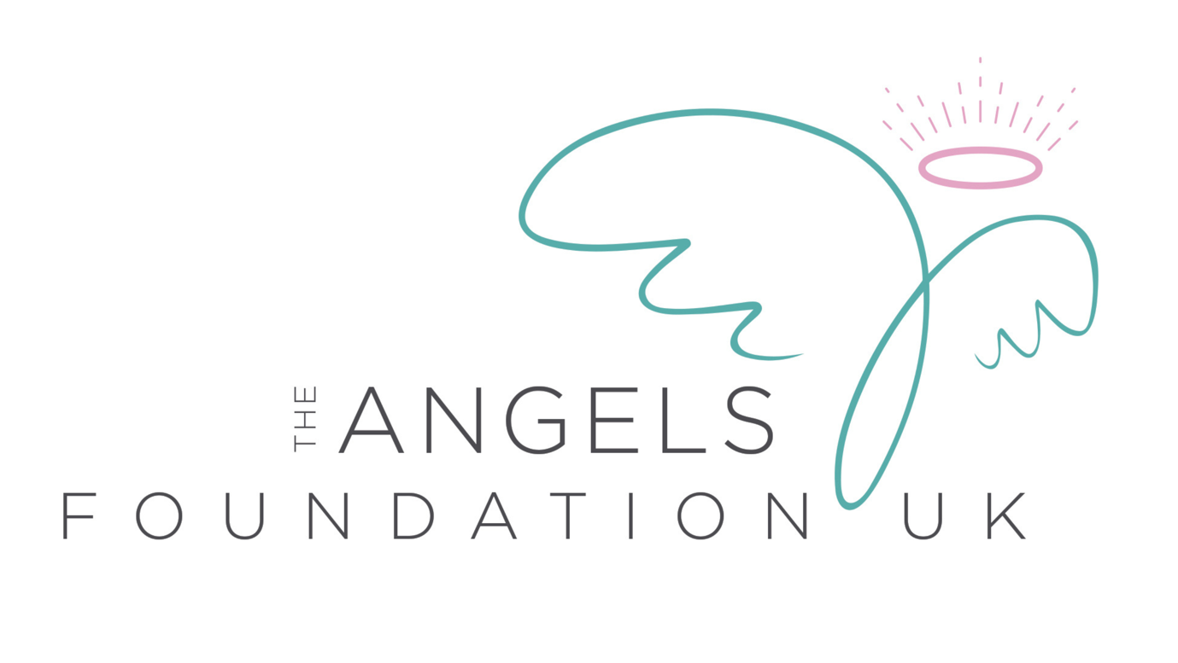

Privacy Notice
June 2026

Who We Are
The Angels Foundation UK is a registered charity providing support, counselling and advocacy services for individuals affected by abuse, trauma and related challenges.
The Angels Foundation UK is the Data Controller for the personal information we collect.
Information We Collect
We may collect:
- Name, address and contact details
- Date of birth
- Emergency contact information
- Referral information
- Counselling and support records
- Safeguarding information
- Equality and diversity information
- Volunteer and employment information
- Donation and fundraising records
- Website and communication preferences

Why We Process Personal Information
We process personal information to:
- Deliver support services
- Manage counselling and therapy provision
- Safeguard children and adults at risk
- Manage volunteers, staff and trustees
- Communicate with supporters and donors
- Meet legal and regulatory obligations
- Monitor and improve services
Lawful Bases for Processing
We process personal data under one or more lawful bases under UK GDPR, including:
- Consent
- Contract
- Legal obligation
- Vital interests
- Legitimate interests
- Provision of health or social care services
Sharing Information
Information may be shared with:
- Safeguarding agencies
- Local authorities
- Health services
- Police
- Commissioners and funders (where anonymised or required)
- Professional supervisors where appropriate
Information will only be shared where there is a lawful basis to do so.
How We Store Information
The Angels Foundation UK uses secure systems including:
- Beacon CRM
- Microsoft 365 / SharePoint
- Secure electronic storage
- Locked physical storage where applicable

Access is restricted to authorised personnel.

How Long We Keep Information
Records are retained in accordance with the charity’s Data Retention Schedule and legal requirements.
Your Rights
Under UK GDPR you have the right to:
- Access your information
- Request correction of inaccurate information
- Request erasure where applicable
- Restrict processing
- Object to processing
- Data portability where applicable
- Withdraw consent where consent is relied upon
How to Make a Complaint
If you have concerns about how we have handled your personal information, please contact us first:
Email: support@angelsfoundation.org.uk
Website: www.angelsfoundation.org.uk
We will acknowledge your complaint within 30 calendar days and investigate it without undue delay.
If you remain dissatisfied, you may contact:
Information Commissioner’s Office
www.ico.org.uk
0303 123 1113
Contact
The Angels Foundation UK
support@angelsfoundation.org.uk
01480 271771
Registered Charity Number: 1205725

