cTracker – Display Settings Guide
- Set Rows 10, Font Size 8, and select AutoFit
- Save your settings and start the cTracker

- The cTracker’s size will automatically calibrated to your monitors screen resolution. Look to make sure the cTracker is displaying all data rows and columns.

Example where all rows and columns display:
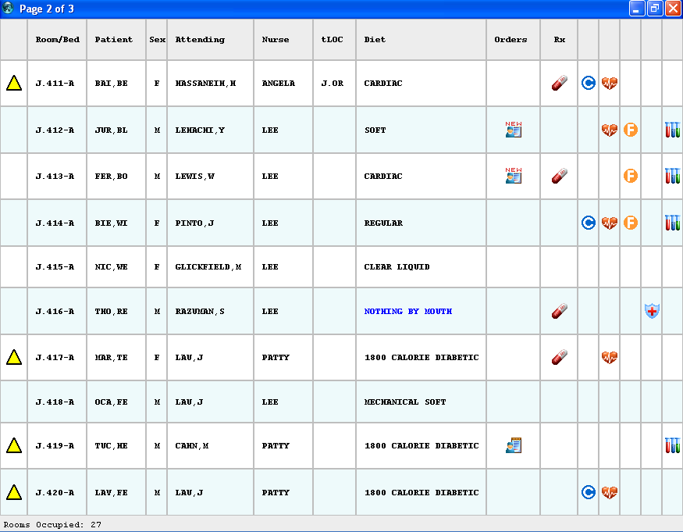

Example where all the rows are appearing, but notice the columns do not fit properly.
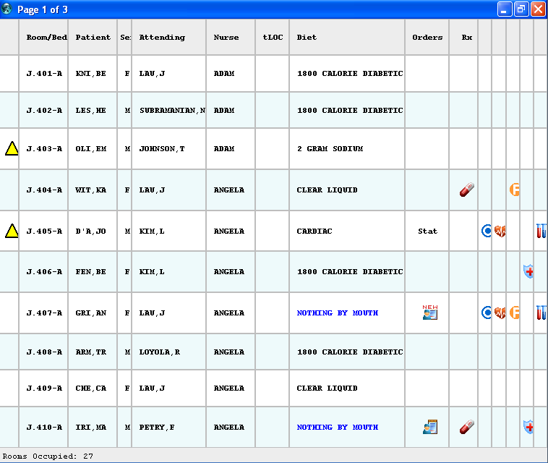

If your monitor is not displaying all the rows and columns properly, it is impossible for you to get the cTracker to fit at your current screen resolution. You will need to adjust the monitor to a higher resolution and repeat these setup instructions.

If your monitor will not adjust to a higher resolution, the current NPR Report will not work. The only solution is to have custom NPR Report procedure developed to work at your best screen resolution.

- Once you have all the rows and columns fitting correctly, increase the font size to the maximim value that will still fit your monitor.

Example where I increased the font size from 8 to 9. Everything looks fine:
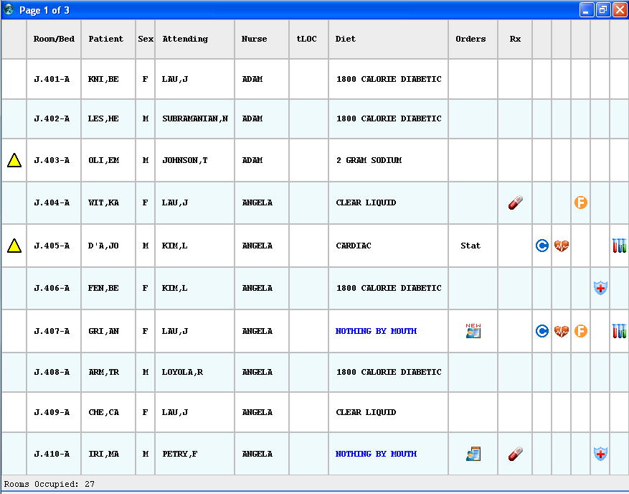

After I increase the font size to 10 notice things did not look so good. This means my maximum font size is 9 for this cTracker. Make sure you have the font size set to the maximum before continuing to the next step.

- Increase rows to maximize the space of the monitor. Continue to increase the number of rows until all the rows no longer fit.
In this example I increased the rows to 23 before I experienced problems. Notice in the screenshot below the last row is partialy missing. This means my maximum number of rows is 22.

- Your setup is now complete. Make you saved your settings with the maximum font size, maximum rows, and AutoFit selected.

