92, Elmfield Avenue, Birstall. Leicester. LE4 3DF Email: [pen@birstalluk.com](mailto:pen@birstalluk.com) Christmas 2024

Our year has been eventful with a series of highs and lows. At first, it seemed as though not much had happened compared to previous years but on reflection it has been quite busy.

India is our destination this Christmas and New Year. We fly to Mumbai on Christmas Eve and later to Goa for a bit of sun, sea and sand.

Our first away trip during the year took us to Sweden again. In the depths of mid-winter, we joined our ‘Aussie/Swedish godsons’ to celebrate their grandmother’s 80th birthday. She had flown over with her husband and son Graham for the occasion, and we were delighted to be part of weekend. We’ve never been to Vasteras in such cold temperatures and the estuary and lake were solid blocks of ice!

Ben’s aunt Rose, from South Africa, visited the UK in April and we were pleased to have her and his cousins from Surrey visit us and enjoy a weekend together.

The early part of our year was governed by Ben’s training for the London Marathon in April. He had secured a charity place with MS UK and was able to join and train with friends Jeanette and Rupesh who had won ballot places. It was a rigorous training schedule which all three followed well. For the marathon weekend, we based ourselves in a hotel in Piccadilly, so we were near the finish in the Mall and within easy reach of Charing Cross to get the train out to the start at Greenwich. It was without doubt a momentous day and achievement. Ben completed the run in 4 hours 45 minutes and raised £4000 for his charity.

Running continued throughout the year with Ben taking part in the Ashby 20 and Naseby1664 as part of his marathon training and culminating – outside our usual Birstall Running Club activities - with Equinox 24 at Belvoir Castle. Not a great fan of camping, Ben coped reasonably well despite thunder, lightning and heavy rain on the Saturday night. The Friday night and Saturday daytime were quite pleasant as we joined with a few other running club members. Ben and Jeanette made up a team and did 5 laps each of the 10km course including the 2 day and night 10k runs which Pete also took part in. Not put off by the experience Ben has entered solo for next year.

July took us to France for our annual summer holiday. We had a gorgeous apartment overlooking the sea at Roquebune-Cap-Martin on the French Riviera. We had fantastic weather and both ventured into the warm waters of the Mediterranean each day. Our only slight mishap was wandering into a very expensive bar one evening and ending up with 38 euro cocktail each instead of our usual lagers.

Week to week we continue to enjoy our own hobbies and interests. Ben has had a few trips to visit friends in Amsterdam joining a lively crowd on a boat for Pride Weekend. He also enjoys the relaxation and challenges from cooking (ably assisted by Mary Berry!) and our -wouldn’t be without now – air fryer.

The bikes have been out on nice warm sunny weekends visiting our usual haunts for a coffee stop and we have continued to frequent antique or curiosity shops as we come by them. In early autumn, we found a Book Farm Shop in Warwickshire and visited in the hope of passing on some of Pete dad’s theology books but we are still looking for a good home for them and once again came back with more books!

Pete’s model railway continues to expand or change shape - depending how you look at it - though I doubt it will ever be finished. Both his ‘N’ Guage in his workshop and ‘OO’ Guage in the loft have developed considerably over the last few years but ‘playing trains’ - as Ben sees it - can sometime interrupt the household chores!

We managed through a crisis with Ben’s mum who was rushed to hospital in October having had an up and down year health wise but is now back to good health.

In August, we had a visit from our eldest godson Evan, from Sweden. We were pleased to have him with us on our trips to Bristol and Weymouth to see Pete’s aunt and sister. We then took him up to London for a few days before returning to Leicester. Evan is a good 400m athlete and is hoping to come to UK to follow up on training to an international standard. We took him to a few athletic clubs who have international standard coaches. We look forward to him coming over again in January.

Ancestry as we have mentioned before is one of our interests and we both revisit our growing family tree now and then and follow some of the family history we uncover. It’s a fascinating interest made even more so by the extensive resources of the internet software available. In November, we were delighted to meet some of Pete’s Canadian cousins in London. They were over from Vancouver, Canada, and we had a great time with them and sharing updates and intel for our family tree.

Ben clocked up his 18th year working for Coles Nurseries during November. His duties and role have continued to grow and he has taken on IT support and the complexities of purchasing post Brexit.

Although all of his work can be done at home via internet and cloud software Pete continues to go up to Newcastle every 5 or 6 weeks where he acts as Financial Controller for a footwear manufacturer and over to Oadby once a week to his client in the leisure industry.

Check out our website [www.penprivate.com](http://www.penprivate.com) or see us on Facebook (under our individual names) to keep up with our adventures.

We would be delighted to see any of our family and friends, at any time, at ours should you be nearby or like to visit us. We both hope you have a Merry Christmas and a Prosperous, Contented and Happy New

Peter and Ben

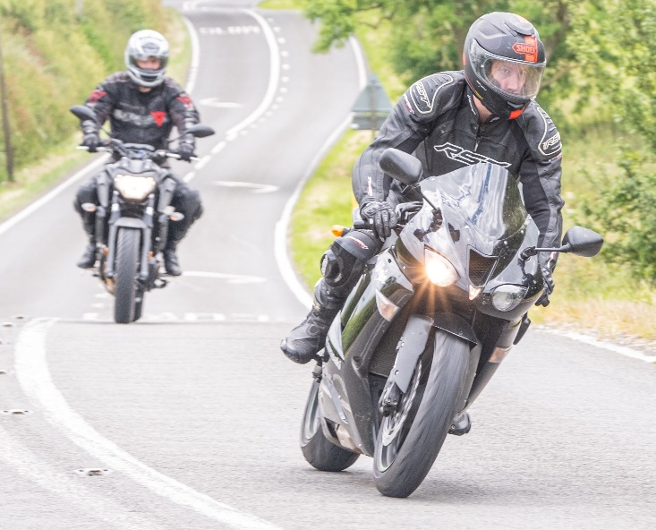

Following Ben on our bikes in summer London Marathon

France Holiday July 2024 Park Run at Conkers with Jeanette September 2024