
Well what a year we have all experienced and endured! Like everyone we look forward to Easter next year and hope we have some return to normality. Our vocabulary has been extended by the words ‘Zoom’, ‘Virtual’, ‘Lockdown’, and if your anything like us your car, house and pockets have quantities of masks, gloves and mini-sanitisers in them.

We welcomed in 2020 at a Celebration Dinner in Malta which was our only overseas trip or indeed holiday this year. It wasn’t as warm as we would have liked and our view of Malta left much to be desired but it was a break and we long for the next.

The enforced lockdown, at the end of March, saw us both working from home which was an interesting experience. Ben, fortunately, remained fully employed and set up his desk in the back bedroom. The stock control of Coles Nurseries was managed from Elmfield Avenue for several months. In anticipation of possible further lockdowns, we decided to refurbish one of our studies to Ben’s own design. Peter who had planned to gradually reduce his work load, over the year, suddenly found it increase dramatically having to assist all his clients with CIBILS, advice, furlough claims, monitor their worsening cash flows and generally give what assistance he could to help them all through their individual problems as Covid19 hit their businesses.

We did a few useful things during lockdown and converted an ageing bench table into a log store and mini table for the garden. We invested in a Pressure Washer and discovered a lovely coloured patio under the dirty paving which has given us a nice garden aspect all summer. The washing machine gave up in early April and as tips were closed and instead of leaving it outside for scrap collection, Peter dissected it and recycled wires for model railway, other bits to his workshop. Even the metal shell was turned into an incinerator ! (Much to Ben’s annoyance – he’s not always over keen on my recycling habit )

Our membership of the Birstall running club has kept active throughout with many virtual activities. We ceased to meet as a full club in March but many members have introduced virtual events and challenged us all. In June, Ben hosted a virtual ‘round the world challenge’. Every day BRC members would run a distance on their own and post their mileage thereafter. He would then collect the totals and determine how far we had travelled as a club. He would plot it on the world map and tell the club where we had got to each day. It was fun as we travelled Birstall to Hong Kong via Budapest, Tbilisi, the ‘Taj Mahal’ in India giving a few facts of each place visited. We covered 9,032 miles in total !
We have enjoyed all the activities but miss our park runs and the club’s social events and look forward to their eventual return.

In April, we had a fun morning (or night in the case of our friends ) linking with Adelaide and Tasmania via Zoom and playing ‘Kahoots’ together. If you’ve not heard of it you should download the app it’s a fun family game. It was so successful, we tried it with Peter’s family the following week where we had Guernsey, Bristol, Weymouth and Leicester all online together.

Once the first lockdown eased we did venture out for a few short bike rides (motor and pedal ) often ending up at our favourite local place – Wymondam Windmill for an outdoor coffee.
Peter’s model railway has extended into the laundry (temporarily) and occupies him from time to time though this year he has taken to reading much more. Ben remains absorbed in his ancestry.

In mid- summer, Ben’s Mum and Dad announced their desire to move nearer to either Ben or their daughter Ellie who lives in Sheffield. After much heartache over the decision it was eventually decided they would move to Leicester. Shortly after, an ideal bungalow some 750 yards from us in Birstall, appeared on the market and they put an offer in for it. Finally, on December 2nd we exchanged contracts. Meanwhile, we are in the process of selling their house in Stafford. All very stressful dealing with lenders, solicitors and agents.!

For several years now, Ben’s three godsons in Australia have referred to us as the ‘Uncles Pen’ and it has stuck with us. Our own website – which we update frequently – is called the ‘World of PEN’. This letter was started on the morning of 5th December whilst we were eagerly awaiting a new arrival in the family – we delayed its completion in the hope the baby would soon arrive as it was already 11 days overdue!

Ben’s niece, ‘Pippa’, arrived later in the day weighing in at 8lbs 9oz. Her ‘Uncles PEN’ are delighted.

MERRY CHRISTMAS AND HAPPY NEW YEAR TO ALL

www.penprivate.com

92,Elmfield Avenue, Birstall. Leicester. LE4 3DF

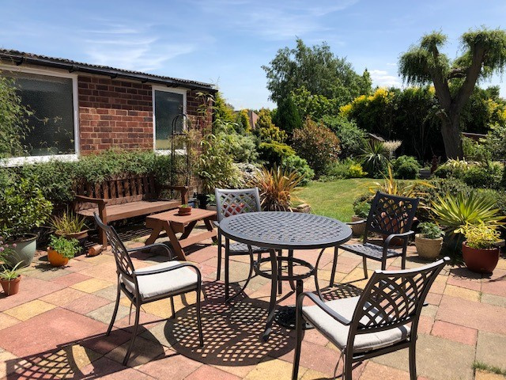 Summertime 2020 at Elmfield
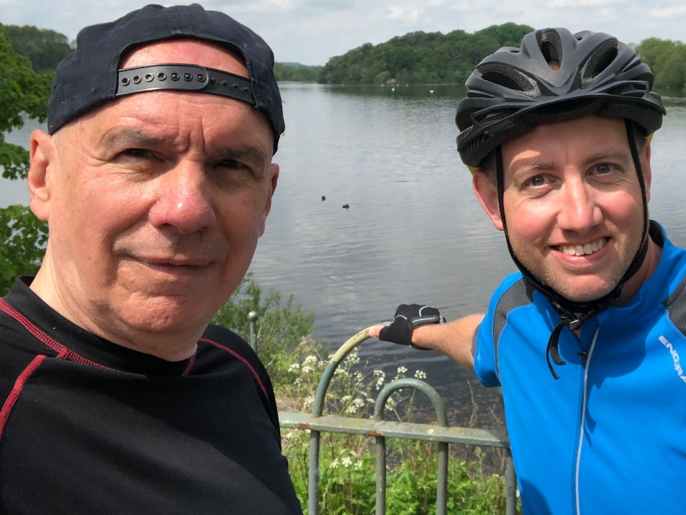 Out cycling together. May 2020

