92, Elmfield Avenue, Birstall. Leicester. LE4 3DF

I think if you were to ask us about this year we would both say we have found it more difficult than 2020. We are both suffering from a touch of ‘cabin fever’! Like everyone else we have endured another year hand in hand with Covid19 and whilst we fortunately have not had the virus, we have felt the effects of it and the continued restrictions it has inevitably had on our lives. Masks, sanitiser and distancing continue to be the order of the day and we have been particularly careful in not mixing in large gatherings.

In November 2020. we were in the final stages of selling Ben’s parent’s home in Stafford and buying them a bungalow, here in Birstall. We finally got the keys to ‘Ambergate’ on December 14th and completed the sale of the Stafford house on January 8th. These transactions were done completely ‘online’ and we can only thank technology for enabling it all to be done and providing a platform for our entire family and friends to keep in touch in these difficult times. There were several things we had to attend to in the new house, namely the bedroom and bathroom and we had to wait for carpets and electrics but finally Ben’s Mum and Dad were able to move in during March. Owing to essential building work on their Stafford property they had lived with us for almost 5 months during the whole move. I think we all appreciated the return to our own space and now they are happily settled in as Birstall villagers!

Our happy event towards the end of last year was the arrival of Ben’s niece Pippa Mae on December 5th. Although Ellie, Aled and Pippa live in Sheffield it is an easy journey to and from Birstall and as soon as we were able, we made the journey to meet her and have enjoyed visits both ways throughout the year. Peter particularly likes the visits to Sheffield as they live in walking distance to a big model railway shop! It was good to be able to celebrate her first birthday in Sheffield on the actual day.

Work wise we have both remained busy. Ben had a short spell working from home again but is now fully back in the office and continues to make his mark on the stock management at James Coles Nurseries. With various personnel leaving he has gradually increased his workload and responsibilities and has now firmly established himself as a member of the management team. Peter has retirement in sight but has remained very busy advising and helping clients with issues arising from the pandemic. He has been to Newcastle several times where he has found a nice compact apartment by the river to stay at so he can take his own food etc, so managed to get round the closure of restaurants etc earlier in the year. He has gradually been engaging other accountants to take on his clients so 2022 can be his final year at work.

In the first half of 2021 our running club did not have full club meetings but when permitted small groups of six organised runs together so Ben was able to keep up his running and socialising with other members and friends. Peter bought a new mountain bike and we did a few cycle rides out together. Ben did a 50 mile ride to Belvoir Castle with a group from the club and did a Charity Bike ride of 70 miles plus several other rides with another club member over the summer. In September, Birstall Running Club launched the Watermead Park Run so we now have a park run on our doorstep and either run or marshal on Saturdays from time to time. In October, Ben finally did the Leicester Half Marathon. Peter was a marshal and yet again needed his umbrella and even his motorcycle waterproofs to stay dry !

There have been some nice dry days and we have been out for a few motorcycle rides often to our favourite spot - the Wymonham Windmill for coffee and a bacon roll.

Peter’s model railway has continued to expand and now has a double feature. 00 gauge and N gauge plus the addition of sound fitted trains – which I have to admit do sound good.

We changed Ben’s car in March for a new Citroen DS so we have one good car though my 10 year old Ford Focus is still in pretty good condition for its age. It tends to be the one used for taking things to the skip or collecting logs for the wood burner ! During the warm weather spell in July we took Ben’s mum down to Plymouth to visit an old friend and enjoyed a few days on the English riviera. We refrained from any foreign travel due to the uncertainties of quarantine but travelled into Wales to visit family and friends moving from south-west near Aberporth up to the north coast. It gave us a break and we were fortunate with a hot week of weather

November - although neither of us like the month with dark mornings and nights – was going reasonably ok until Peter collapsed on the morning of 11th. It was fortunate his godson Ryan has just popped in for a coffee. The ambulance crew and all NHS staff at Leicester Royal Infirmary were marvellous. He had an internal bleed from an ulcer. A blood transfusion and treatment got him back to rights but it was a bit of shock to both of us and a 7 day spell in hospital.

We both hope you have a Merry Christmas and a Happy New Year.

[www.penprivate.com](http://www.penprivate.com)

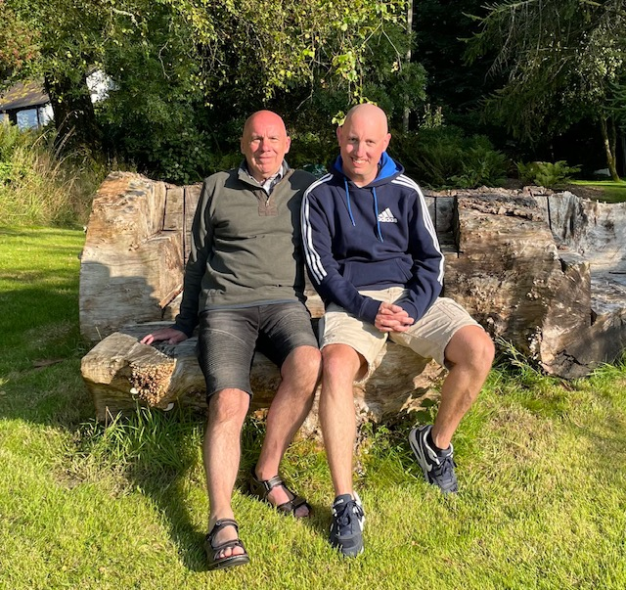

Photos clockwise,

A glorious summer evening in Wales, August 2021

A pleasant walk in North Wales August 2021

A ride out on our bikes October 2021

Birstall Running Clubs ‘Poppy Run’ November 2021