
92, Elmfield Avenue, Birstall. Leicester. LE4 3DF Email: pen@birstalluk.com Christmas 2025

We sent out our first Christmas Letter in December 2012. That was the year of our Civil Partnership. This year, we celebrated being together 20 years! We first met for a bike ride on a sunny but cold December 10th, 2005. Since then, we have travelled widely, enjoyed our interests together and had many happy times with family and friends.

For us 2025 began on the beach in Goa, India where we enjoyed a relaxing holiday. We basked in the sun again in August when we returned to our favourite place in the south of France. This year we did the trip entirely by train – taking Eurostar to Paris where we stopped for overnight stays, then TGV to Nice.

February saw the birth of Ben’s nephew Finley. It was an interesting time for us as we had ‘Pippa’ his niece to stay with us over that time. This was an experience for both of us looking after a very independent 4-year-old. Peter was very grateful that we were able to seek the help of ‘Peppa Pig’. He thinks he’s seen every episode!

In March, we were delighted to spend a weekend in Yorkshire, in the village of Appletreewick, with our good friends James and Jeanette, celebrating Jeanette’s 60th birthday. We did the park run at Fountains Abbey, visited a brewery and a creamery and enjoyed some pies and gravy at a real northern pub in the moors.
A planned few days in Windsor had to be changed due to a family friends funeral. Instead, we both ended up in Eastbourne so walked the south downs and visited Glynde where Ben spent some of his early years.

Belvoir Castle and the 24-hour running event ‘Equinox’ beckoned again in September. Ben and Jeanette had signed up for solo laps and managed the 10-k course 7 times during the 24 hours despite the stormy weather on the Saturday night. Pete still runs occasionally! He did 2 10k laps at Equinox, the ‘Over 70’s’ park run at our local course in Watermead Park and one at Weymouth, in the summer.
Running has been somewhat irregular for Ben throughout this year. He has entered for the Paris Marathon in April 2026 so he hopes to start a regular training plan with Jeanette in December.

We spent a couple of days in Weymouth in August and were able to catch up with Pete’s two sisters and brothers in law.

Our hobbies and interests remain much the same. We both bought new bikes in May, though we have not been out on as many rides as we would have liked. Ben’s best friend ‘Mary Berry’ has introduced him to many new recipes and he continues to enjoy his cooking. Pete’s model railways continue to expand or change shape and his workshop can look very untidy at times.

Our visits to Sweden have now ended as our ‘Aussie family’friends have now moved to South Africa! Our godsons Evan and Scott visited us during the year so it was good spending time with them here in the UK. Evan in fact lived with us for a good part of the year and frequently went over to Birmingham to pursue his running ambitions at Alexandra Stadium.

Ben continues to work for Coles Nurseries and seems continually sorting out their IT issues as well as his own job as Stock Control Manager. I still enjoy my trips up to Newcastle. Continual IT advances by HMRC are now proving a challenge to me as they move ever forward on digital tax.

Check out our website www.penprivate.com or see us on Facebook (under our individual names) to keep up with our adventures.
As always, we would be delighted to see any of our family and friends, at any time, should you be nearby or like to visit us. We both hope you have a Merry Christmas and a Happy New Year.

Peter and Ben

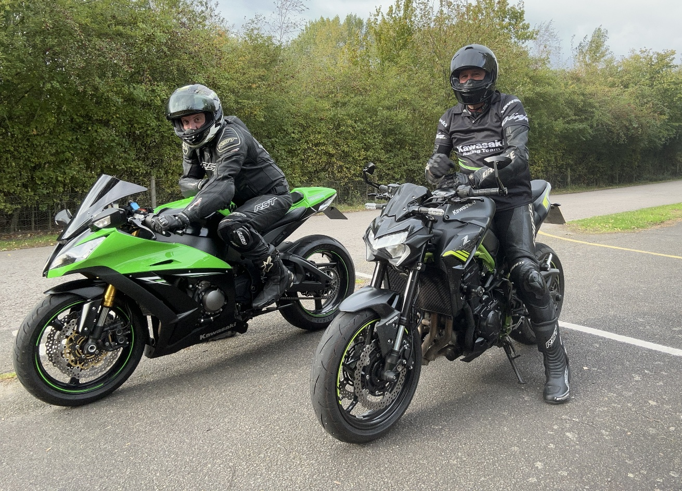
Out on our new bikes in summer

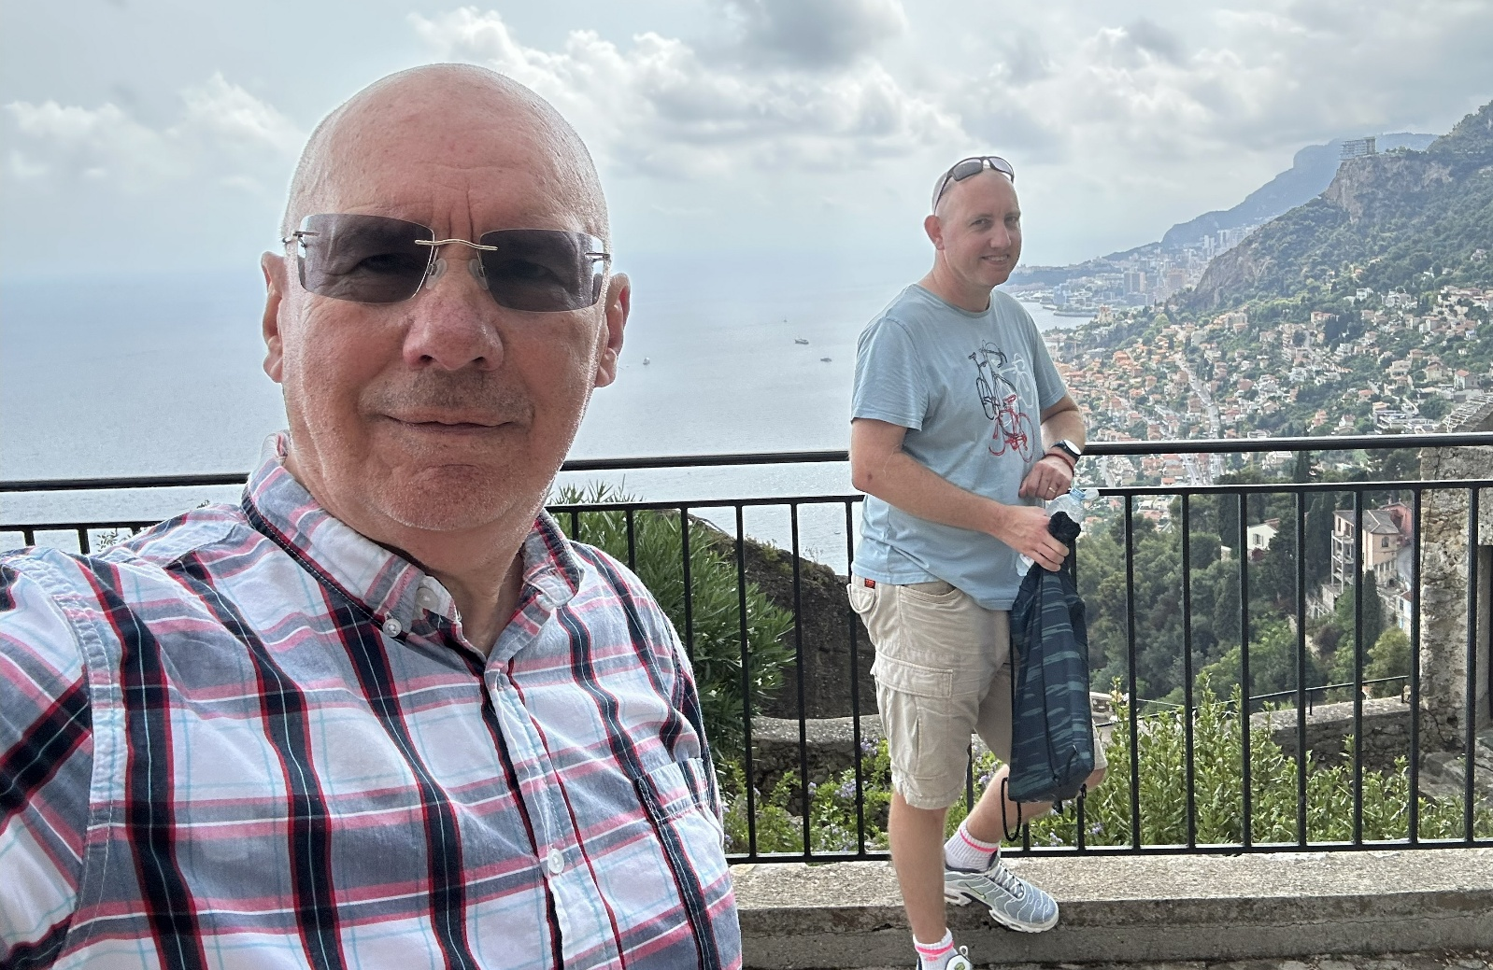
Overlooking Monaco during trip to Medieval Castle. Holiday South of France August

